DATE HERE - info, figures, whatever afterwards, DATE EVERYTHING

DO NOT USE IMAGES DEPENDENT ON QUALITY FROM THIS DOCUMENT, WORD COMPRESSES HEAVILY

09/10/2022 – Image detection literature study

<https://www.mygreatlearning.com/blog/introduction-to-edge-detection/>

Edge detection described as: “a technique of image processing used to identify points in a digital image with discontinuities, simply to say, sharp changes in the image brightness”

There are several methods, all involvi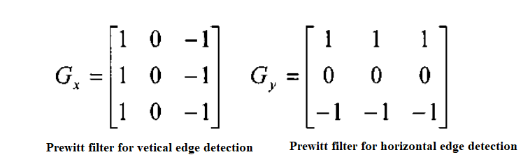ng applying a filter matrix to the image at all possible points.

For all given pixels that the matrix will fit for, apply these coefficients for a given pixel, then sum the values and take this as the new value to be later normalized for the image:

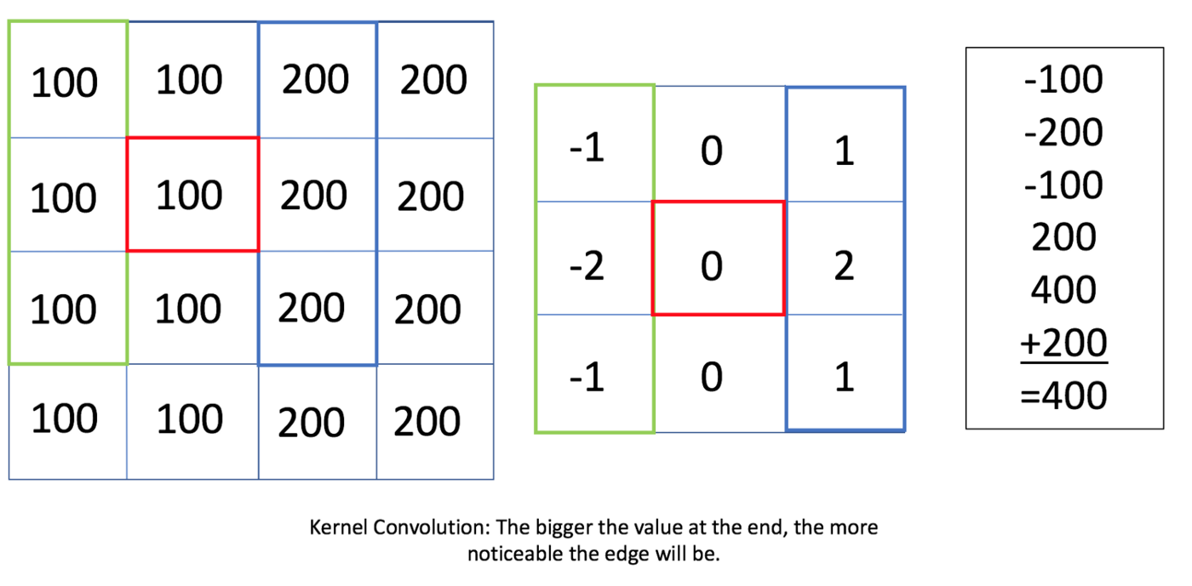

This method results in the output being shrunk in dimensions, for an n*n image and a r*r filter the output image will be ( (n-r)+1)*( (n-r)+1).

Canny edge detection is the most common. The process involves:

* Convert the image to grayscale
* Reduce noise – as the edge detection that using derivatives is sensitive to noise, we reduce it.
* Calculate the gradient – helps identify the edge intensity and direction.
* Non-maximum suppression – to thin the edges of the image.
* Double threshold –  to identify the strong, weak and irrelevant pixels in the images.
* Hysteresis edge tracking – helps convert the weak pixels into strong ones only if they have a strong pixel around them.

Attempt to implement a Sobel filter in MATLAB:

<https://www.geeksforgeeks.org/matlab-image-edge-detection-using-sobel-operator-from-scratch/>

**Advantages:**

1. Simple and time efficient computation *(for small images, cannot go above 720p at least for Arduino)*
2. Very easy at searching for smooth edges *(good for searching for edges of license plates)*

**Limitations:**

1. Diagonal direction points are not preserved always
2. Sensitive to noise
3. Not very accurate in edge detection
4. Detect with thick and rough edges does not give appropriate results

Overall quality detection if the threshold values are set correctly:

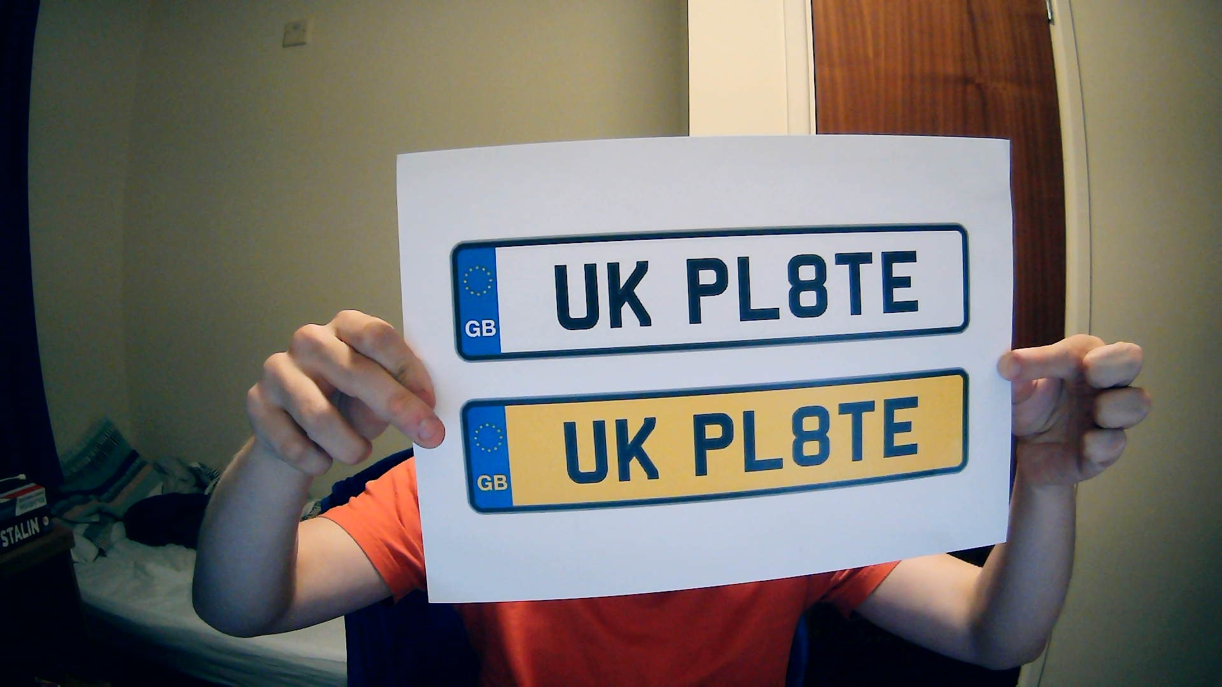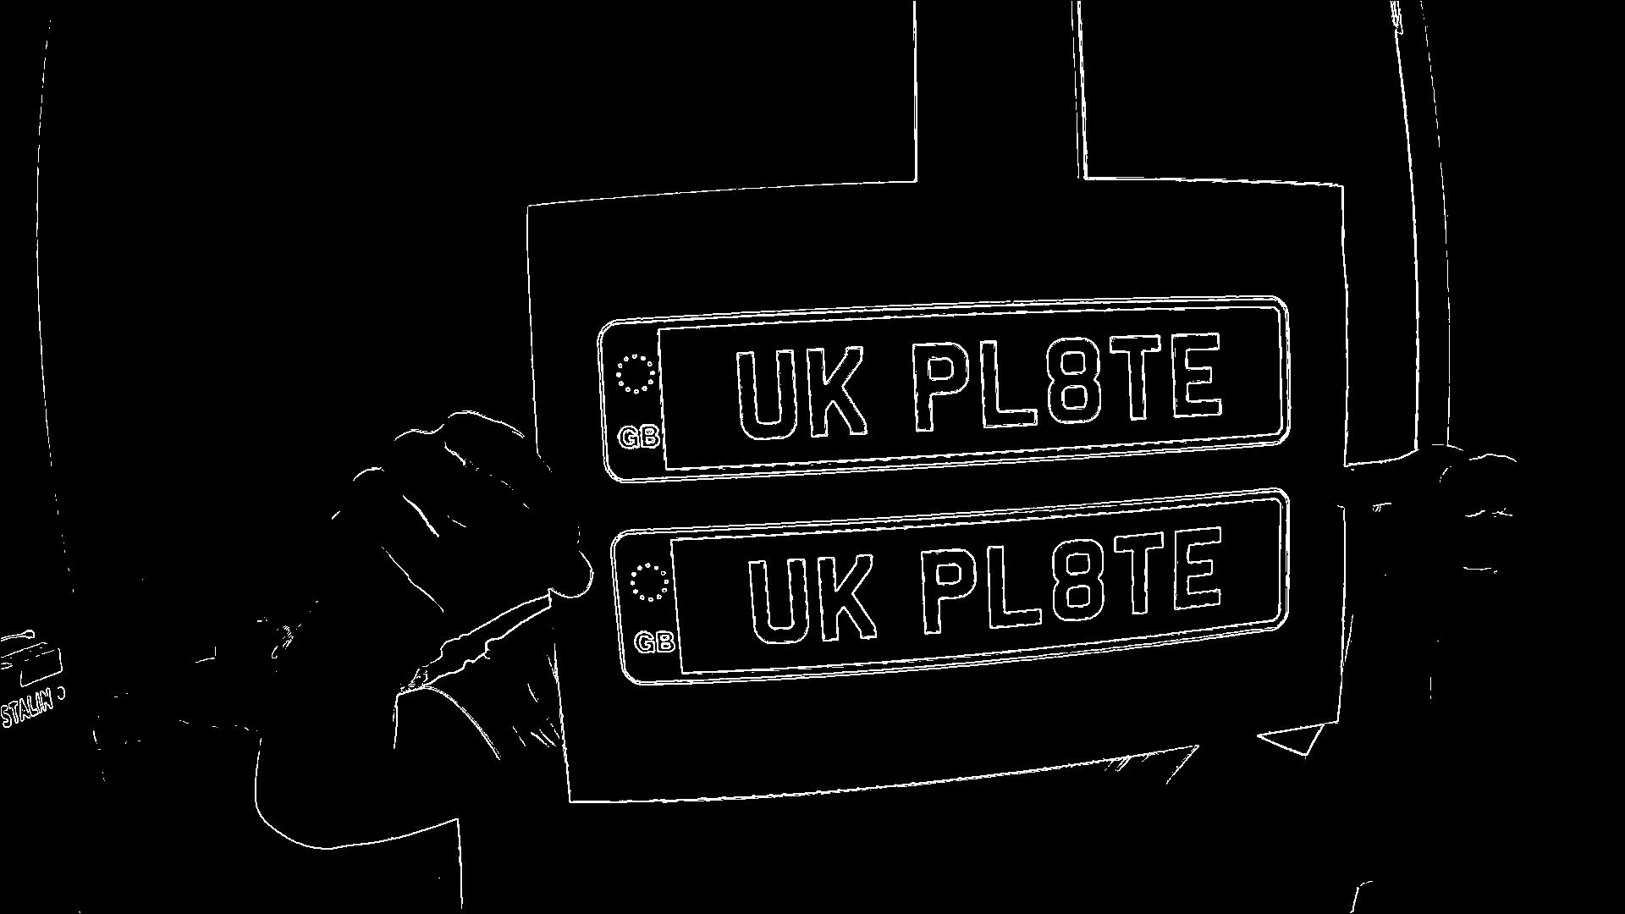

Main concern here is the potential overhead and memory requirements needed for this level of image processing, alongside all the extra processing surrounding finding the bounding box of the plate.

10/10/2022 – Attempts at bounding edged image

Attempted to use code found online to create bounding boxes for the edge filtered image

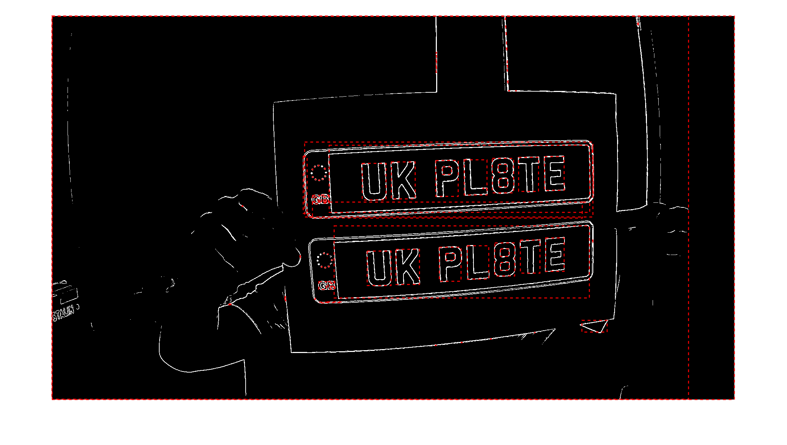<https://uk.mathworks.com/matlabcentral/answers/35243-detecting-rectangle-shape-in-an-image>

Not great, will need some tinkering with algorithm to detect correct bounding box.

Need to think of extra info that could help detect corners of plate. The corners themselves seem fairly distinct, perhaps a similar filter to the edge detection could be used to find the corners of the plate. A filter for this use may have been found by using the **Robert Operator**.

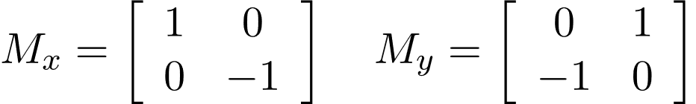

This could be utilized to filter out diagonal edges, which the licence plate has at its corners, take the highest intensity spots and use these to find the approximate location for the edges of the licence plate.

12/10/2022 – Checking image processing requirements

Looking at an image size calculator, the stated value of a 1280x720p image in 8bit monochrome would be around 0.85MB which is significantly more than most microcontroller SRAM.

<https://toolstud.io/photo/filesize.php?imagewidth=1280&imageheight=720>

Given that working with the actual pixels of the image itself will be necessary, it doesn’t seem feasible to save the image in a compressed format (unless some Realtime decompression can be performed). The image could potentially be streamed from the onboard storage if necessary, taking the data and reducing it to a very low-level form (4bit mono-chrome) for processing. Although the maximum level of SRAM I have found on an affordable board is 256KB of SRAM. I could find an external module to assist in storing images, but I am uncertain, even 4 bits per pixel on 480p leaves very little room for processing. I should probably work on getting the system working at a higher level before attempting to design anything though.

12/10/2022 – diagonal edge detection

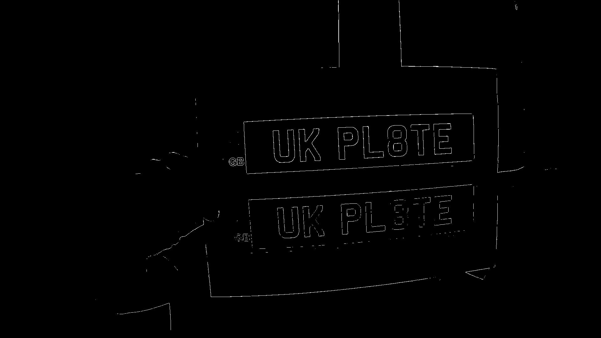

The Robert filter doesn’t work well. I might need to design my own filter to get the corners I want or find another method.

15/10/2022 – Background reading

Some of the methods that *‘Computer vision for security applications’* talks about is the motion detection aspect. In early systems there where a large amount of false positives due to the system being unable to differ between camera shake and actual motion, along with rain and sunlight changes. The methods used to combat this were using low pass filtering to counter rain and a high pass filter to remove sunlight gradient effects and to make the image appear flatter. These filters could be used to get a range of motion frequency for a range of vehicle speeds to clean up the wake-up detection image.

*‘An Automated Vehicle License Plate Recognition System’* uses a method of weighting the pixels of a RGB image differently to produce different styles of greyscale conversion. Looking at the MATLAB documentation for im2grey it also appears to use a weighted conversion to greyscale.

15/10/2022 – new idea for detecting bounds

The standard for the UK licence plate is such that, for any given plate, there will be 7 letters enclosed within a bounded box. An idea could be to find all areas that are bounded, such as with the code seen earlier in doc, and try to find a bounded area containing 7 bounded areas within it.

16/10/2022 – testing above idea

Tried to use far and angled image for testing a worse case scenario.

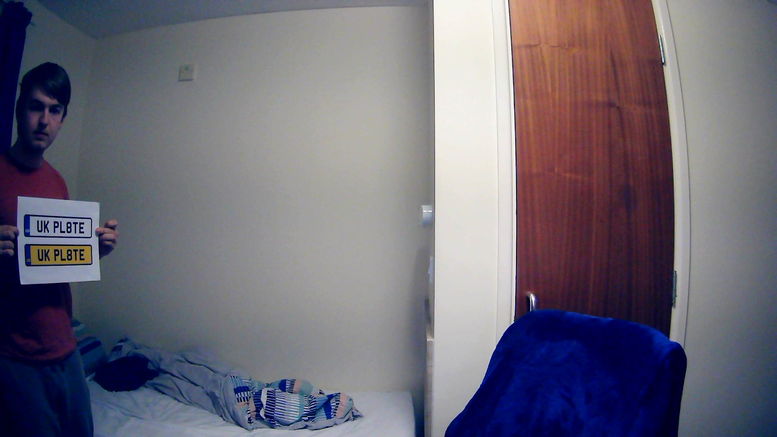

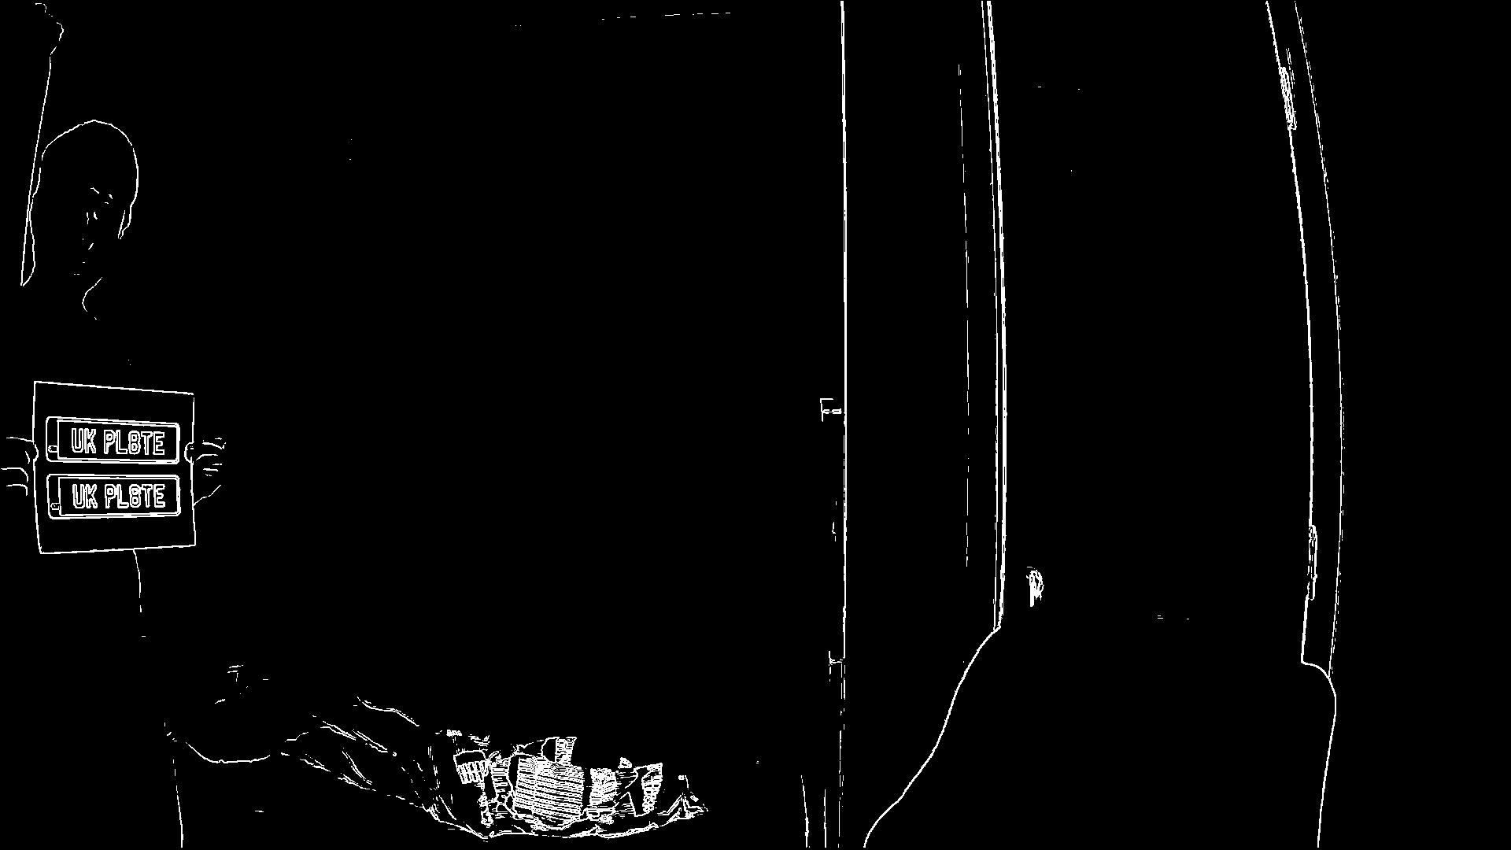

Still effective, checking and all letters appear to be creating bounded zones. Interesting effect is the fisheye lens that can be seen slightly on the image above. Given that I’m using relative pixel heights for this it could be an issue.

Checking the bounding data, some interesting effects on 1080p:

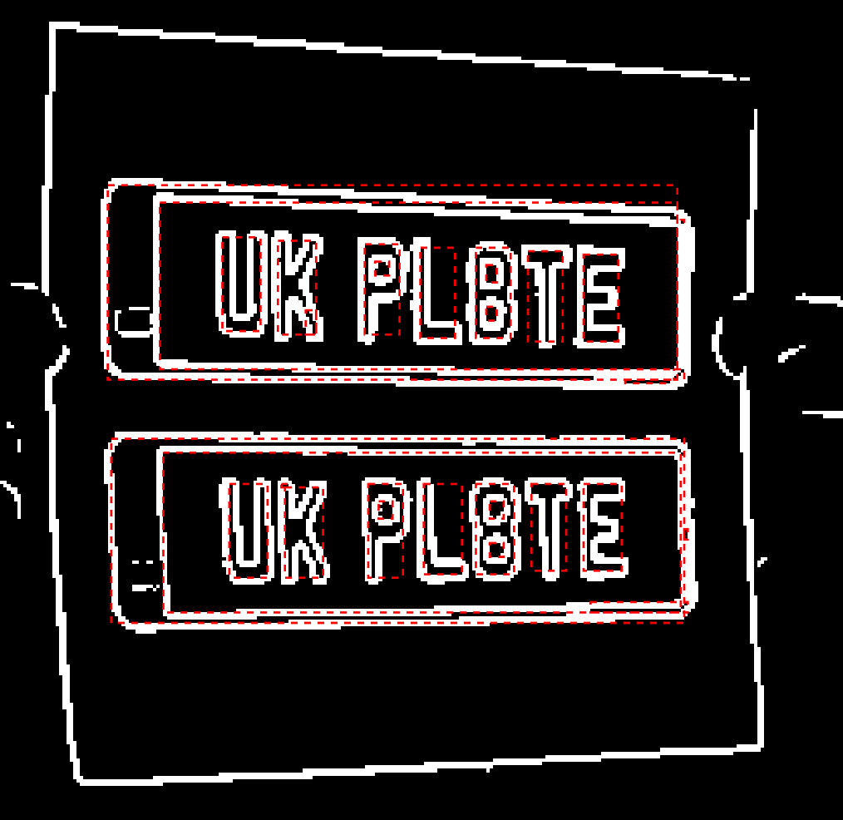

Both plates have clearly detectable bounded lettering, which creates 7 bounded areas. Tests at 720p also conducted:



Not great, pixel density is too great in some areas for plate letters to be counted as bounding areas. Seems like reducing the resolution reduces the number of pixels a fixed object size has to be represented in the image. Will try 480p with plate at closer range.

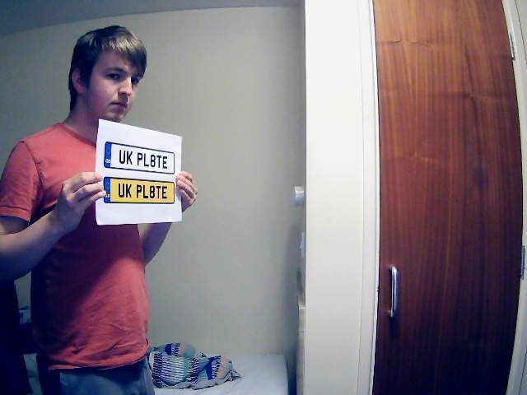

This 480p image is a closer range, hopefully better detectable.

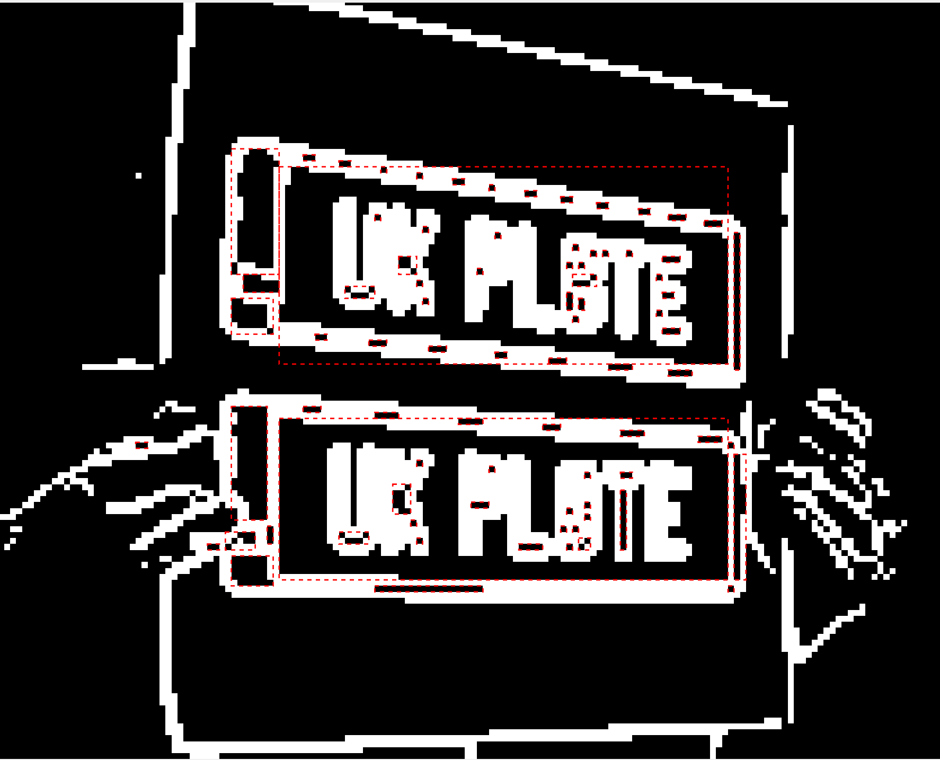

Not much better, lettering still too pixel poor to create properly enclosed letter spaces. Notably the bounding box for the licence plate is still moderately accurate. In general I think I should aim for the highest resolution feasible when working with hardware.

Possibility of using the bwareafilt function to get all white pixel shapes that have a size within a given range:

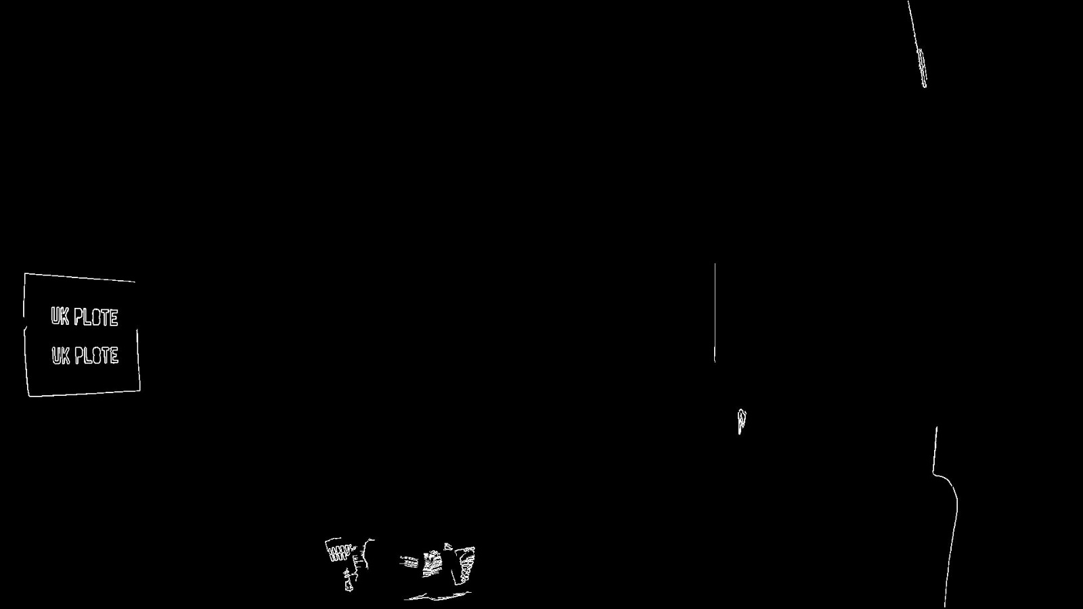

The above is a 1080p image with filters set to take all shapes within 100-1000 pixels, not working for detection by itself but could be useful elsewhere. Problems would probably emerge as tracked plate will change pixel size across image sequence.

17/10/2022 – Video testing

Might get some more useful data if I try to work on tacking the plate across a video. Created some short footage of me walking across a room.

Found a way to split video into single frames and process those. Working on 1080p video now.

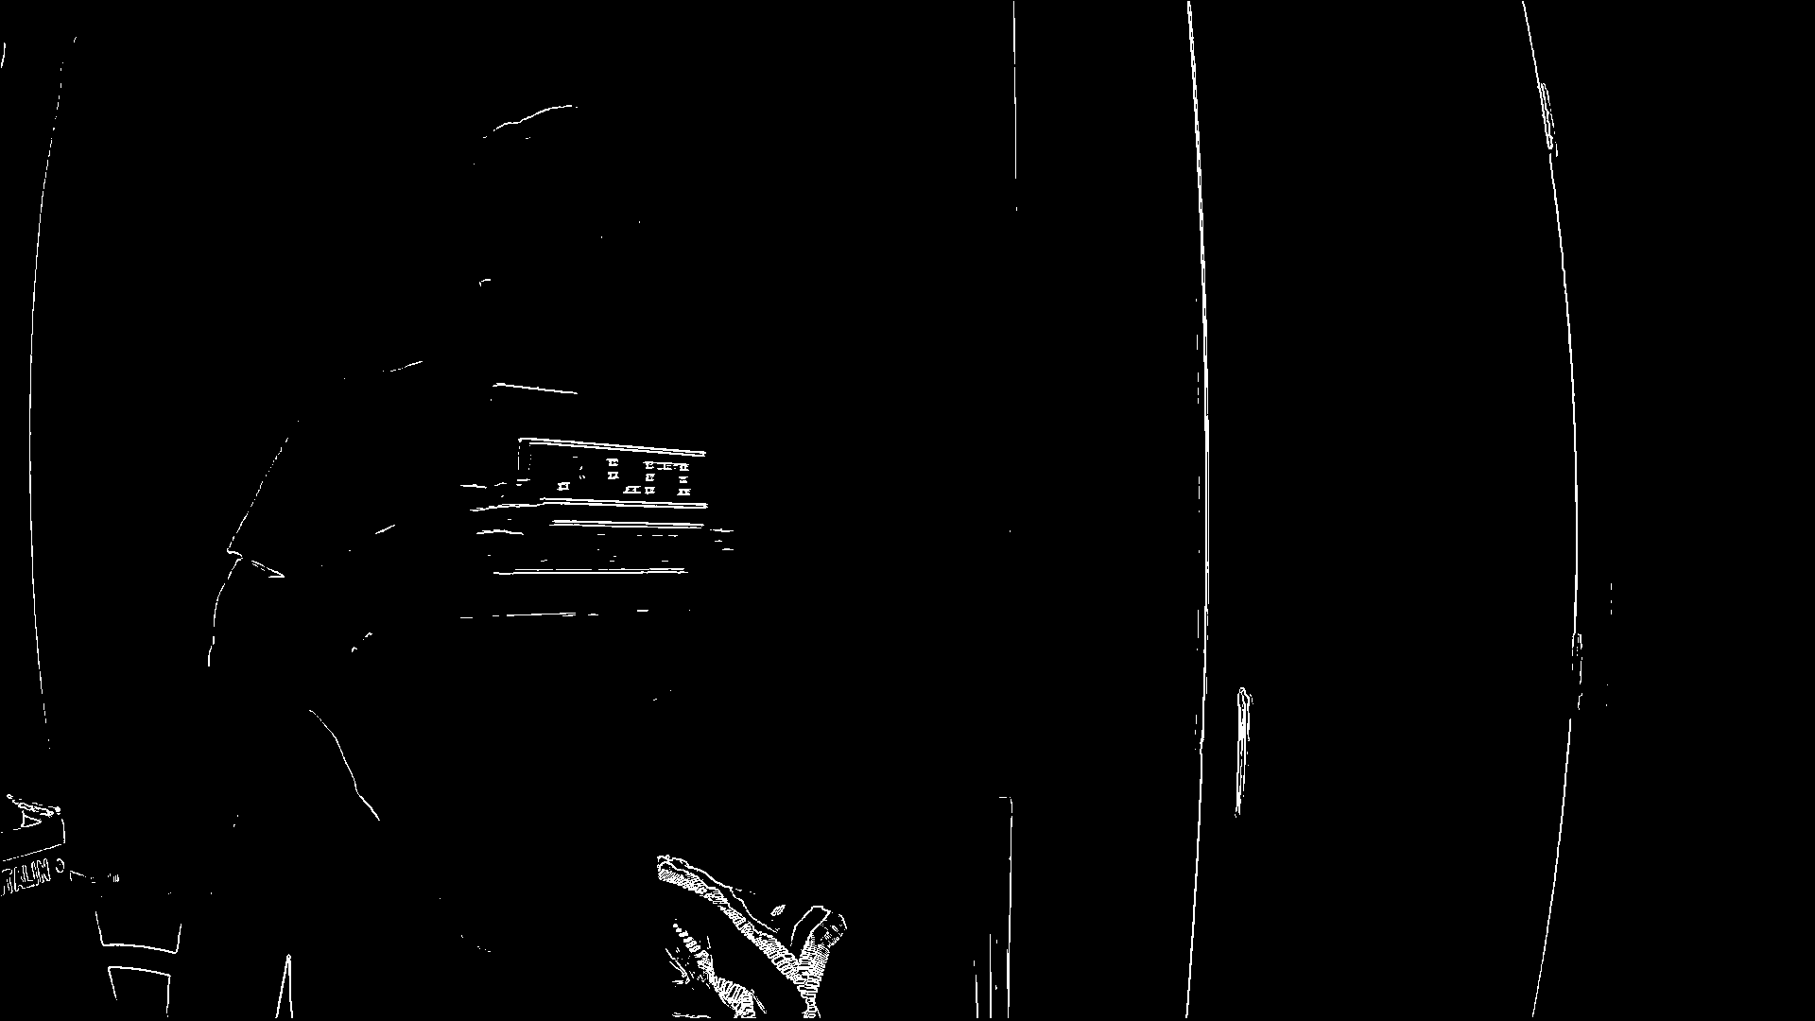

Not great, motion blur ends up being a severe problem for the system, also the angle may be too steep for the entire 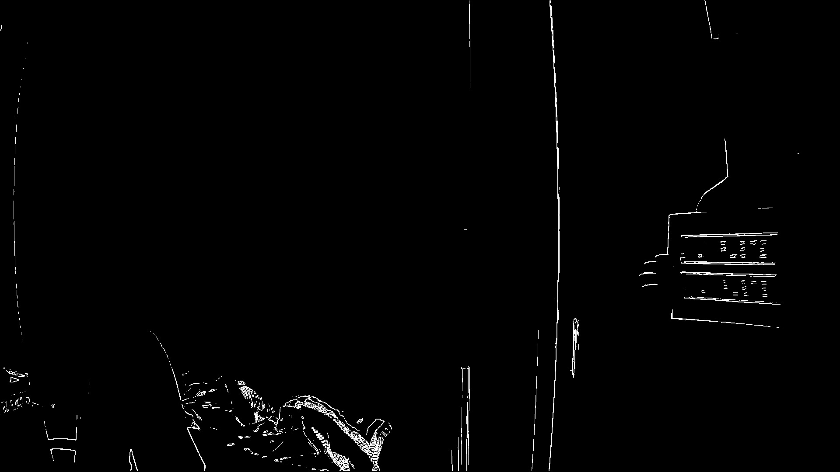

Not much better in the other direction. Maybe angle is too steep, will try to create a video simply advancing straight towards camera. Notably the processing takes a concerning long time even on desktop, hoping that most of that is MATLAB overhead and not core functionality to the algorithm.

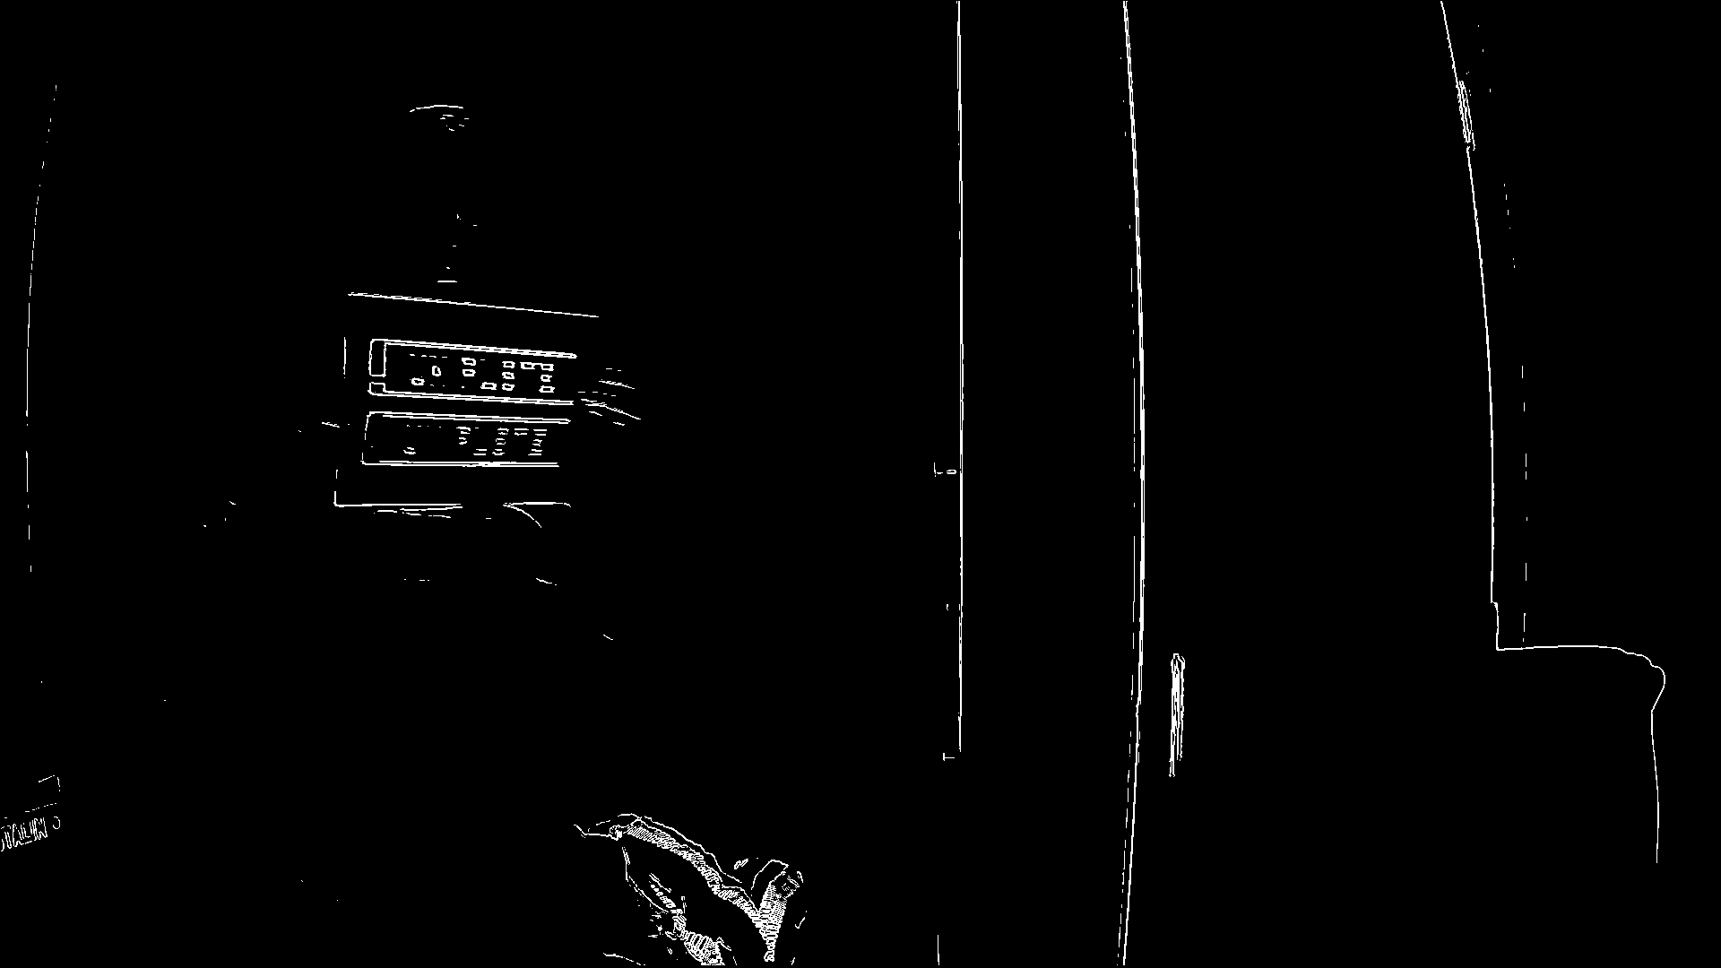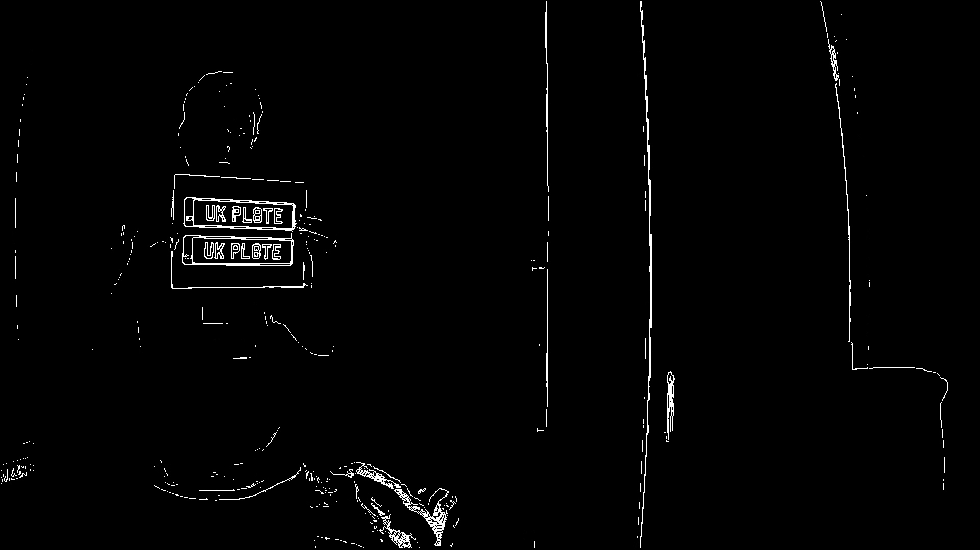

Issue with motion can be seen quite clearly above, two images are from 10 frames apart. Motion appears to immediately destroy the edge information in the sobel filter. Could try the canny edge detection to see if any improvement is made.

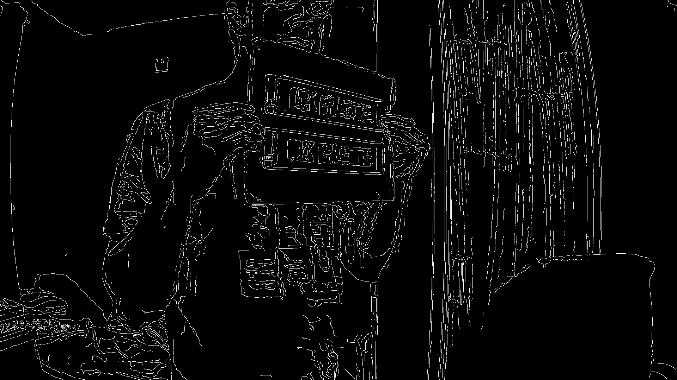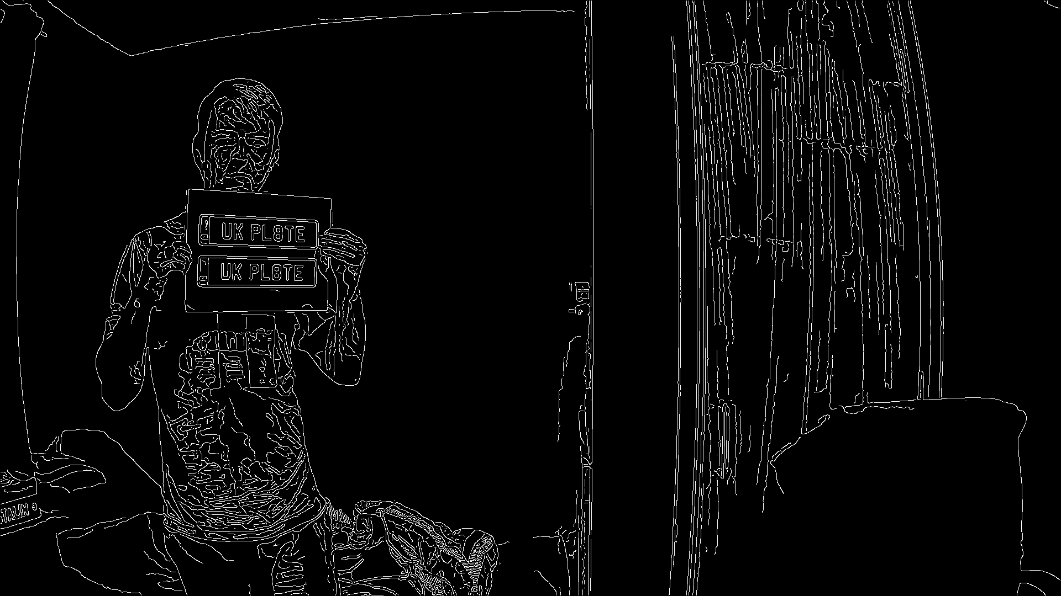

Major improvement, in both image clarity while stationary as well as in motion. Some warping observed but I think understanding how the canny edge filter works is now a high priority.

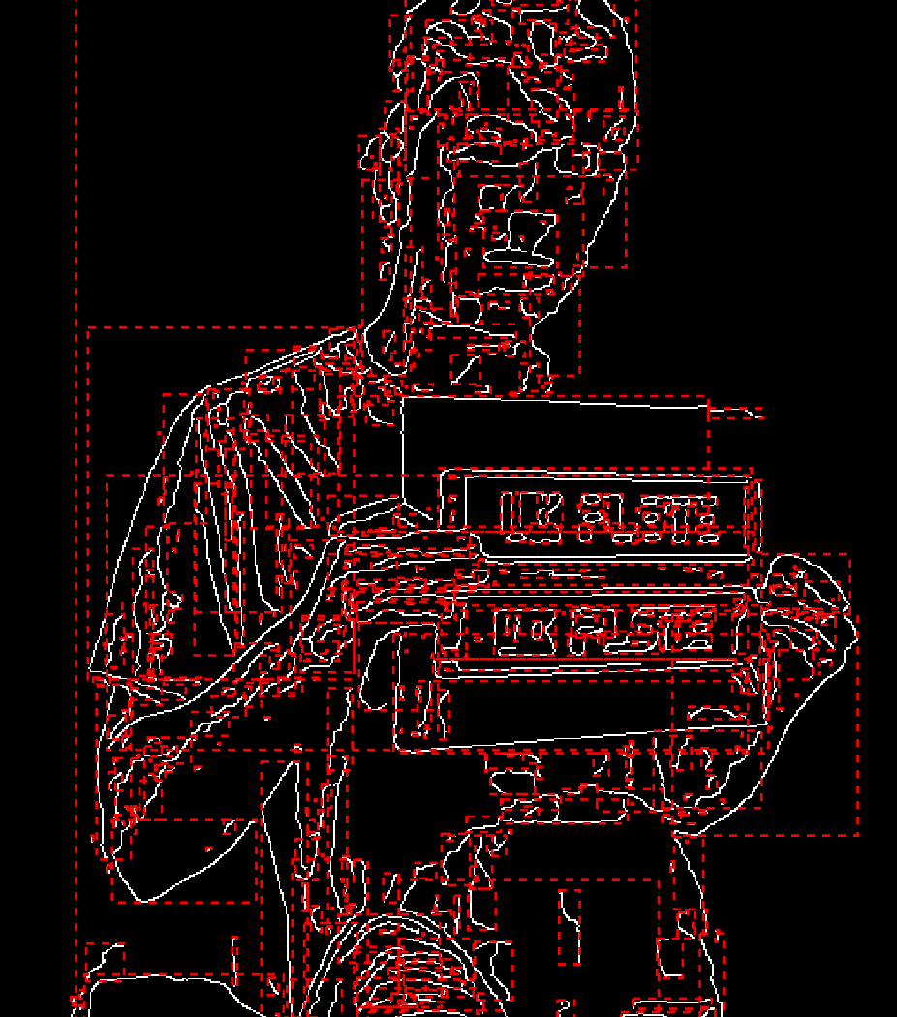

Observing the bounding data, it appears that there will still be an issue with noise from the edged image creating a mess of bounded zones. However, within the range that a plate is even detectable, there will likely be a large retention of the original shape of the plate (assuming a horizontal orientation). This could allow for looking for a specific ratio of bounded area height to width to be viable.

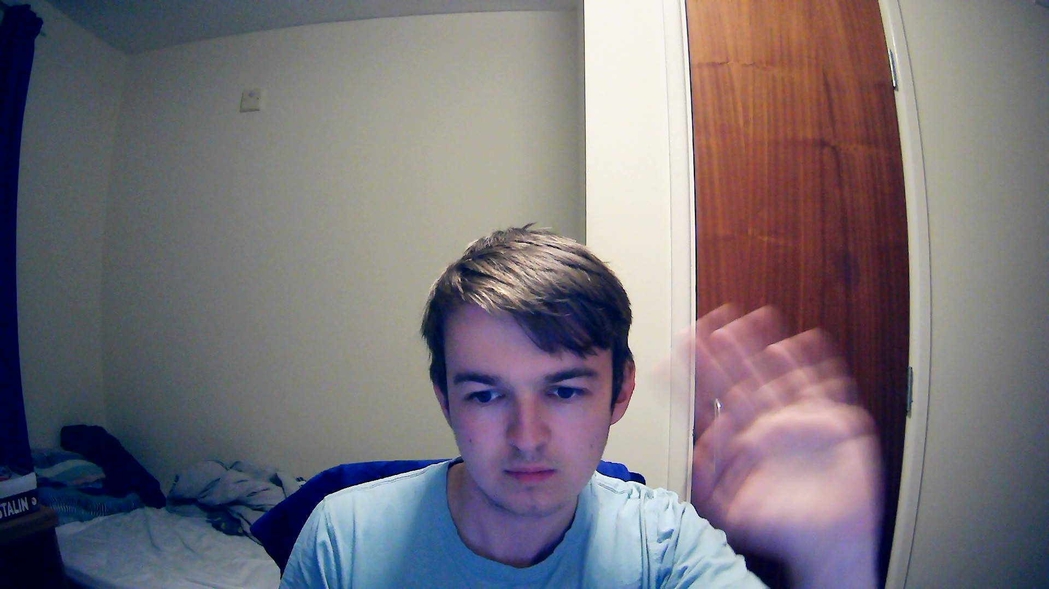

This image above demonstrates the effect of motion blur on my images. Having viewed images taken of speeding vehicles before, this effect is not observed. I will have to see if it is possible to correct or turn off this effect. One suggestion I have seen is to use a more robust video capture software than the windows default, such as OBS.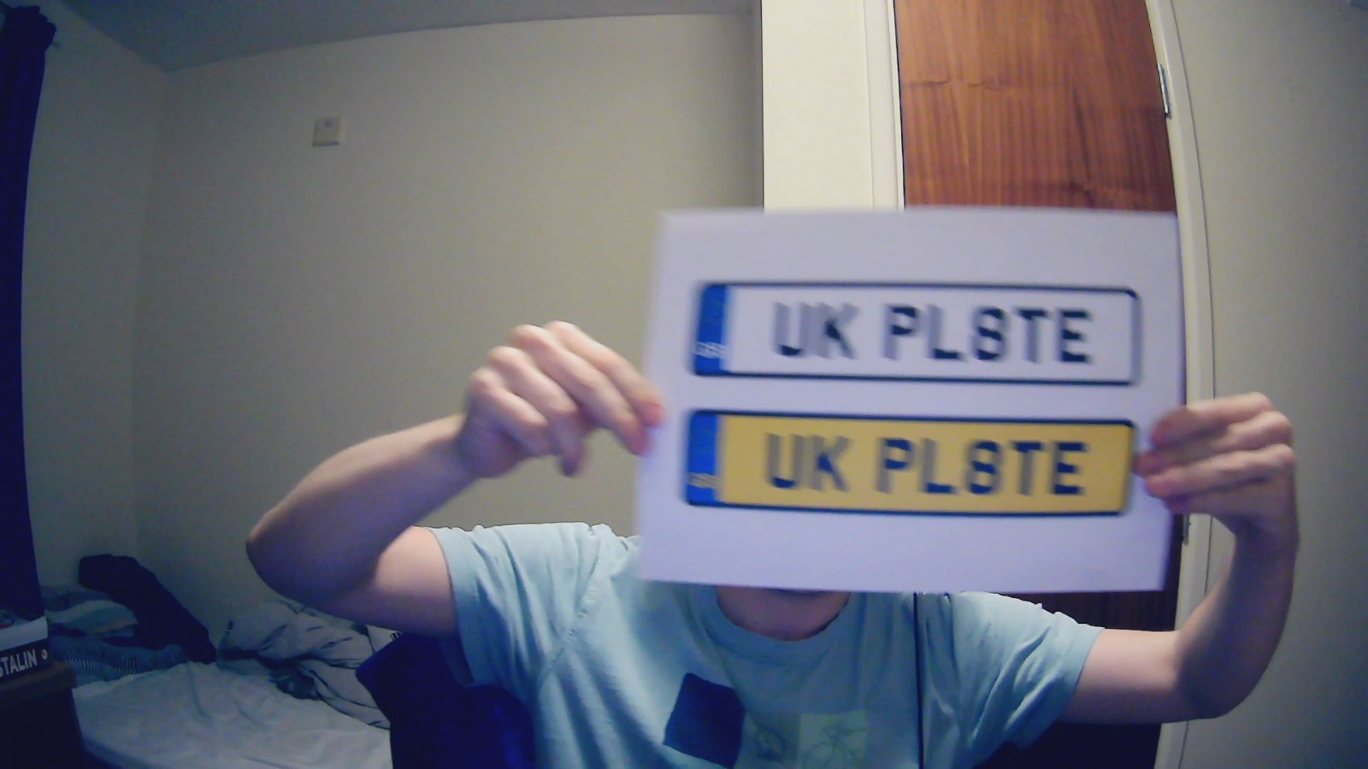

The above image is from OBS captured footage with MJPEG for video format, while not complete. The motion blur seems reduced.

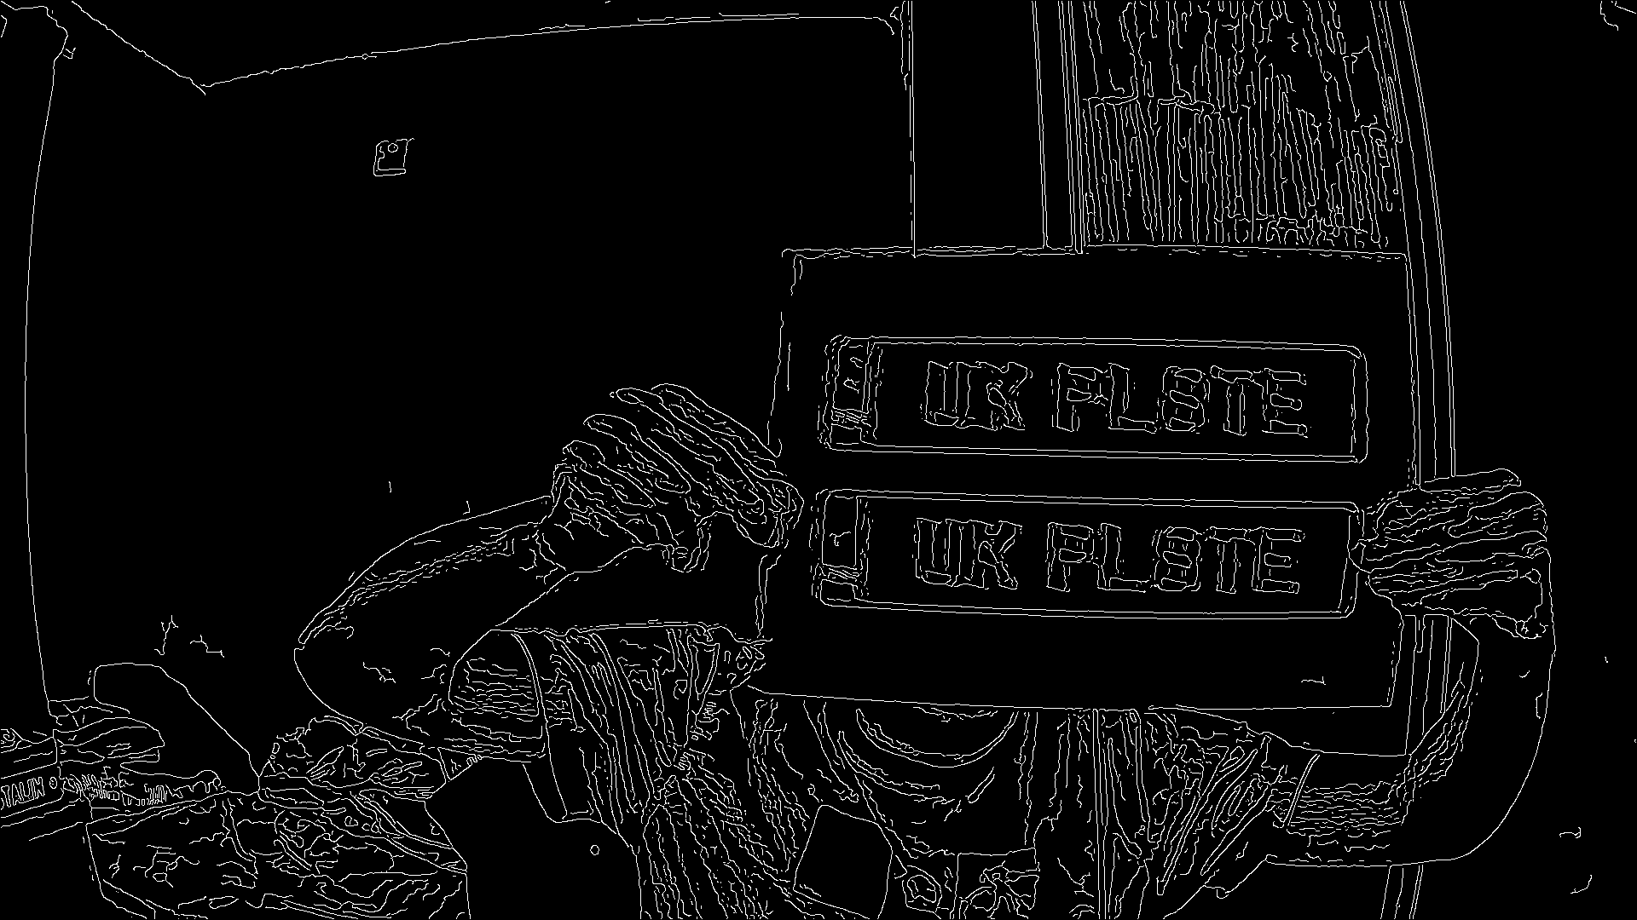

The same image after canny edge detection seems much clearer as well. I will need to see what the result of a picture run would be for motion blur.

18/10/22 – understanding canny edge detection

Canny edge detection supposedly operates with the following steps:

1. Reducing Noise By Applying Blur.
2. Calculating (sobel) Gradient.
3. Non-Maximum Suppression.
4. Double Threshold.
5. Edge Linking.

A gaussian blur is applied in a similar way that the Sobel filter is, with a kernel creating a new pixel matrix out of the old.

19/10/2022 – cont.

A gaussian filter is used to create a kernel to apply to each pixel a weighting, similar to the graph below.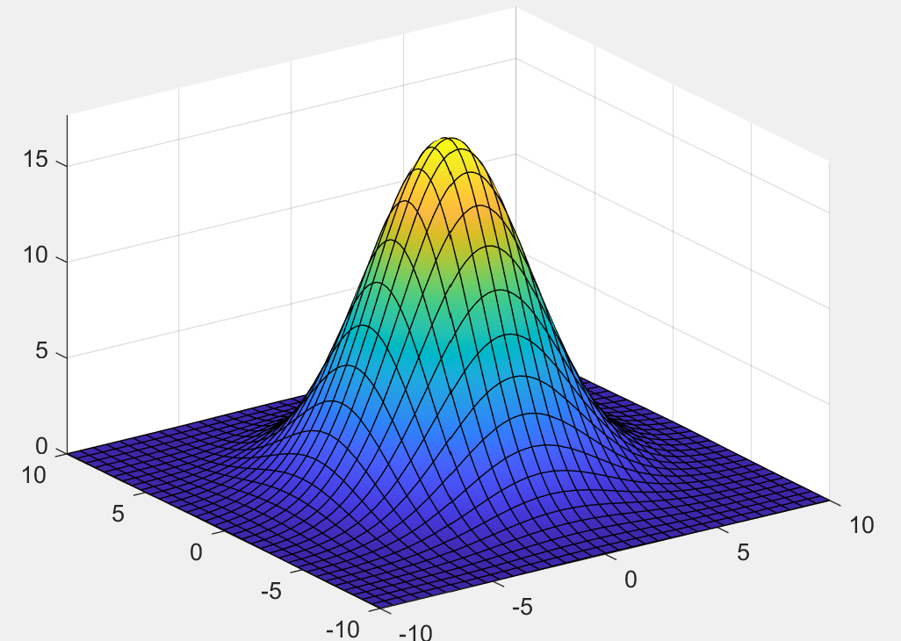

This weighting is then used to sum the pixels enclosed inside the kernel, which is then normalized and placed back at the origin pixel. This results in blurring or smoothing seen in the final image.

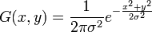

This would be a difficult task to carry out in image processing, as a complete Sobel filter task would need to be performed alongside another kernel filter. A property of the gaussian filter, however, is that the two elements are separable:

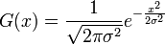

These 2 gaussian filters can then be ran over their respective directions and the result on the kernel will be the same as the combined equation. While this still requires polling each element within the kernel, this requires far less memory to hold 2 N tap pixel weights arrays than 1 N*N matrix.

The storage of these values becomes even simpler by using a binomial coefficient list, which only contains positive integers, and a scaling factor applied that is the inverse of the sum of the list. I will attempt to use this information to create a gaussian filter custom to my needs.

I have made the filter, with some promising results when given to a Sobel operator.

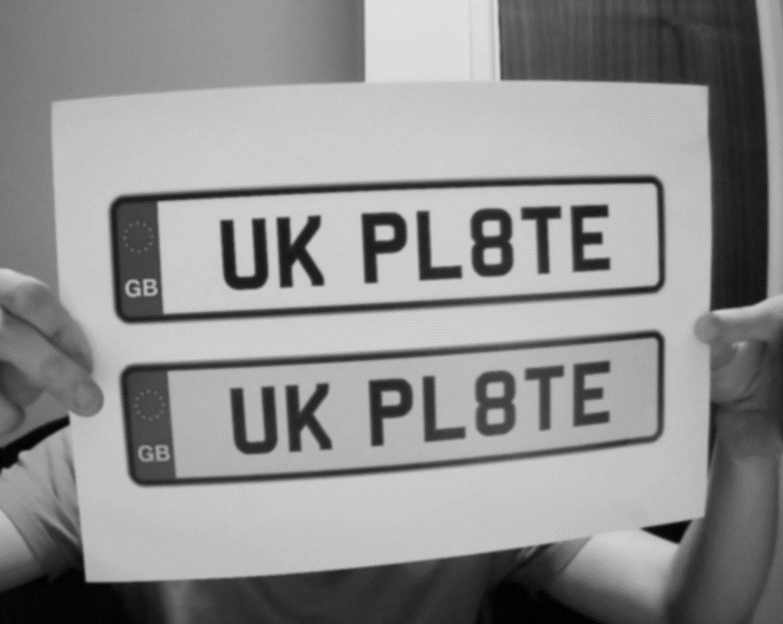

While this image may appear to be only mildly altered, the results in Sobel when compared to an unsmoothed image are clear.

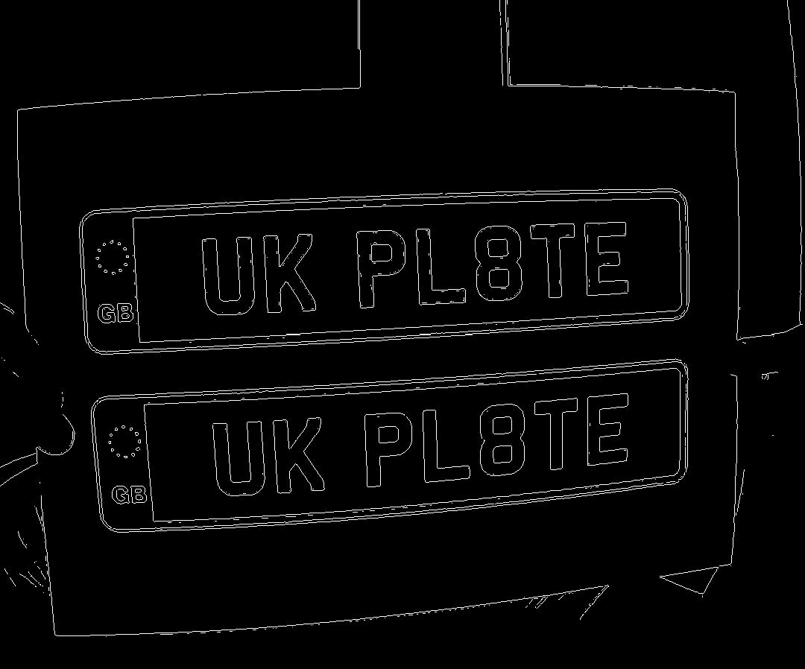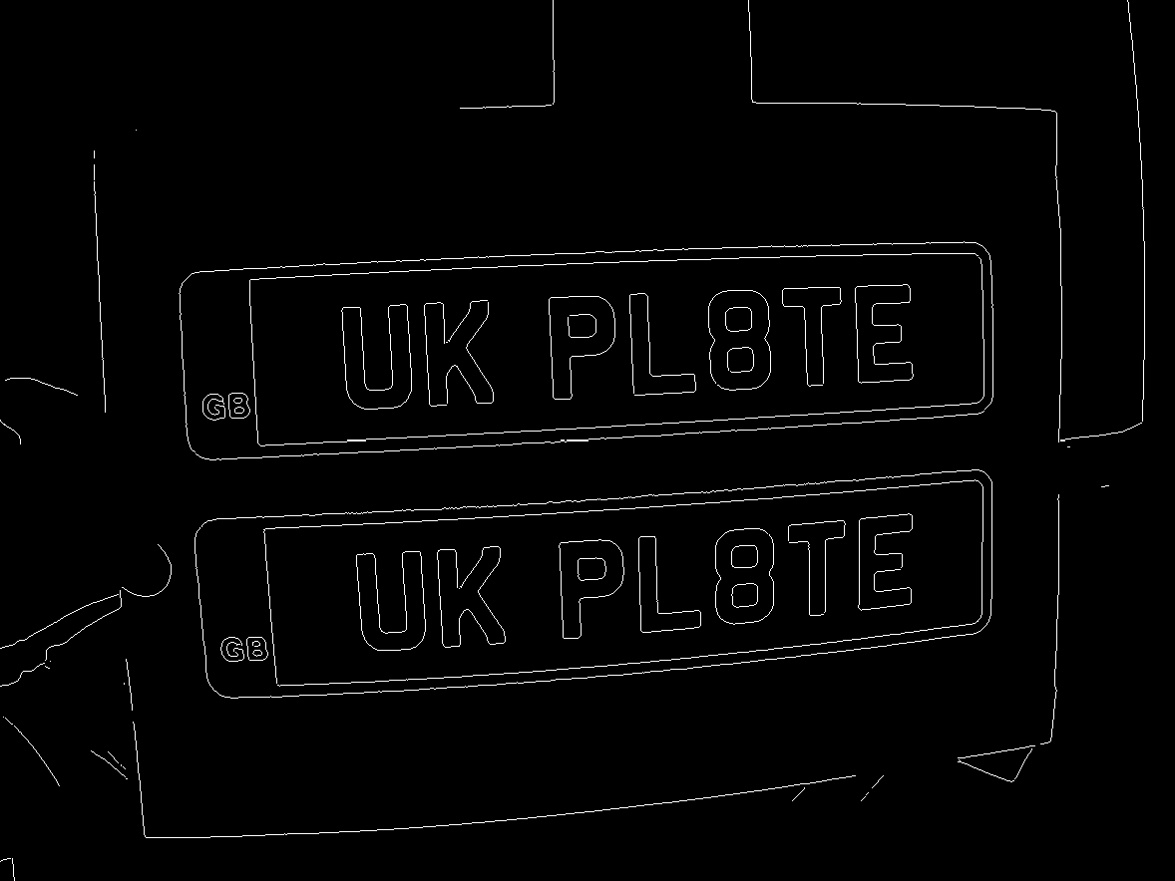

The bottom image compared to the top has far less noise and the letters can be read clearly in the edge detection. Testing shows that a larger kernel results in a heavier blur, the algorithm could theoretically also be run several times in order to repeatedly blur the image. But as this would require multiple image buffers and blurring seems suitable at this level, I think controlling with the kernel size is best here.

Images in with a degree of motion blur are also improved.

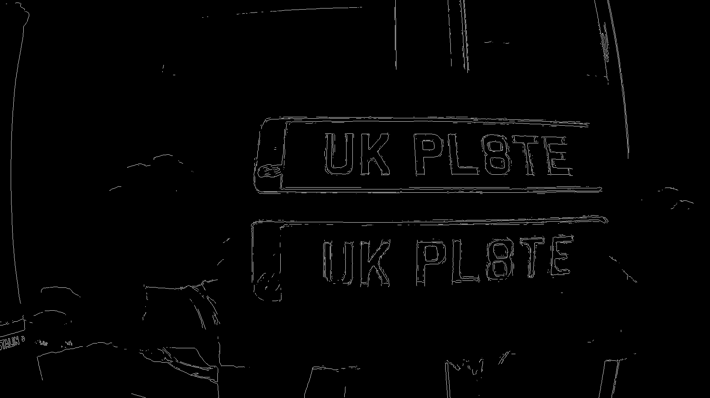

This however has raised an important point surrounding the use of the whole licence plate for tracking the vehicle. The lettering is perhaps even more standardized that the size of the plate, perhaps a bounding box looking for the letters could be gathered and averaged for all letters found to get an average location per image that can be the basis of tracking.

20/10/2022 – letter tracking idea

Looking further into my idea of letter tracking, I used my algorithm to find the edges of a real photo, and the results seem encouraging when using the bounding boxes:

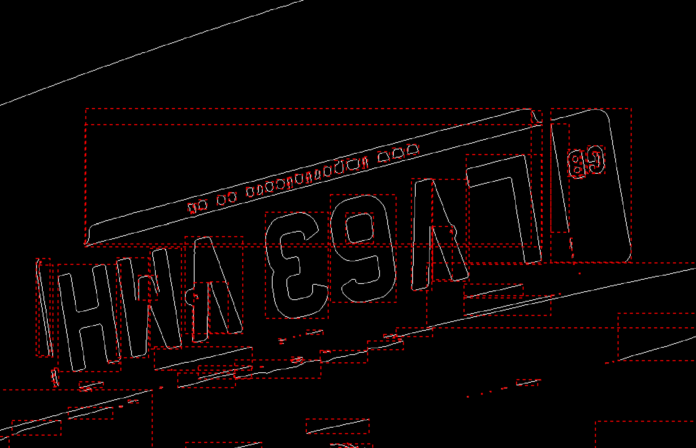

This seems quite promising; all the letters seem to be bounded with a consistent size between them. The licence plate lines are also nonvisible after filtering, confirming a suspicion that they are less useful and consistent than the lettering. The lettering also appears to be more strictly defined in the INF104 document that the actual size of the licence plate.

The full specification for the letters is:

* 1. characters must be 79mm tall
  2. characters (except the number 1 or letter I) must be 50mm wide
  3. the character stroke (the thickness of the black print) must be 14mm
  4. the space between characters must be 11mm
  5. the space between the age identifier and the random letters must be 33mm
  6. the margins at the top, bottom and side of the plate must be 11mm
  7. vertical space between the age identifier and the random letters must be 19mm

Points 1 and 2 seem the most relevant here. Taking the ratio of letter width to height (50:79 -> 1:1.58) gives me a tool to look for bounded areas fitting this size ratio (W:H - > x:y distance). By taking y/x for a given bounding box and checking its closeness to 1.58 I could potentially extract the bounding boxes for all the letters.

Having attempted to use my own custom Sobel filter code and comparing it to the MATLAB provided Sobel, I can see some clear differences:

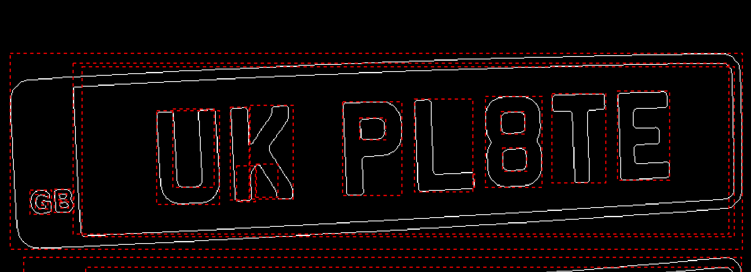

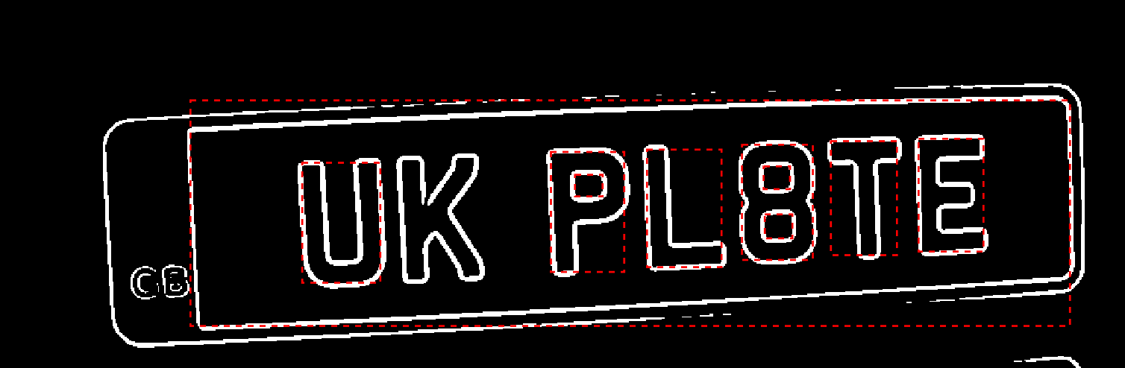

My code on the bottom clearly generates thicker boarders and occasionally leaves holes in the letters, meaning the bounding box fails to detect them. I suspect some degree of linking and line thinning is going on behind the MATLAB code. I will use the MATLAB Sobel code for now as it seems more consistent.

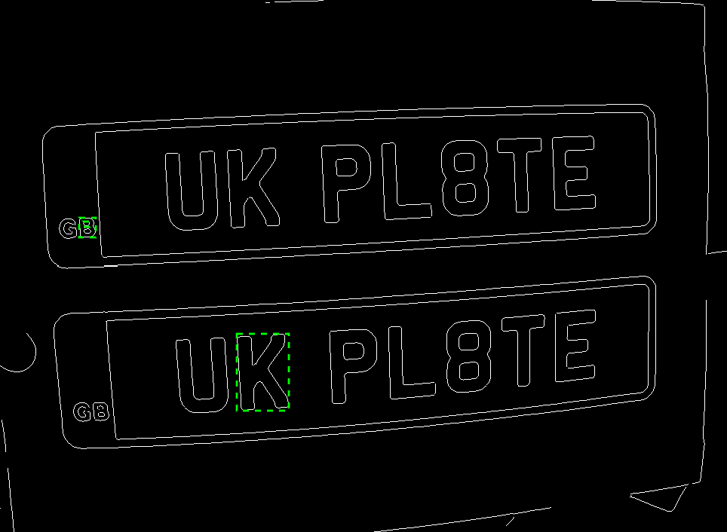

This was captured with 5% tolerance on the size of the letters. Not a great capture, will try a higher tolerance.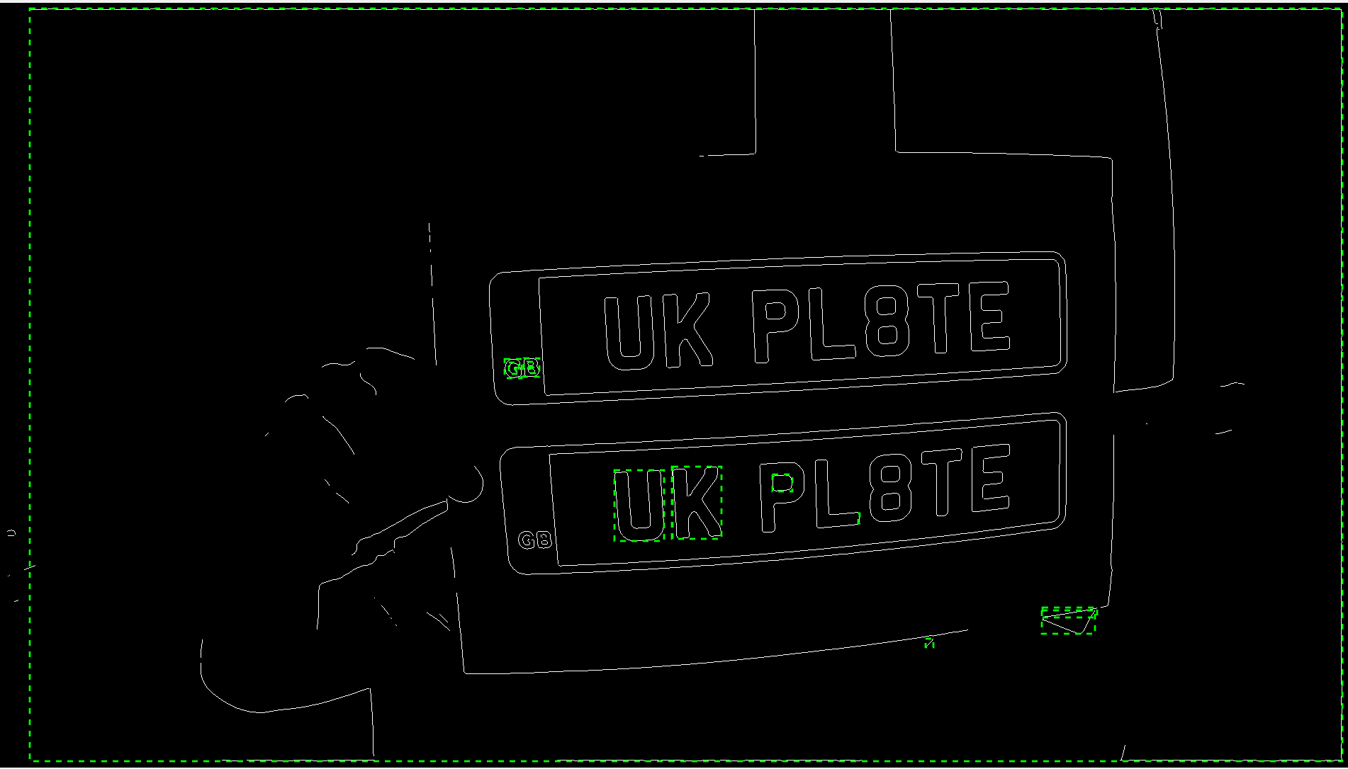

A lot of these captures are outright incorrect, something is likely wrong with my code.

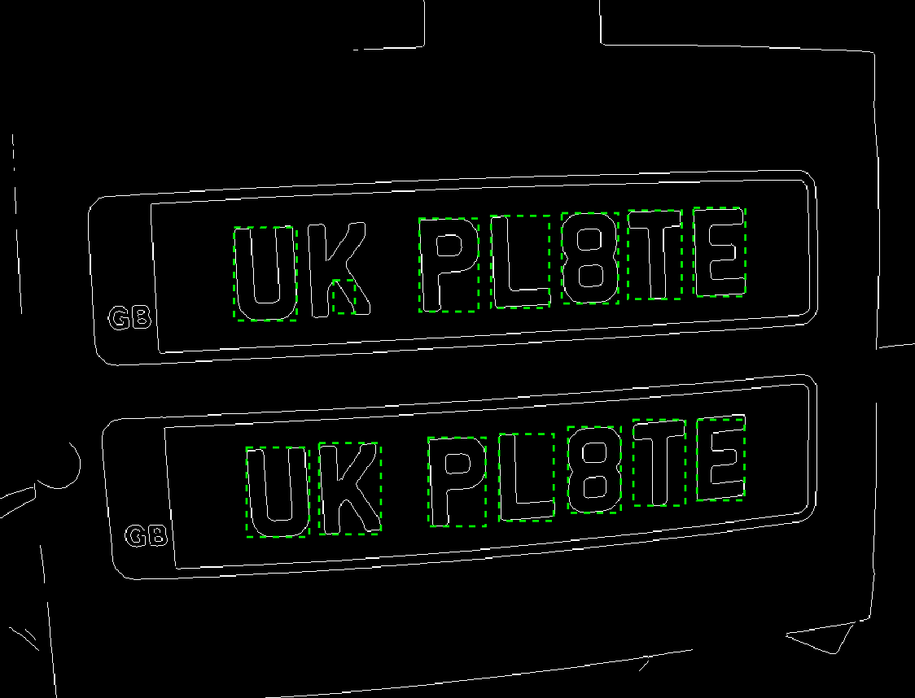

Turns out I was misinterpreting the return from the region finder incorrectly, at 10% tolerance the letters appear to be very easy to extract, nothing else was caught in this region filter.

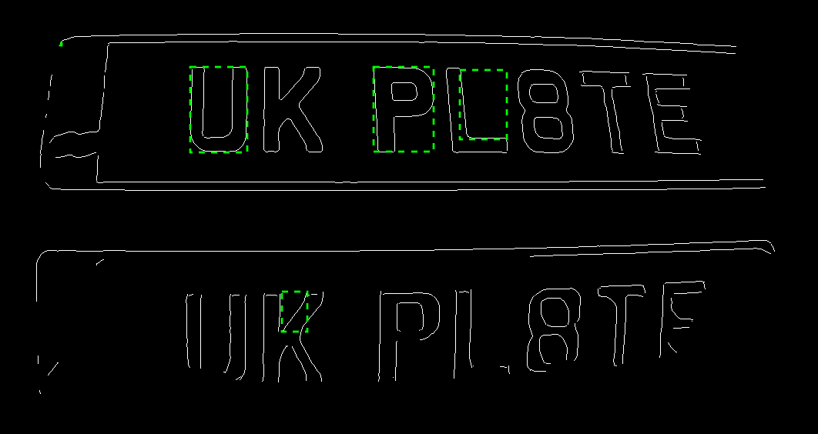

Performing this filter on the noisy motion blur image had less accurate results. Increasing the tolerance had some positive effect but created a large number of false positives. Perhaps a maximum/minimum region size should be implemented for positives, perhaps a region should be within 1-15% of an images total size to be valid.

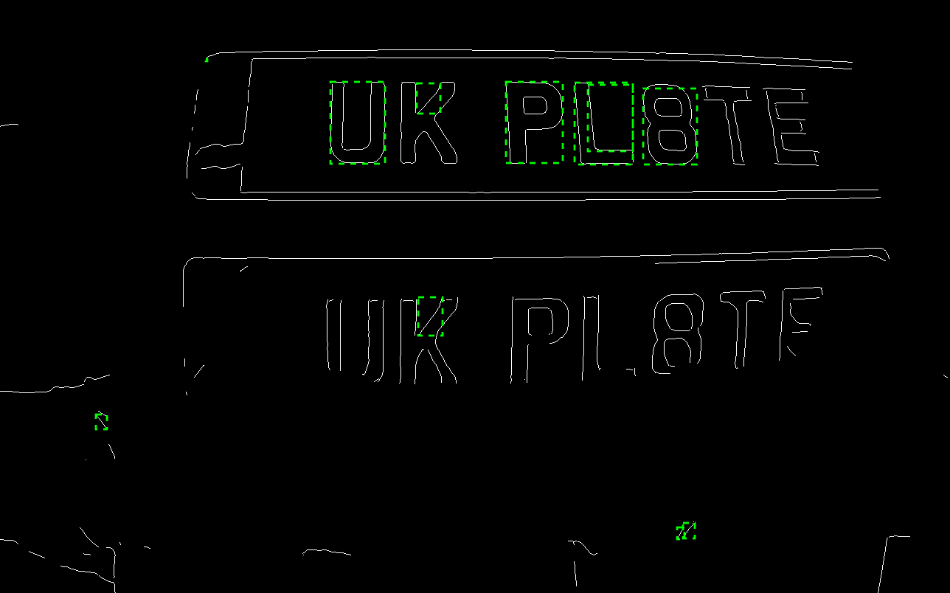

At 20% outside range tolerance in the above. My plan is to then take a cumulative average of these bounding boxes to get an average position to track the vehicle with.

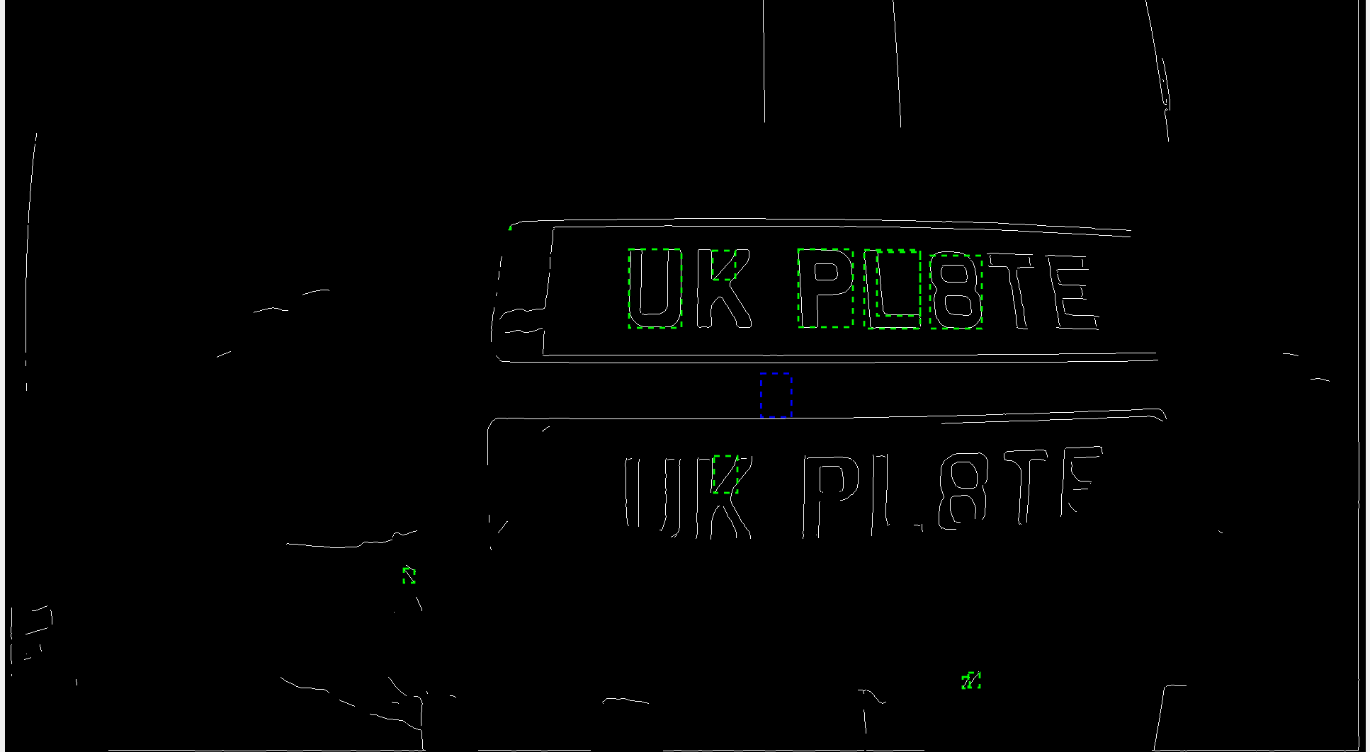

The ‘average’ bounding box is shown in blue. While its location is somewhat accurate, some filtering of false positives is needed to prevent skewing.

24/10/2022 – filtering of false positives

I have a set of ideas that could be used together to filter the false positives. First perhaps a crude filter should be used to remove obvious fails, a 5-20% of image size bounding box limit should filter out the tiny areas that were picked up.

Realized something, area scales quickly with image size, and any small section of area will be much smaller than the total area of an image. This is probably why my algorithm has 0 hits for valid boxes as 5% of this size is still immense compared to any bounding box. Might want to try width or height bounding as this scales linearly with the image size, something percentages work well with.

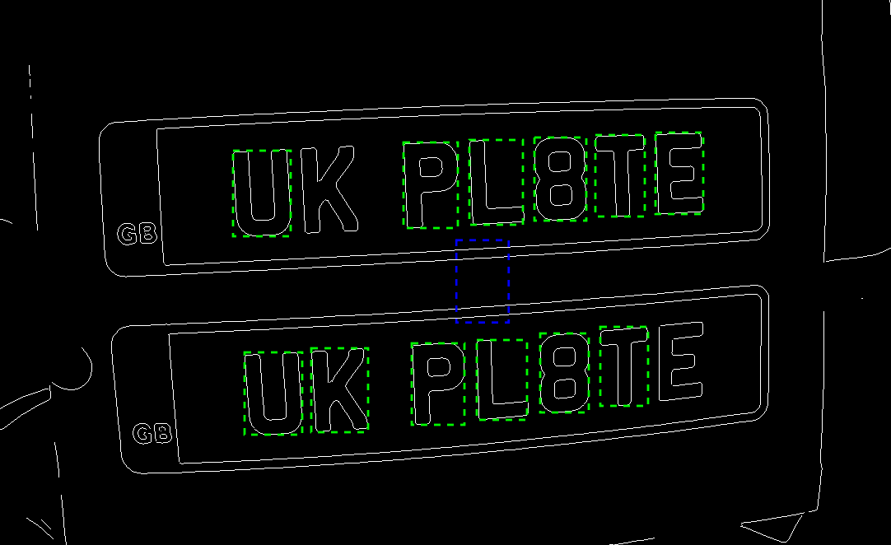

Width bounding within 5-20% of image size appears to work very well, average box is well centered.

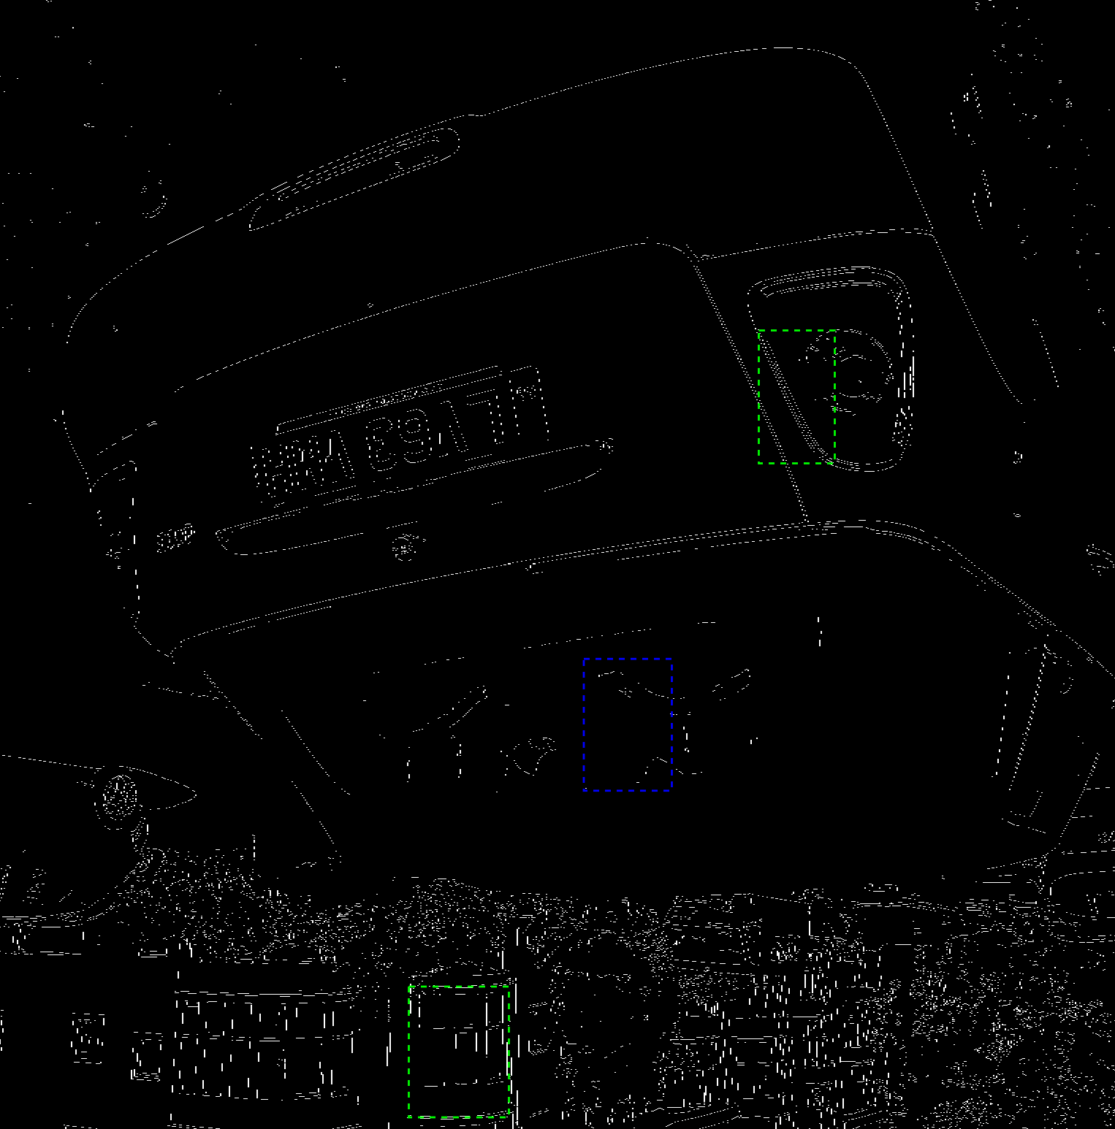

This technique seems to need some refining based on image size (above is 4608x3456).

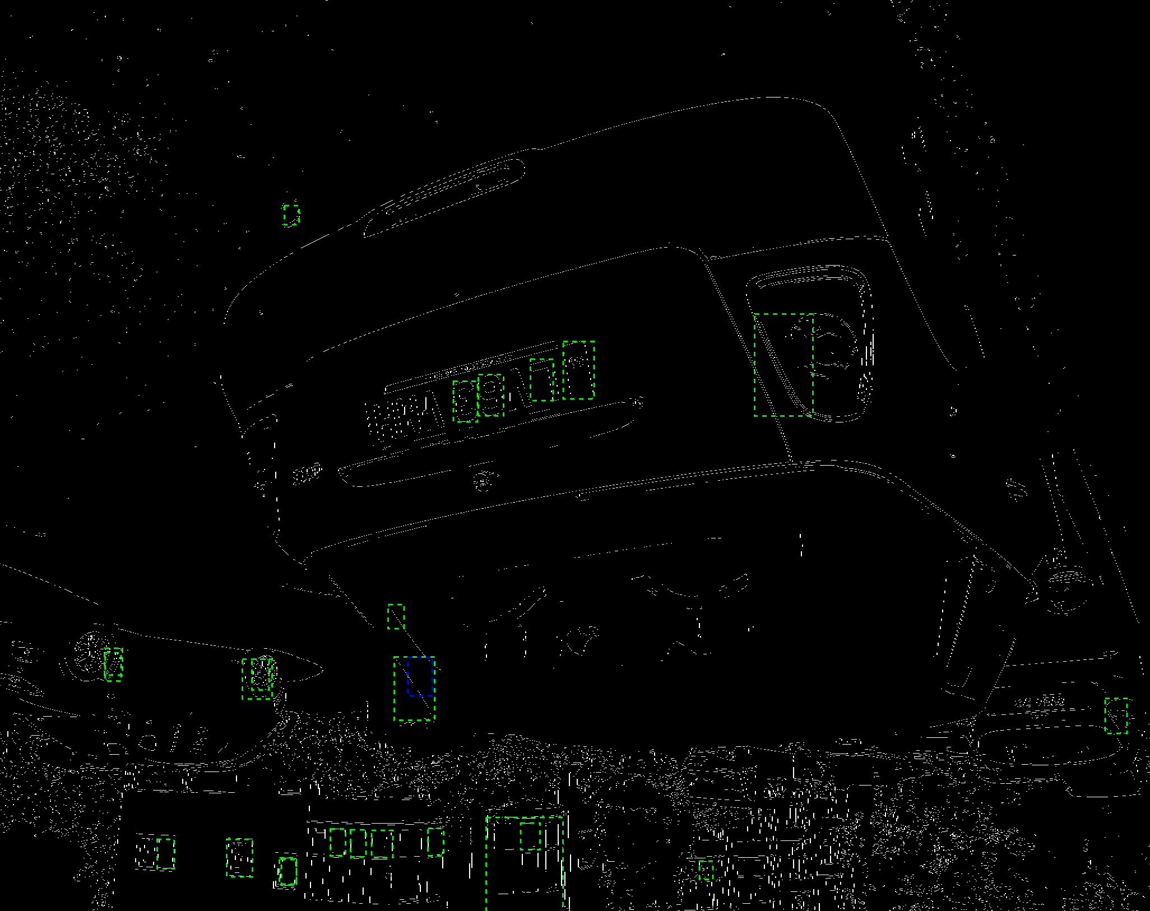

Even with threshold adjustments (1-10% for above), it seems that further detail will need to be given to the bounding boxes I select.

Another idea I had was to take the biggest set of cords that were within a certain range of each other. The symbols on a number plate are relatively well grouped together. What could be done is some minor statistics on the coordinates of the bounding boxes to find the largest set grouped within a certain x and y range of each other. This should work as, if other filtering has worked properly, the system should be detecting the highest density of boxes at the licence plate.

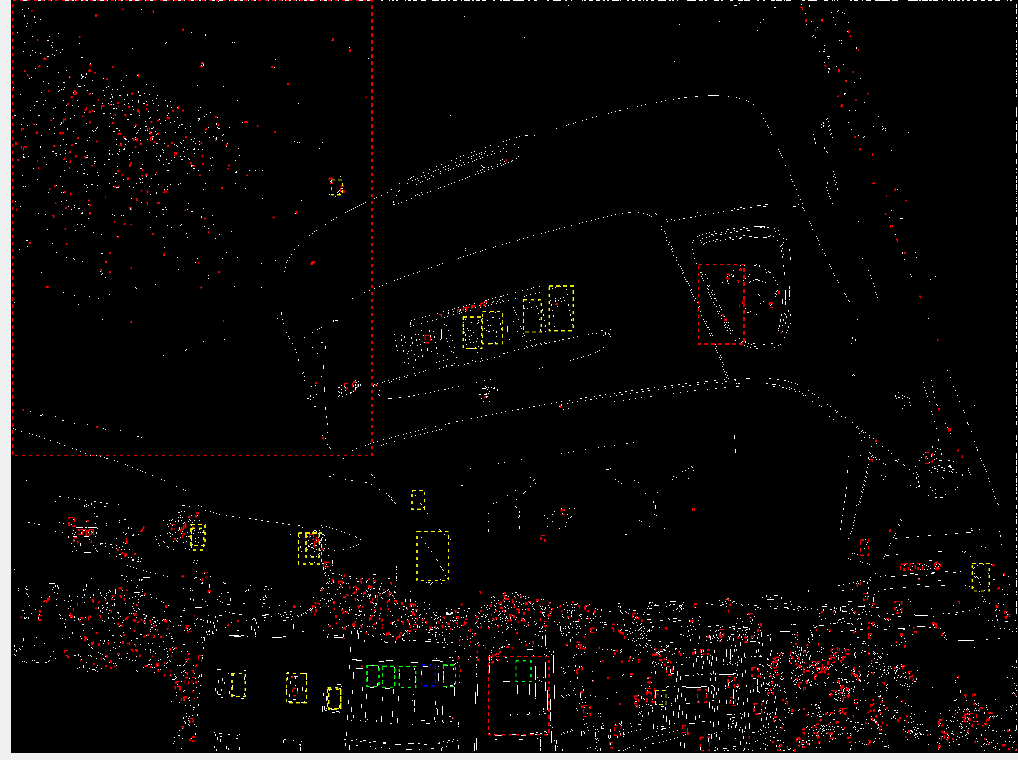

The boxes that pass the ratio test are in red, passes for the size limit are in yellow and the closely grouped set is in green with the average of the set in blue. As can be seen there was a previously unknown group of areas in the windows. This is technically my algorithm working correctly, as this appears to be the most consistent and lined up set of bounding boxes in the image.

I think a further amount of selection will be needed, one idea I thought of previously was originally a method of saving processing time. Image subtraction could be used to find the area of activity, and a bounding box drawn to create a sub image to only work on areas where motion was detected. With this method I could exclude all stationary elements and only have my algorithms ‘observe’ the moving vehicle, ignoring anything that would be otherwise hard to filter out.

25/10/2022 – Ordering parts

Ordered a Pi Pico. Ordered a small greyscale SPI camera module: <https://thepihut.com/products/qvga-spi-camera-module-for-raspberry-pi-pico-hm01b0>

Ordered a 5MP SPI camera module from university requisitions: <https://www.amazon.co.uk/Arducam-Module-Megapixels-Arduino-Mega2560/dp/B013JUKZ48>

27/10/22 – motion masking

My aim today is to create a system that can take video and create a bounding box based on where it thinks motion has occurred. It will then use this system to mask the frame and output.

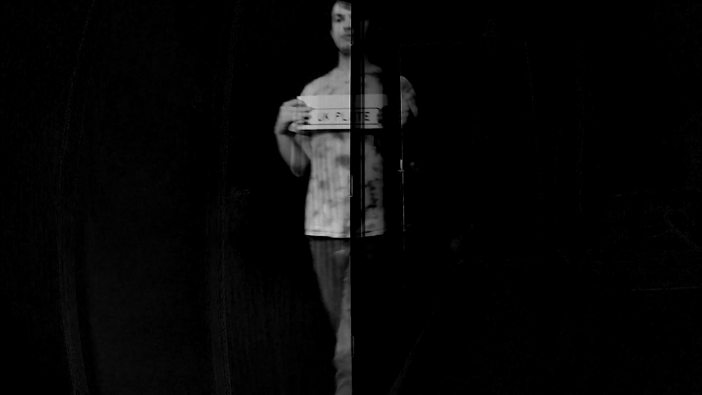

Using a simple image subtraction function, the current frame has been subtracted from the baseline. Some noise cleaning will need to occur, but otherwise this seems suitable for creating a bounding box algorithm for.

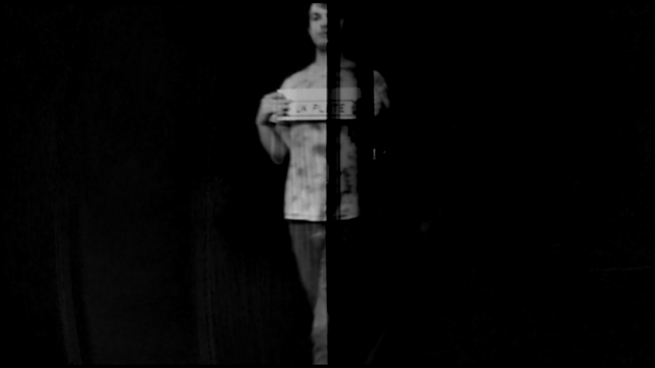

This seems to be less overall noisy, although this does in turn introduce the need to perform blurring on the entire image. Perhaps the bounding box can be constructed without the blurring.

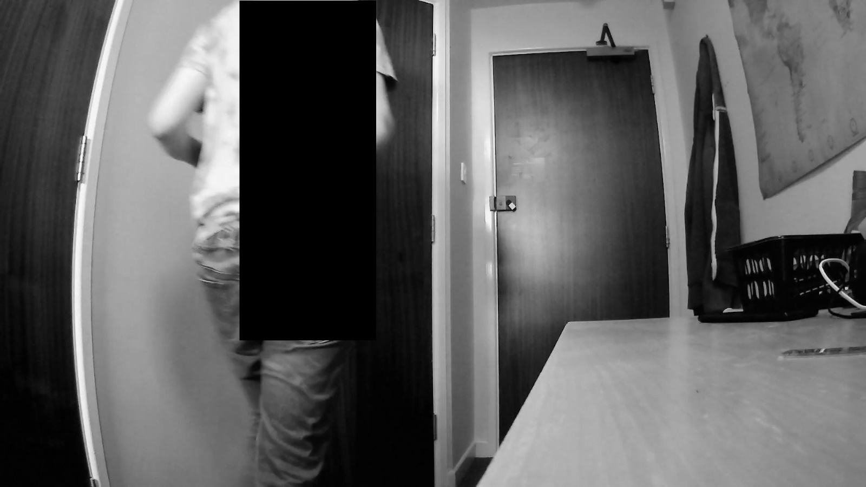

This was done without the blurring, it seems to work, despite the result being inverted to what I would want. My logic appears sound.

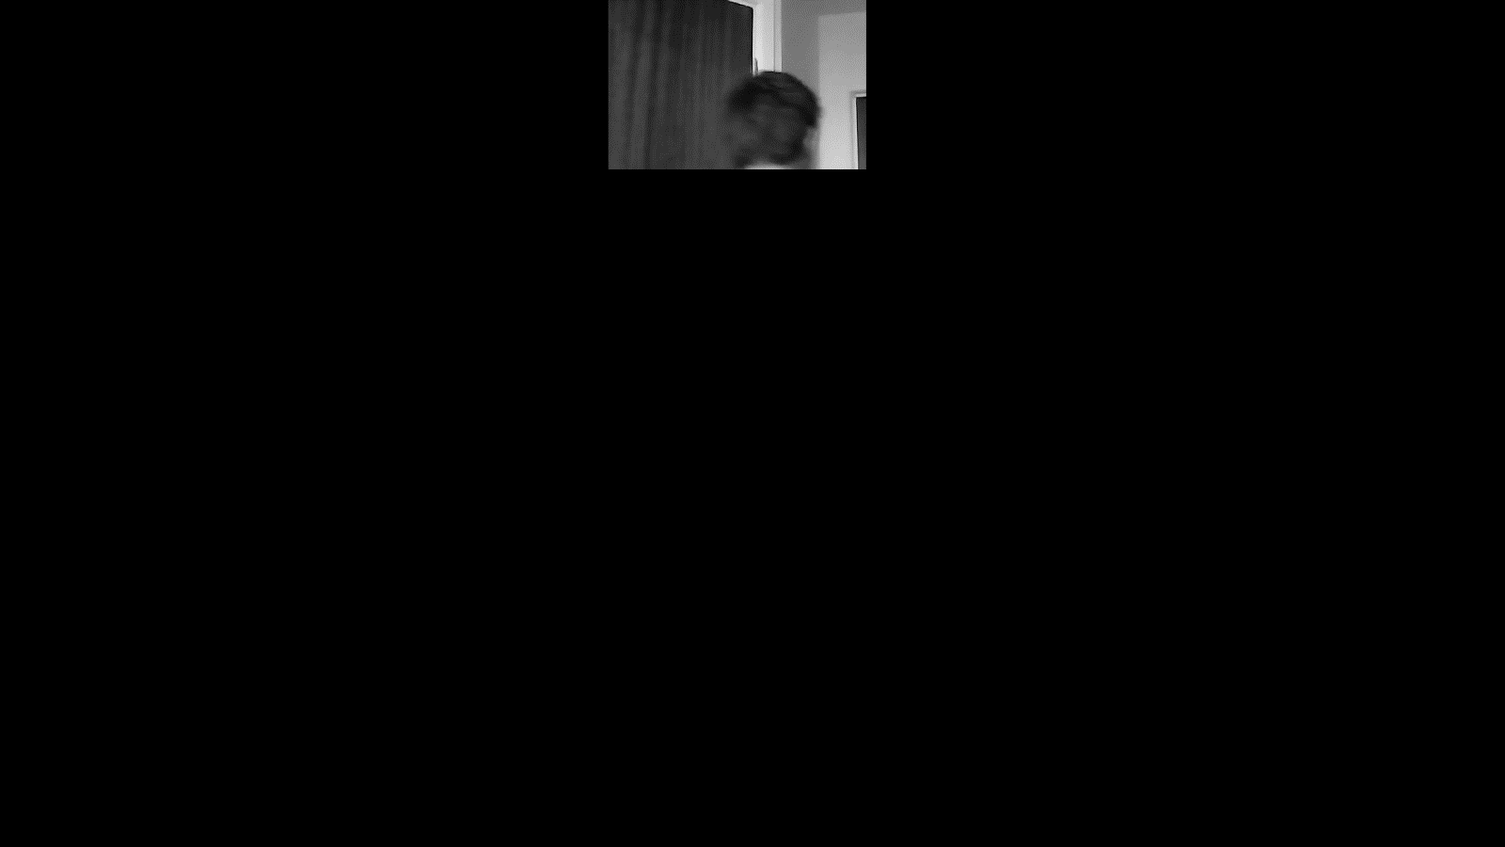

The primary issue here appears to be that the algorithm isn’t sensitive enough, this is fine and controllable, but I was hoping that the motion would be more prominent.

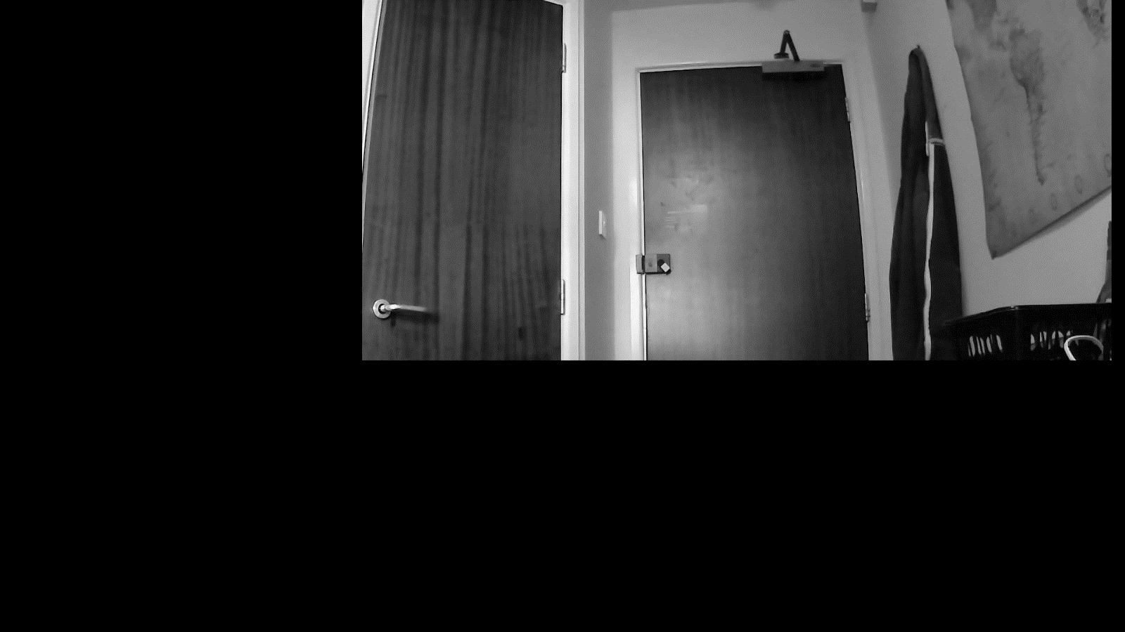

Taking the sensitivity down hasn’t fixed the problem, I think the gaussian blur will be necessary.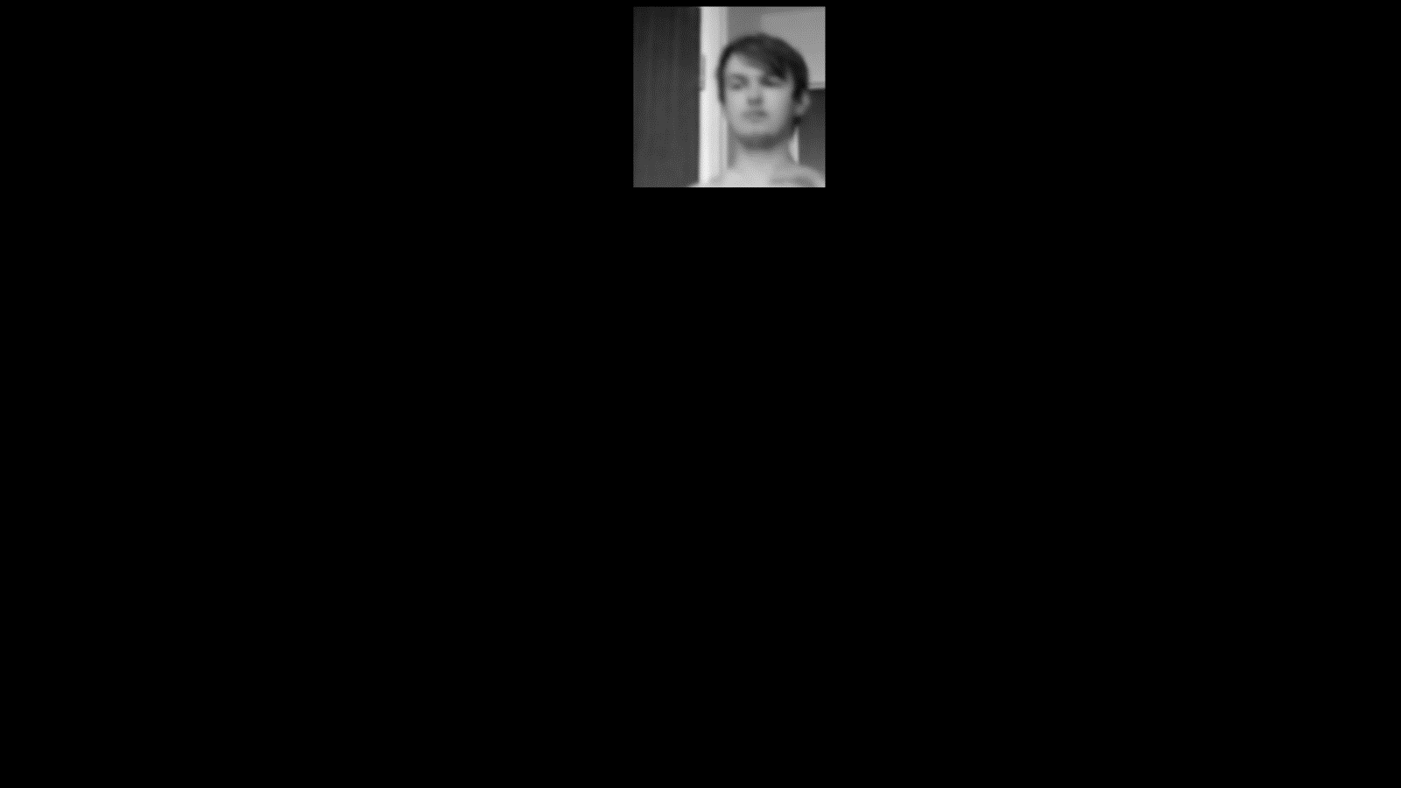

This does not seem much of an improvement. Even controlling the threshold for motion lower seems to not solve this problem. I will need to figure out if my footage is bad or my algorithm is.

29/10/2022 – application of sobel

New idea, since noise appears to be the issue here, what if both the background and new frame had sobel applied to them. This could allow for a greater level of differentiation of the useful information.

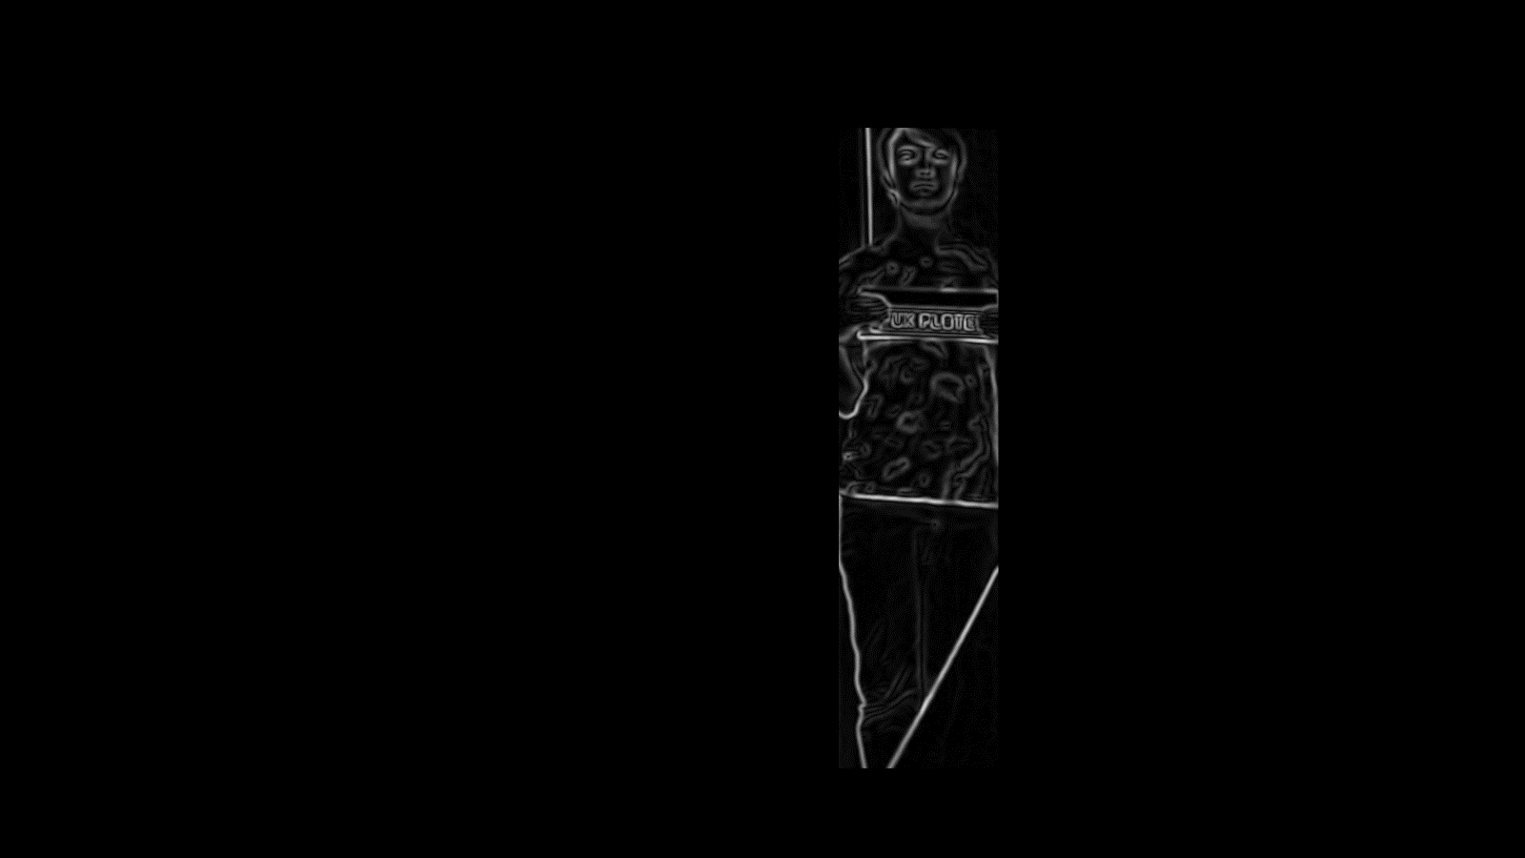

This appears to be far more effective. The unfortunate part is that this means that the 2 more intensive edge detection steps, gaussian blur and Sobel filter, need to be performed on the entire image before the reduced image can be used.

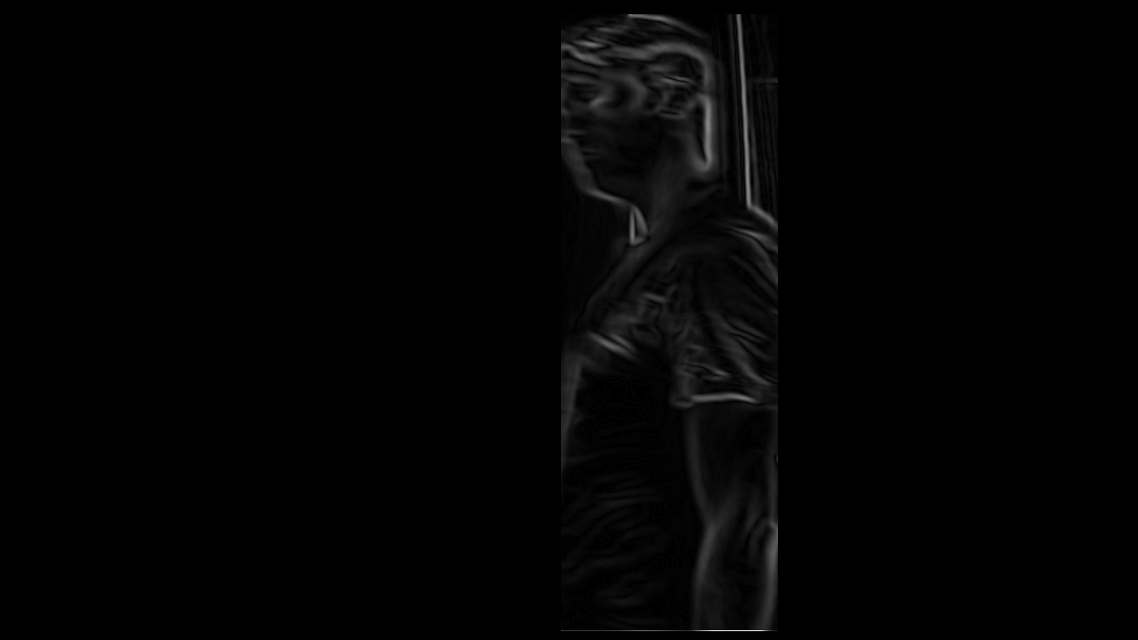

Still, with some controlling for the threshold where motion is detected. This seems to be a very effective way to bound the search area for the licence plate numbers.

29/10/2022 – Theta and non-maximum suppression

Apparently in the Sobel filter there is a second value produced for each pixel besides intensity, edge direction or angle.

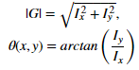

This angle is then used to perform non-maximum suppression.

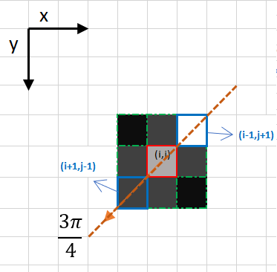

For a given pixels direction, the two adjacent pixels in that direction are compared. The pixel with the highest value is preserved, and the centre pixel is set to 0, unless the centre pixel itself is the highest, in which case it is preserved.

Preserving angles is definitely a problem for storage, as doubles would be far to costly in this amount. The fact that there are only 4 unique directions could help me here (up->down and down->up result in identical operations). If I can find a way to skip the arctan function and calculate the result directly, then I could save a large amount of time and memory.

Finding these angles, and converting them out of radians, we can see some pattern to their values.

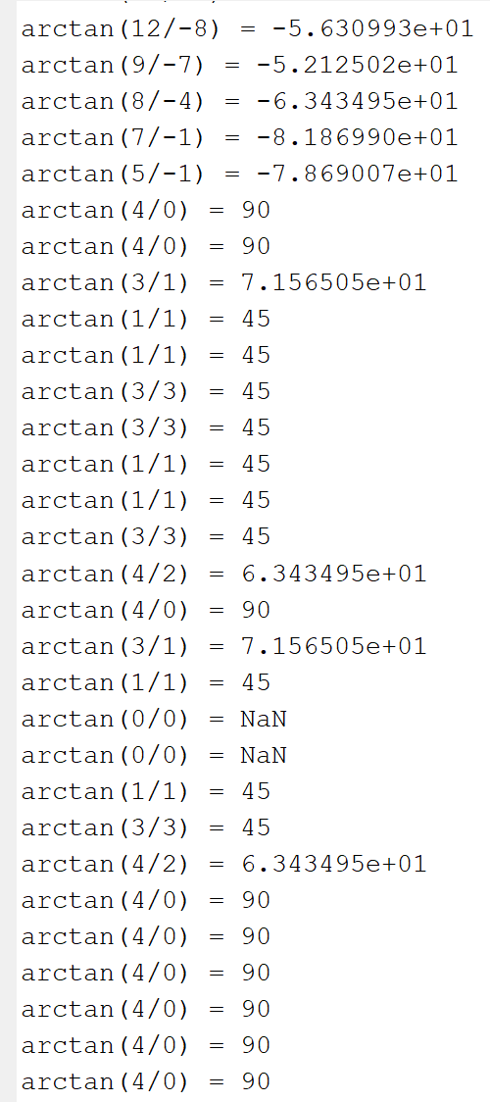

From this we can already identify 3 of the 4 possible states: If Gy = 0 -> Ang = 0 (up-down). If Gx = 0 -> Ang = 90 (left-right). If Gx and Gy are both have same sign -> Ang = 45 (bottomLeft-UpperRight).

The fourth state can be identified as being when Gx xor Gy are negative, creating Ang = -45 (UpperLeft-BottomRight).

This covers all the possible directions. Testing will need to be conducted to see the results of a system that applies this principle to remove non-maximums.

01/11/2022 – Implementing directionality

Using the above idea, I will now try to create a function that can perform the suppression.

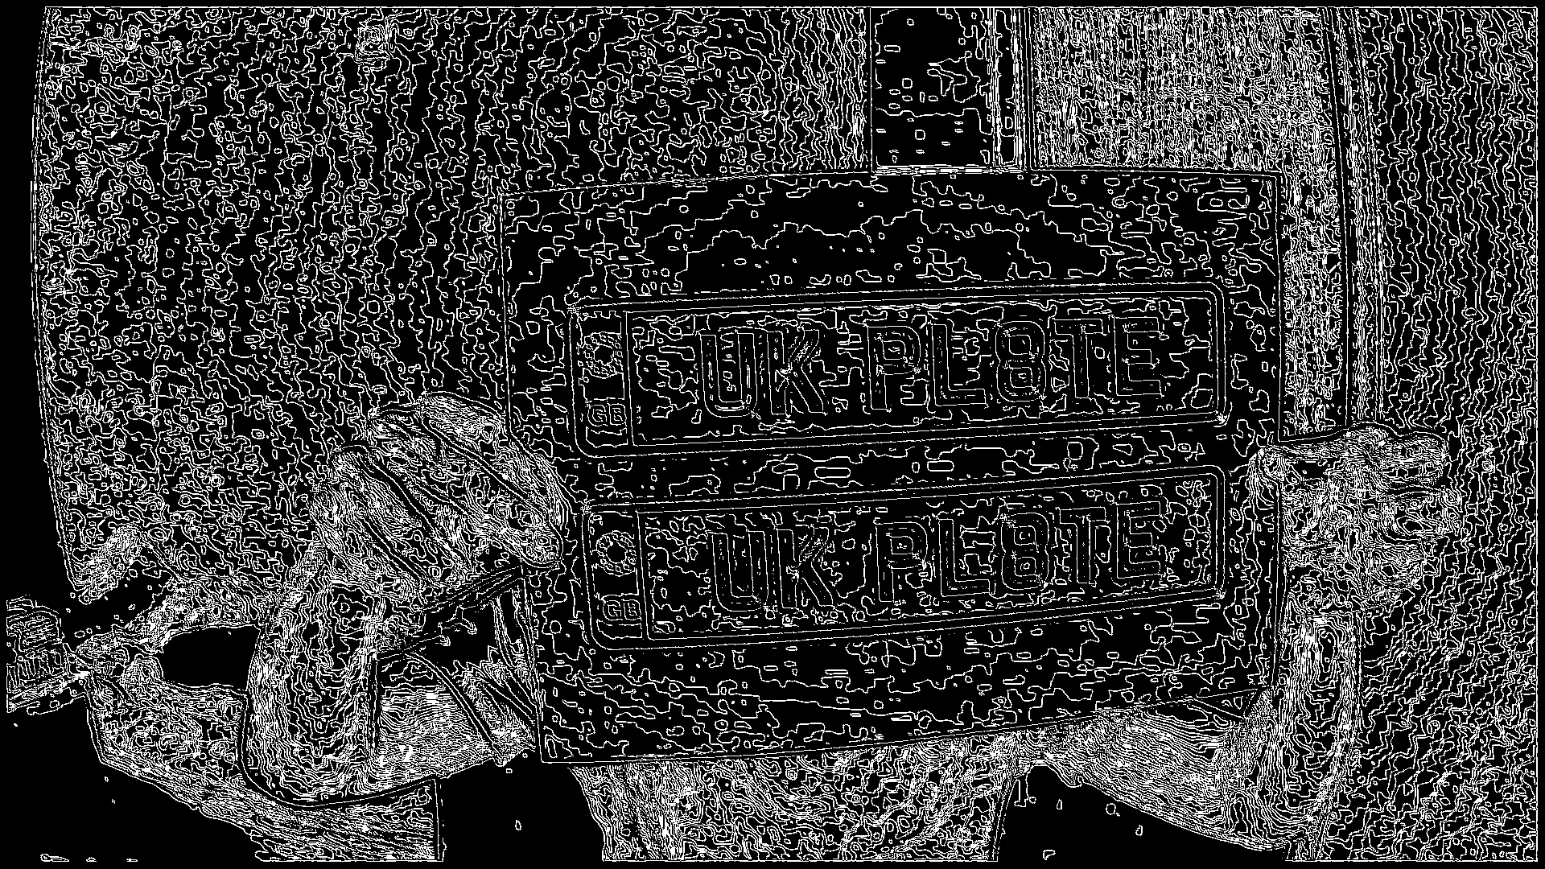

While visually interesting, this is not correct.

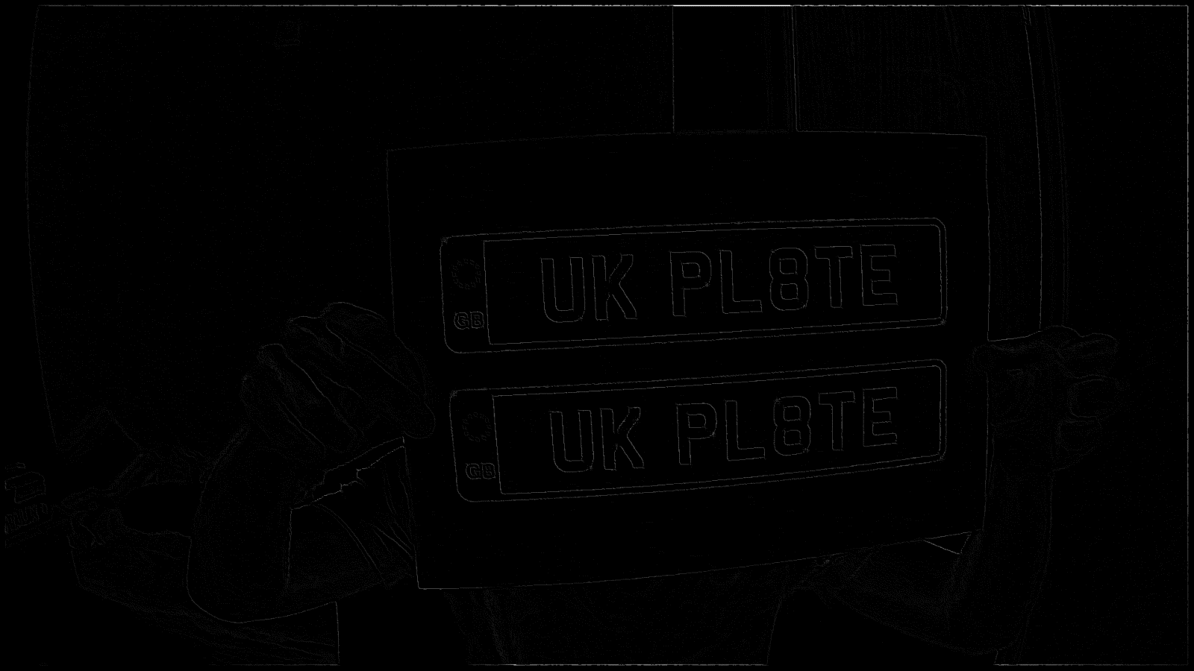

This seems to be working better, converting back to uint8 array seems to correct this. The algorithm seems to work well to at least set all background noise to a very low level. Setting a threshold for a filtering system my be able to extract the stronger pixels.

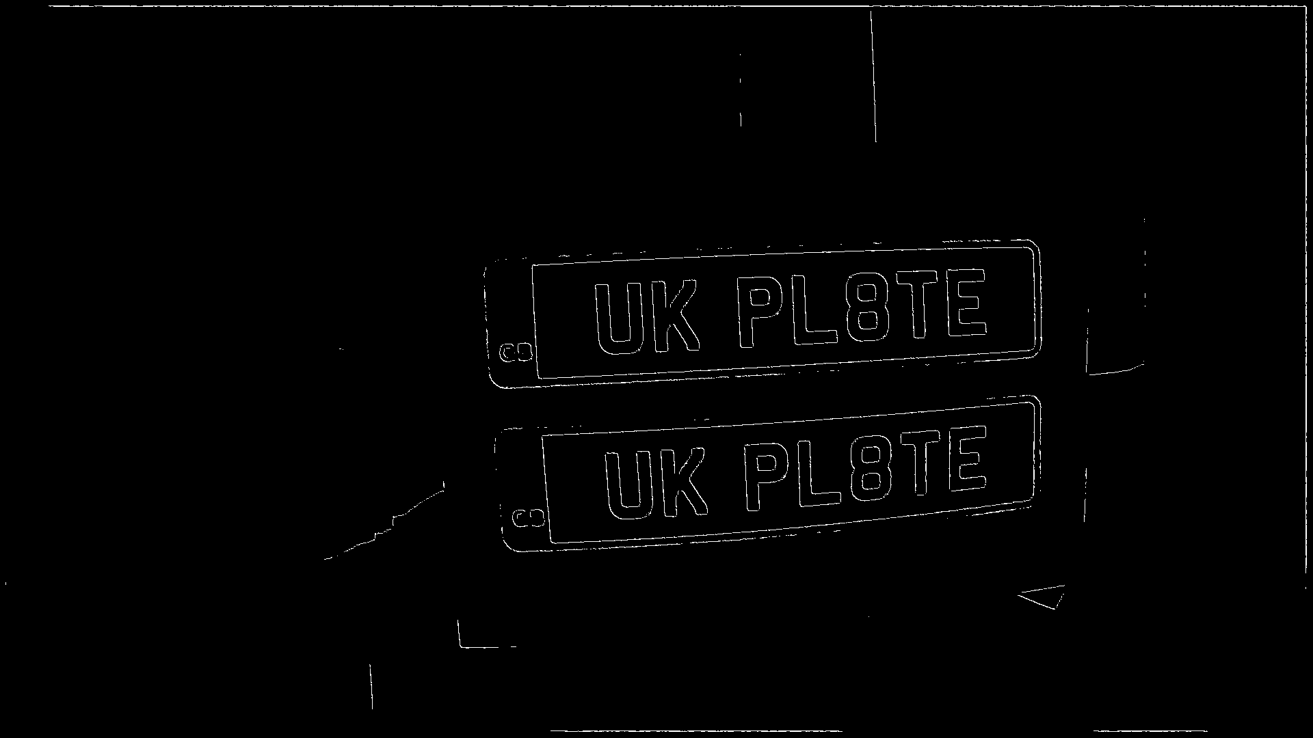

This seems to work well, but there are several breaks in the lines enclosing the letters, also something will have to be done about the border pixels resulting from the kernel of the gauss and Sobel filters. Some kind of edge linking will have to be performed to double bound the pixels on the image.

02/11/2022 – Pixel hysteresis

A suggested mode of hysteresis was proposed by the same website that gave the non-max suppression technique. The idea is that a pixel should be set to a ‘strong’ or true value only if it or at least 1 pixel surrounding it were above a certain threshold, else it should be set to a false value.

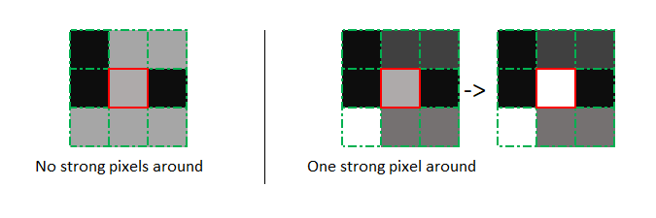

This should perform edge linking, where edges that have pixels that fall below the threshold don’t get broken.

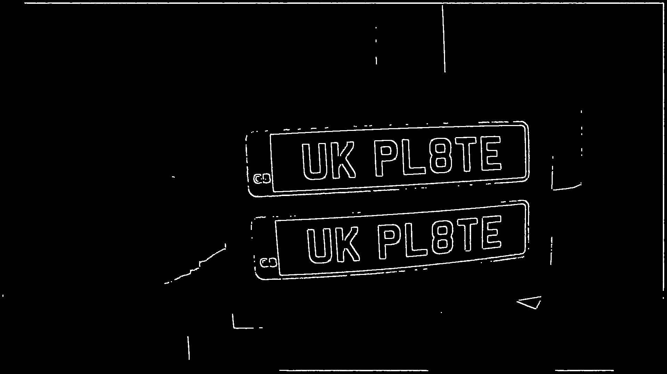

This seems to have worked fairly well, a minor issue is that the threshold had to be set low in order to capture the full bounded area. Additionally, this line is fairly thick. Maybe setting the requirement to 2 adjacent strong pixels will result in a thinner edge line.

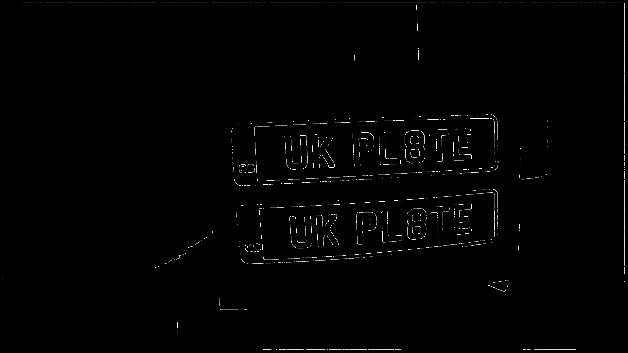

The above was edge linked with a requirement of 6 adjacent pixels. Testing several values for pixel requirements, there seems to be a drop-off in what is filtered after 5 pixels, so this could be set as the filter level.

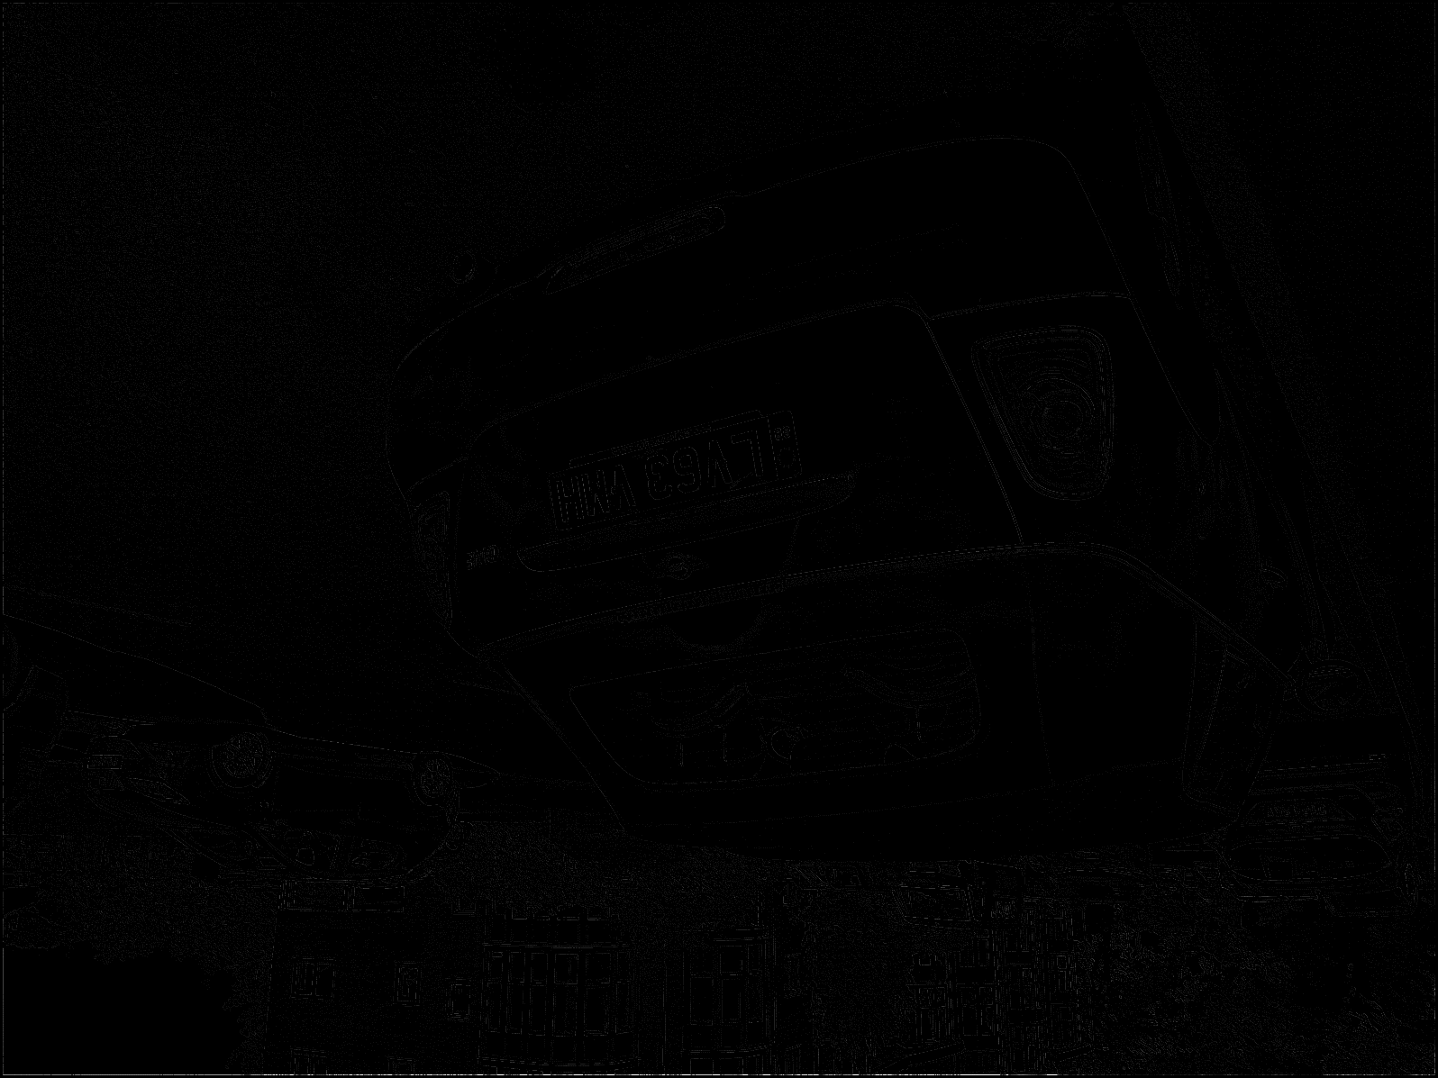

One issue is that after the suppression algorithm the image becomes extremely dim. This is likely the cumulative effects of so many filters on the image, what could be done is a simple doubling of every pixel after the suppression stage. This could be beneficial, as it would increase pixels with higher edge coefficients than lower pixels.

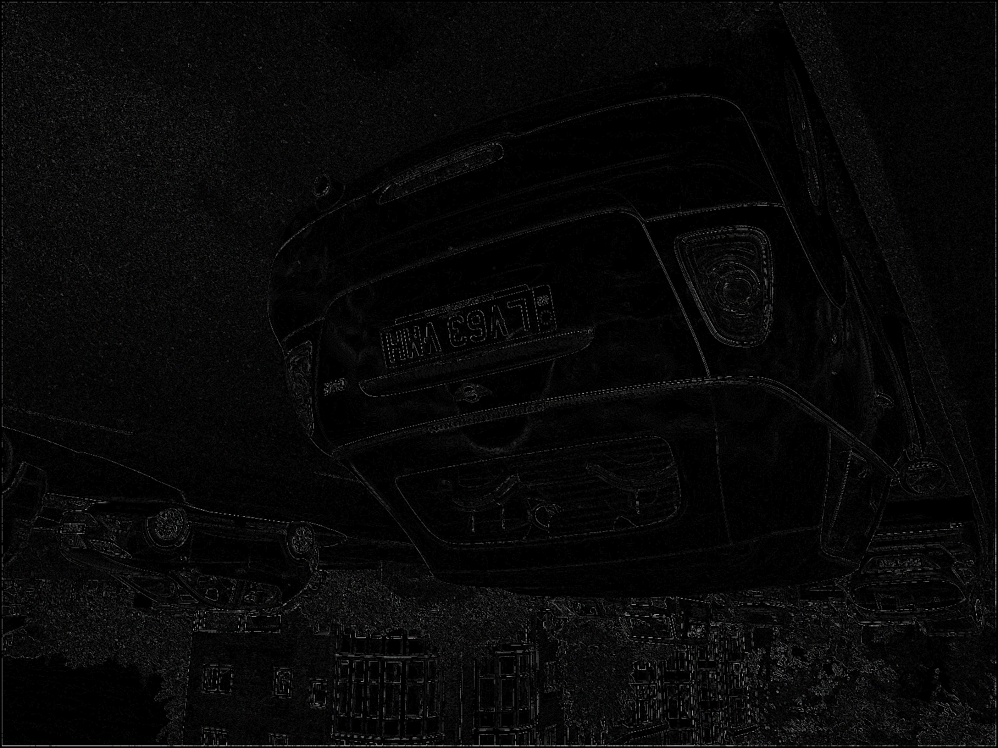

Scaling by a factor of 4 appears to work well.

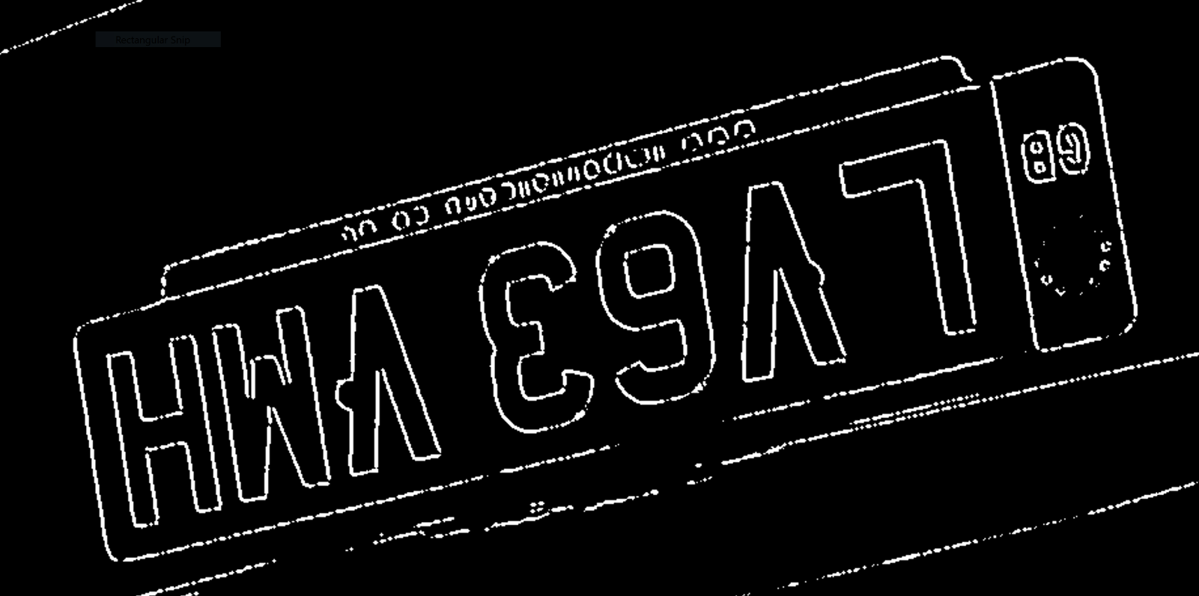

A further problem appears to be that there are small gaps in many edges despite the linking, this could be fixed by expanding the range of adjacency to 2 or 3 pixels away.

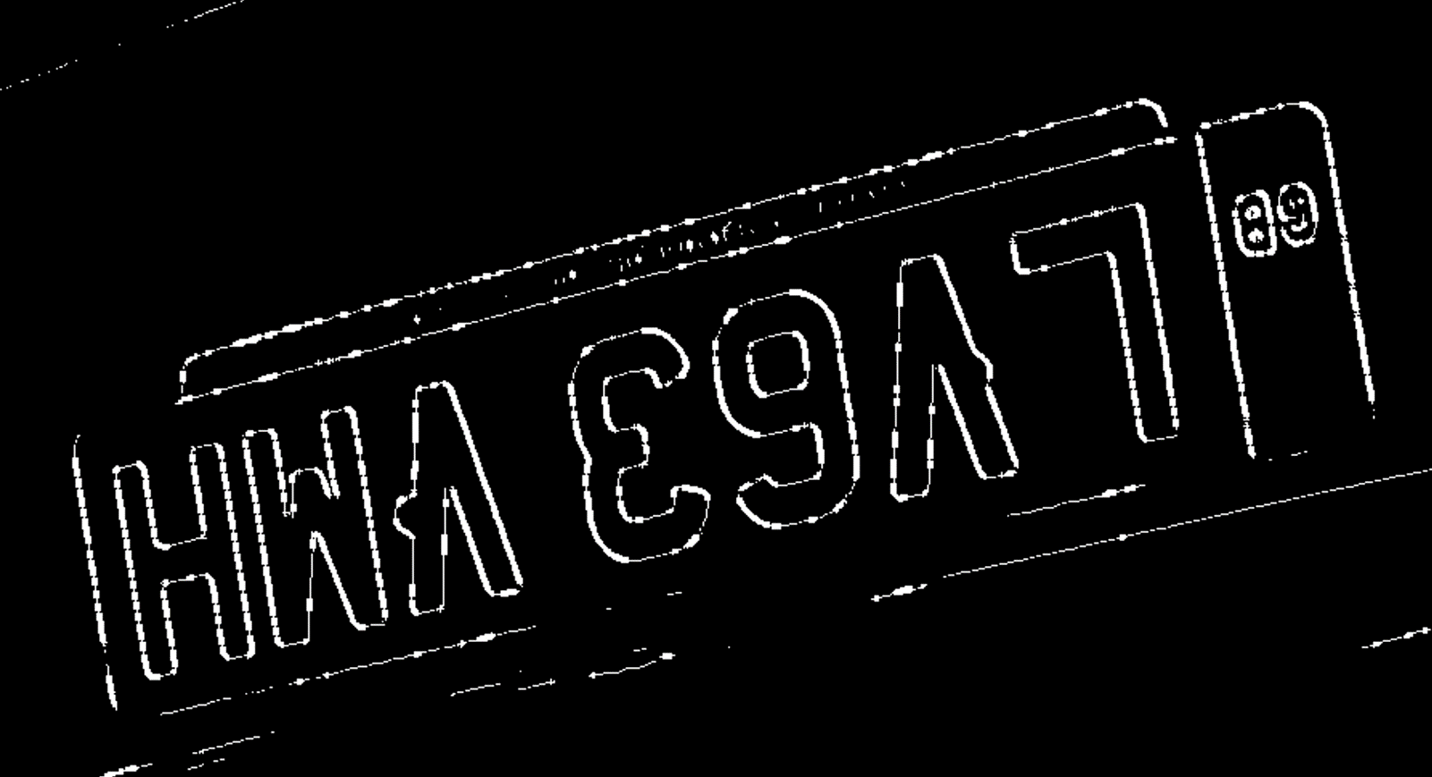

While having an odd appearance, there appears to be far less gaps in the edges when the radius of adjacency is increased to 3 pixels. This seems to be a mostly effective method for edge linking for noisy images.

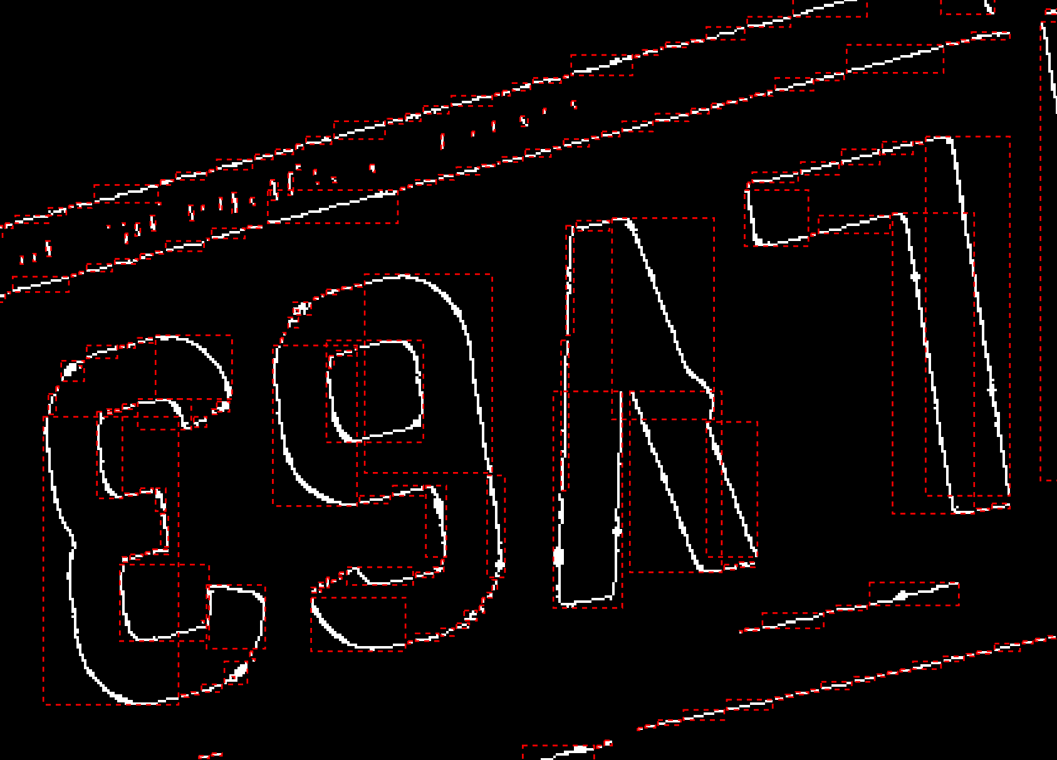

On the use of the existing bounding tools, the problems revealed themselves. It will be necessary to simply allow bounded areas to have gaps of a few pixels to allow for this sort of noise in the image. This will likely have to be resolved in the creation of my own bespoke bounding box algorithm.

04/11/2022 – Review of computational needs

I briefly wanted to review what the actual computational needs of processing the expected 1280x720p image would be, to establish whether or not a microcontroller would suffice to perform these calculations in good time.

I will take the Sobel filter and Gaussian blurring stages as the basis of the calculations, as they by far are the most computationally intense, being the only stage involving calculations instead of simple comparison.

Gaussian blur:

Given the kernel size being variable I will select a size of 11 to be a centred size. Taking the convolution output size algorithm to be: (X – ceiling(kernelLen))x(Y - ceiling(kernelLen)) we are left with (1280 - 6)x(720 - 6) = 909636 pixels.

A Gaussian filter involves multiplying and summing all values inside the kernel by a set of integer constants, then dividing by a constant. 11x11 = 144 multiplications + 144 sums + 144 divisions. If we assume that each of these actions will take on average 5 cycles of a CPU, then for each calculated pixel: (144+144+144)*5 = 2160 cycles per pixel.

Taking the total number of pixels needing calculation and the calculations per pixel: 909636 * 3456 = 1.965e9 cycles needed to calculate the whole image.

Taking the clock speed of the Raspberry PI Pico to be 133MHz, this means processing an entire image with a gaussian filter alone would take around 15 seconds. This is discounting the necessity of writing and reading to memory and camera interfacing.

Clearly, something will need to be done to reduce the overall image size, otherwise even more powerful devices such as a full PI will struggle.

A solution I have considered is to use another camera in conjunction to the full resolution camera. This camera is a smaller monochrome device (320x320p) that should be easier to process. The reason I am not using this camera is that the resolution may be too low to get any useful data from when capturing images (this will have to be further tested). What this camera could be used for is as a motion monitor, the motion detection could be done with this camera, and the area of motion upscaled and sent to the larger resolution camera to only process that specific area.

Taking a 5 length kernel for the Gauss filter: (320-3)*(320-3) = 100489 pixels. 5^2*5 = 125 calculations per pixel. 100489 * 125 = 12.561e6. This would require a processing time of 0.1 seconds to compute.

For the Sobel filter, a necessary part of motion detection: (kernel size = 3)

(320 - 2)*(320 - 2) * (3^2 * 5) = 4.55e6. The Sobel filter would require 0.035 seconds to be calculated.

Assuming basic image subtraction and threshold testing would take around 0.02 seconds, this totals 0.155 seconds to create a basic coordinate set for the detected motion. These coordinates could then be saved alongside the image from the full resolution camera to be scaled up and used to reduce the resolution of the image.

Assuming an extra 0.25 seconds will be needed to fully transfer the full resolution image from the camera buffer to a storage medium. I get a time per (motion detected) image of 0.405 seconds. This results in ~2.47 images per second as the sheer maximum my likely system could handle. Assuming my system could reasonably expect to detect a vehicle at a 20m distance, if a vehicle was moving 40mph (17.88 m/s) then my system would acquire (20/17.88)*2.47 = 2.76 -> floor -> 2 images of it. This is likely too low to make an accurate assessment of velocity.

Unless some way to cheapen the motion detection process, then it appears that the idea of using a cheap microcontroller is unfeasible. This is leaving aside the memory issues which would only further plague the system with is 264kB SRAM memory. While this could be upgraded with an external chip, this could only slow the system down further when performing reads.

Despite this, the basic idea of using the lower resolution camera is likely to be useful in general. A full PI model 3B+ has a clock speed of 1.4GHz, which would allow it to process the motion detection in 0.0122 seconds for filtering and likely a very short period of time for all other steps. The storage would be quicker as well with threading potentially able to transfer the old full resolution image to storage while the new low-resolution image is being processed.

Additionally, very few microcontrollers are built to natively include handling of doubles, instead using several int variables behind the scenes. This slows calculation and increases memory usage further; a PI and other micro-computers can handle doubles along with many other types natively so may be a better choice for this type of processing.

A review of devices will have to take place, with some though given to specially developed microcontrollers, but I do not think it will be likely that any specialist device would be cost effective for the specification of a cheap speed tracking device. The PI and other microcomputers seem distinctly levelled to meet the mid-cost high memory application I am going for.

05/11/2022 – Bounding box creation code

I will need to develop code that can dynamically find the bounding coordinates of each joined set of high pixels in the output binarized image from the edge detection process. The current method I am using utilizes the ‘regionprops’ function from MATLAB, so this seems to be a good place to start.

Looking at the code, I can see that it produces a vector output structured as so: [Xorigin, Yorigin, width, length]. This doesn’t directly tell me how the bounding box was created, but it has led me to think about how to ‘grab’ the upper and lower bounds for a section of pixels.

What I need to do, for any given collection of high pixels that are considered ‘adjacent’ to each other, is to find the lowest and highest x and y cords (all of these cords could be from different pixels) from this collection. This should result in the coordinates needed to bound the given collection and thus the shape they make up.

Perhaps after this the collection of adjacent pixels could be set low so to not interfere with any further shape detection. When all pixels have been examined, the collection of bounding boxes could be mapped back onto the original image to show detected shapes. This method of shape detection also bypasses the problem with single pixel breaks in the shapes of many letters.

An algorithm will be needed to gather the coordinates for every pixel within a shape. Perhaps what could be done is this:

1. Search the image line by line for a positive pixel
2. Once found create two lists for checked and unchecked pixels.
3. Add the current pixel to the checked list
4. Check all adjacent pixels surrounding the current pixel, if positive, check if the positive pixel is contained within the checked pixels list (or the unchecked list).
5. If the pixel is not in the either list, add the pixel to the unchecked list.
6. Once all pixels surrounding the current pixel have been checked, pop the next pixel in the unchecked list to be the current pixel and repeat from step 3.
7. If the unchecked list is empty, then the checked list will be the complete set of all adjacent positive pixels in the shape.
8. Take the lowest/highest x and y values from this list to get the bounding box edges.
9. Add these coordinates to a list and set all pixels inside the checked list to negative. Then repeat from step 1.

Implementing this will be mildly difficult but far from impossible.

06/11/2022 – Implementation continues

One issue I ran into with my algorithm is that it loops forever if the unchecked list is not also checked for containing a copy of the current pixel. A correction has been amended to the algorithm above.

Testing the algorithm for the first time, it takes a long time (<30mins) to complete 1 image. It seems unlikely this will improve, so some kind of optimization must be found. I think a good place to start would be the ‘check both lists for containing found pixel’ step. As the size of the checked pixel list expands, this could very rapidly become a geometric calculation as each pixel needs to be checked inside both lists.

A potential solution could be to keep the two lists, but the moment a pixel is logged in the unchecked list, set it to false. This would mean that it could never be ‘discovered’ as an adjacent pixel again. Having tried this method, this dramatically speeds up the algorithm, with shapes of less than 1000 pixels being completed nearly instantly and over 2500 taking around half a second. In MATLAB all code is interpreted and heavily object based, so there is a large potential for heavy optimizing when working in C++ by using pointers and other quicker methods of switching, along with the general speed improvements of using complied code.

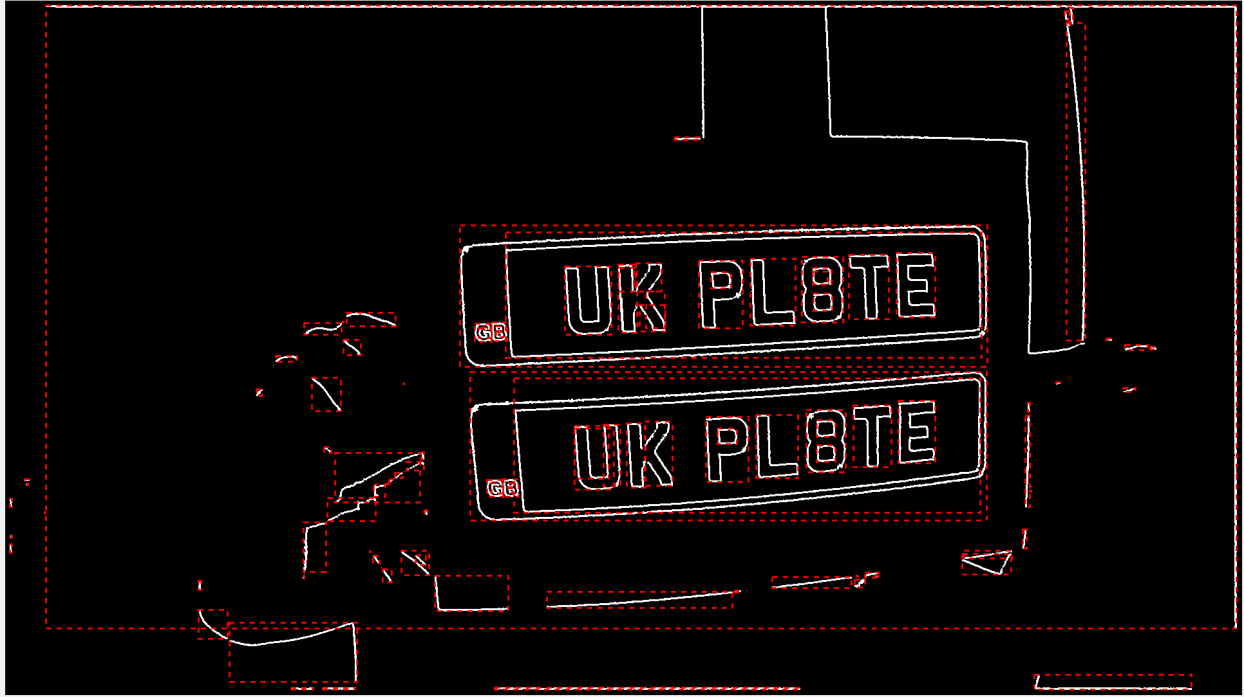

Regardless of other optimization concerns, I have now created an algorithm that can return a set of bounding boxes for all continuous shapes in a binary image.

Additional optimizations could include the ability to not even need to collect the set of checked pixels, just compare the max/min x and y values at the point of pixel discovery and then black the pixel out. Implementing this appears to save me around 3.5 seconds in the processing of the whole image, a great time saving.

Additionally, I have found the new tic; toc function in MATLAB, which is very convenient for showing the elapsed time between the tic and toc commands. I will use this to find the respective weight of all the steps in my filtering process.

I can now get the processing time needed for each of my steps:

* Gaussian blur: 5.135774 sec
* Sobel filter: 4.750566 sec
* Non-max suppression: 0.464676 sec
* Scaling: 0.002188 sec
* Edge linking: 1.658468 sec
* Bounding: 0.618417 sec

Summing this time I get 12.63017 seconds for a full 1080p image to be processed, not including initial reading of image into memory. Assuming that processing time scales linearly with pixel count in an image, a 720p image should be at least a quarter faster to process.

I have made a collection of test images at 720p at various distances from a vehicles licence plate to test the sizes of the found bounding boxes.

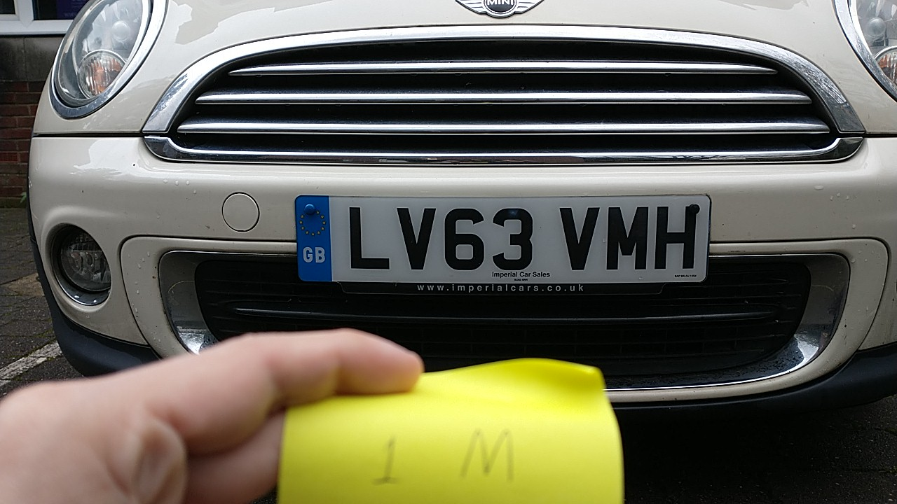

The above image was taken at 1m from the plate. Using this image to test the speed of my algorithm should be suitable.

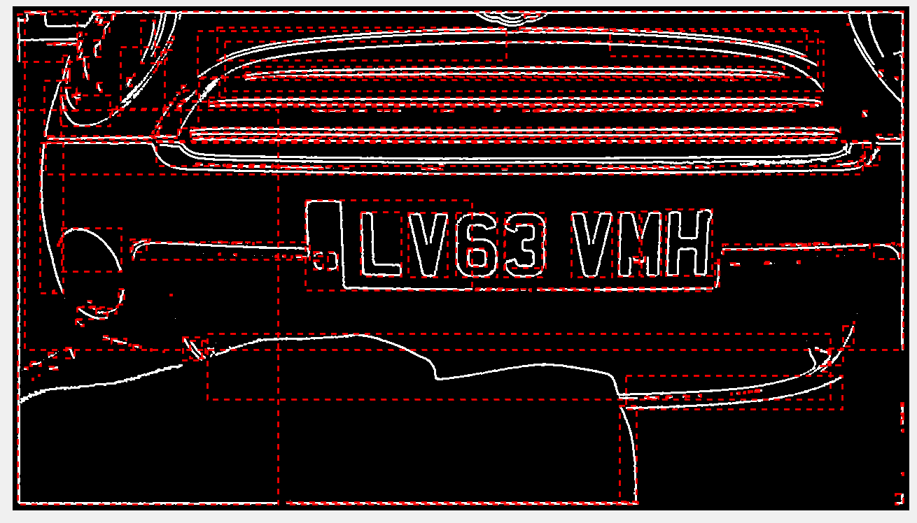

It seems to have performed quite well.

The timing for the steps for this 720p image is:

* Gaussian blur: 2.274873 sec
* Sobel filter: 1.989078 sec
* Non-max suppression: 0.248518 sec
* Scaling: 0.001233 sec
* Edge linking: 0.701243 sec
* Bounding: 0.715391 sec

These results sum to 5.93 seconds, a promising result, but not as much a reduction from 1080p as I had hoped. Noticeably the gaussian blur and the Sobel filter diverge when it comes to decrease, and the bounding step appeared to take longer. This was before any filter settings from 1080p were changed, changing the gauss kernel size and adjacency requirements should result in a better optimized filter.

Changing the major settings to:

* gauss_kernel_len = 9
* adj_strongs_req = 4
* adjacency = 3 (adjacency is the middle-edge length of the square that surrounds the current pixel where adjacent pixels are inside)

I got the result:

* Gaussian blur: 1.606259 sec
* Sobel filter: 1.993386 sec
* Non-max suppression: 0.245612sec
* Scaling: 0.001041 sec
* Edge linking: 0.745828 sec
* Bounding: 1.517400 sec

The gaussian time save is significant, but it is wiped out by the increase in the linking and bounding time, pushing the total to 6.1 seconds. The raise in the linking is obvious due to the large number of checks per pixel but the bounding is stranger, especially as it is larger. The explanation I can think of is that the bounder is having to handle a larger number of positive pixels created by the linker and thus has to bound larger shapes. This could be resolved by reducing the linker adjacency but increasing the bounder adjacency.

Changing the major settings to:

* gauss_kernel_len = 9
* adj_strongs_req = 3
* linker_adjacency = 1
* bounder_ adjacency = 3

I got the result:

* Gaussian blur: 1.598152 sec
* Sobel filter: 1.987469 sec
* Non-max suppression: 0.243727 sec
* Scaling: 0.001062 sec
* Edge linking: 0.697193 sec
* Bounding: 1.030380 sec

These adjustments have significantly decreased the overall time to process, 5.5 seconds. This is despite the increased kernel for the bounding frame, likely due to a lower positive pixel count being overall preferable for the function than a small search radius.

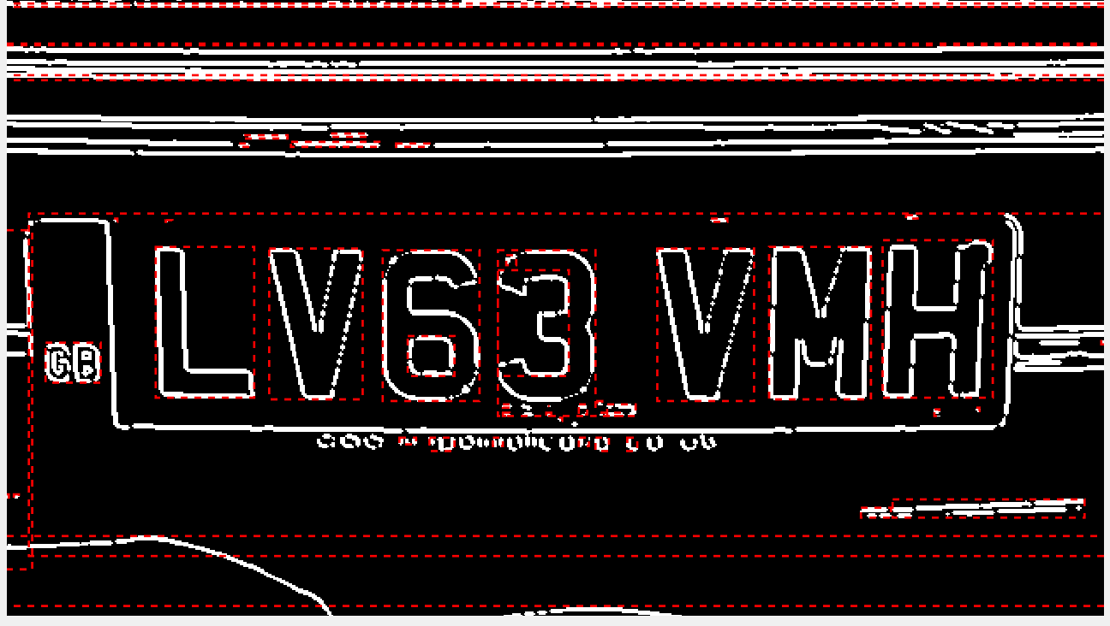

In addition, the increased bounding adjacency allows the detection of shapes even with single pixel breaks in their structure, meaning lower quality edge detections can be used to detect the letters despite any pixel loss.

I can assume there will be significant savings when working with a compiled program compared to the MATLAB interpreter, so it is entirely possible the final output could be made in a worst case estimate 1-2 seconds. Assuming this, for a 20 pictures per second run, over a detection lasting 4 seconds (80 720p images), it would require around 80-160 seconds to fully process the image set and derive a speed (checking the list of bounding boxes and speed calculations should be trivial).

This isn’t great in terms of speed, but this only assumes a 60-80% time save from interpreted code, something that may change drastically once memory and other optimizations come in, and also assumes a single thread. What could be done is using a 4 core system to handle the whole process, 1 thread to handle the motion detection camera, 1 to handle pulling images off of the full camera into storage, and 2 to process the images.

Also, with the partial masking process that is done on the motion detection camera, the actual processed area of the full resolution image will be smaller than the full 720p size, further reducing processing time. Thus, for a full 60-140 image run (3-7 seconds of detection), it seems like a processing time of 15-30 seconds could be expected with full optimizations. Considering expected use case is a low activity country road, 1 car every ~22 seconds isn’t a bad max average rate.

08/11/2022 – Testing on footage, and side to side motion

Creating a short video where I walk with a plate side to side for testing, these are the frame by frame results my bounding box filtering gave back:

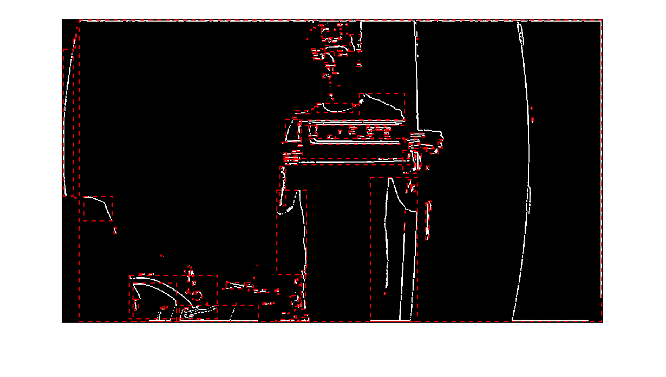

It can be clearly seen how the lettering is too blurred to be visible to the system.

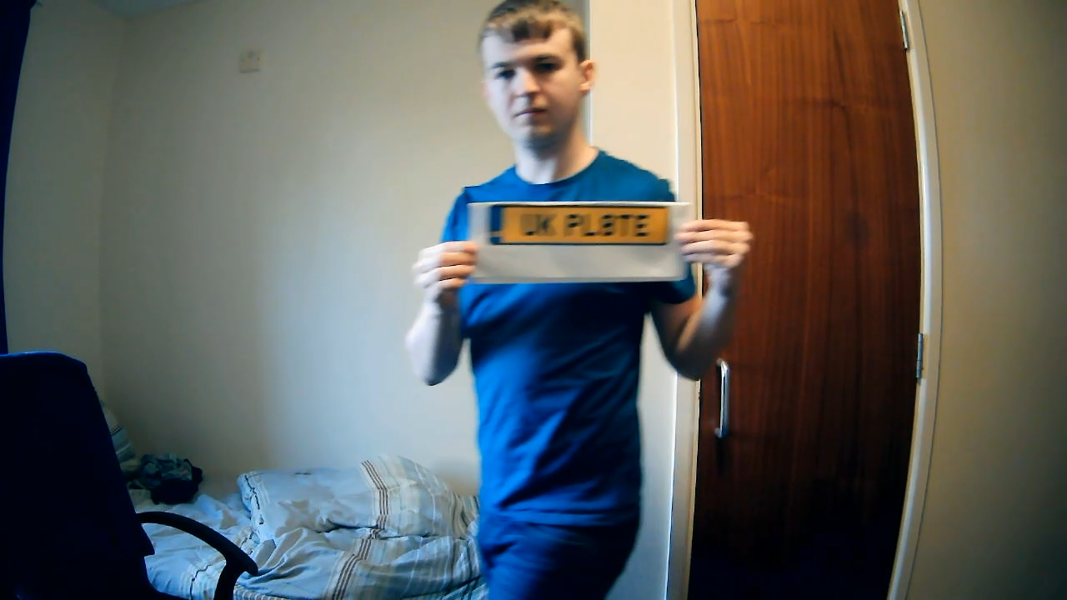

It will need to be determined if side to side motion is the problem or it is some aspect of video smoothing. A single image taken while moving side to side should be able to determine this.

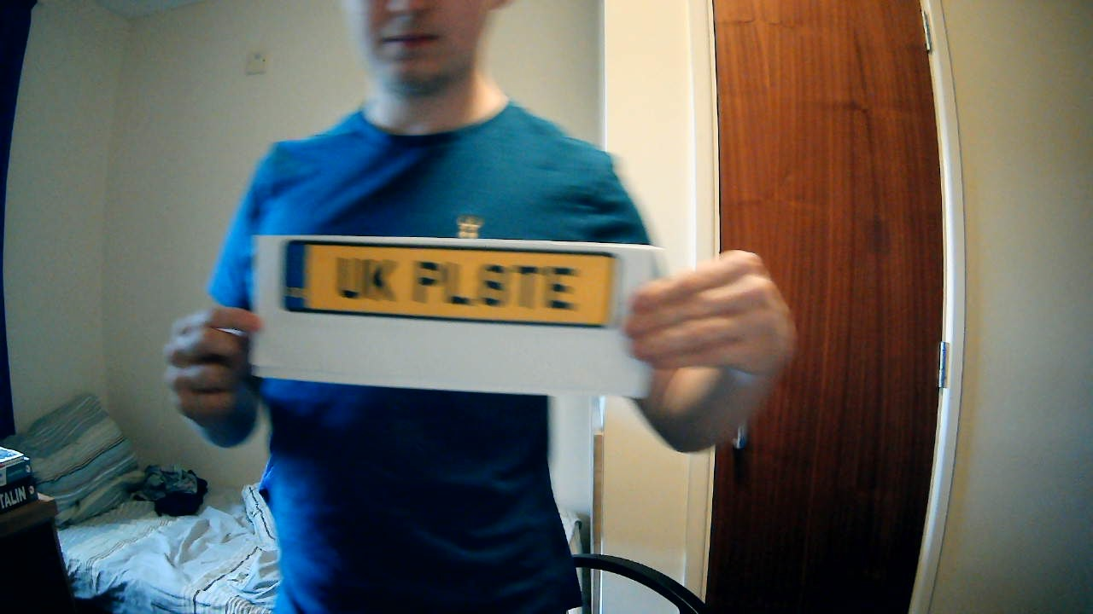

This seems to confirm my suspicion, images taken with strong side to side movement result in heavy blurring. I will try approaching the camera head on.

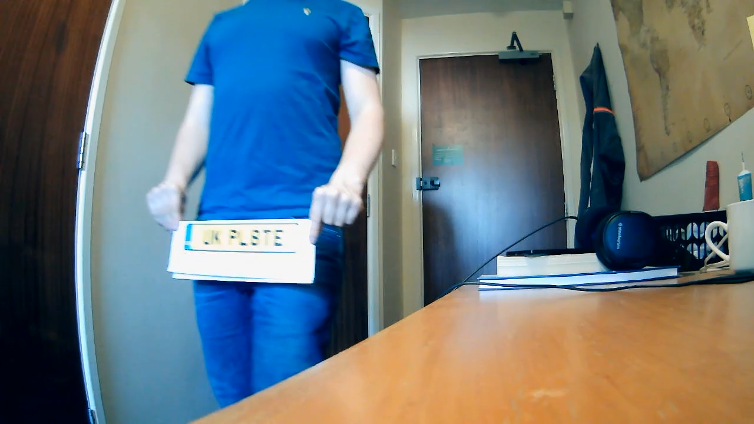

This does not appear to have improved things much.

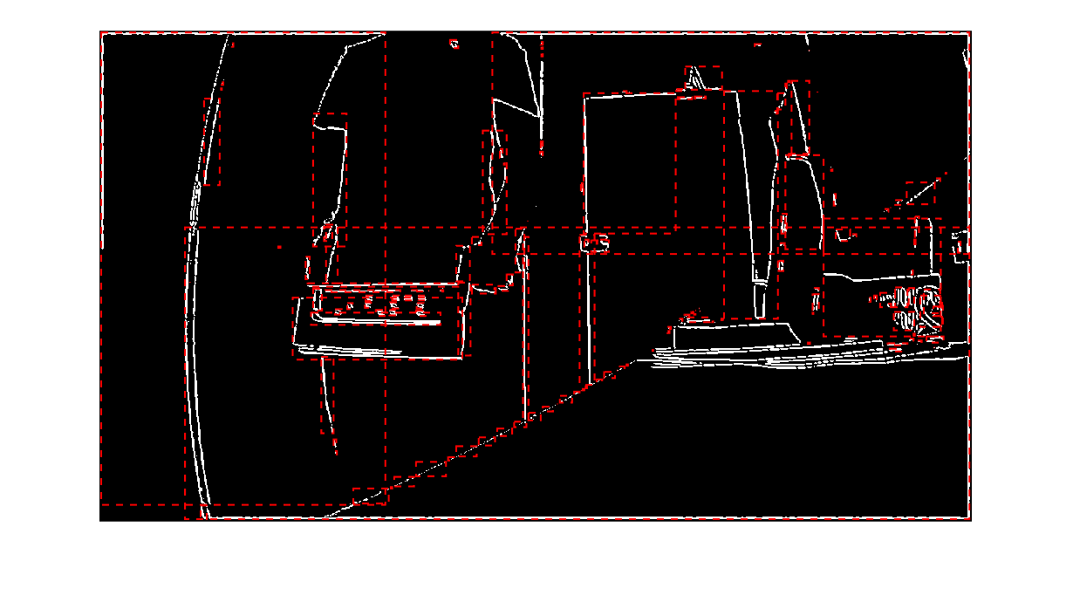

This doesn’t necessarily mean my system is flawed, real licence plates often do not appear as shiny as this. It could be likely that the paper the test plate is printed on could be too reflective to give a good set of frames for detection. Additionally, perhaps an answer is to use a degree of lens zooming if possible, to better capture a more detailed set of the detection area (road).

09/11/2022 – Looking into ways to reduce motion blur

I am certain that there are specific camera techniques that can be used to near complexly eliminate motion blur, how else would pictures of athletes and other races be taken.

Looking around general camera advice, it appears the motion blur is controlled by shutter speed, or how long the photo-resistor matrix is exposed to light before being measured. Reducing this should significantly reduce the motion blur of an image. In general I should want the fastest shutter speed possible without darkening the image to a noticeable degree.

From research and my own attempts, it appears that it is simply impossible to control the shutter speed of a USB web camera. From further research I have confirmed that the small camera I posses does have a controllable shutter speed. This seems like as good a push as any to start working on getting my chosen controller talking to my camera.

I have decided to go with a PI for my computing base, primarily on the basis of cost. All other computer on single board devices out there (even ones that claim affordability) are priced well into the hundreds range. This is in contrast even to the newest Pi 4 which comes in at around £50. The model I am using (Model 3 B+) is currently sold at £40 cost from Pi affiliates and should be similarly priced elsewhere as it is an old model.

In general, the task I am trying to achieve is not to build the most optimal hardware, but the most optimal software. In a real production line device, I would likely suggest a custom board with a pre-packaged chip to save as much as possible without unnecessary I/O. But as this project has a budget of £150 and 6 months, this is outside the scope.

I will aim to get the camera talking and giving images to the Pi as soon as possible. Short of this, I could attempt to produce some test footage using digital cameras at the university. These should have manual control over their shutter speeds and should be able to produce the footage I need for testing.

Additionally, I have found a repository of code that contains several libraries that will be highly useful for controlling and interfacing with the camera. It openly supports Raspberry Pi as well so the selection of board is further supported.

16/11/2022 – Applying bounding box filter to end product filter

The final part of the image processing will be to take the bounding boxes that the filter can provide and filter them to find the likely bounding boxes for the licence plate lettering.

As the filters only use basic mathematical operations on the sets of coordinates, this should be a relatively easy implementation.

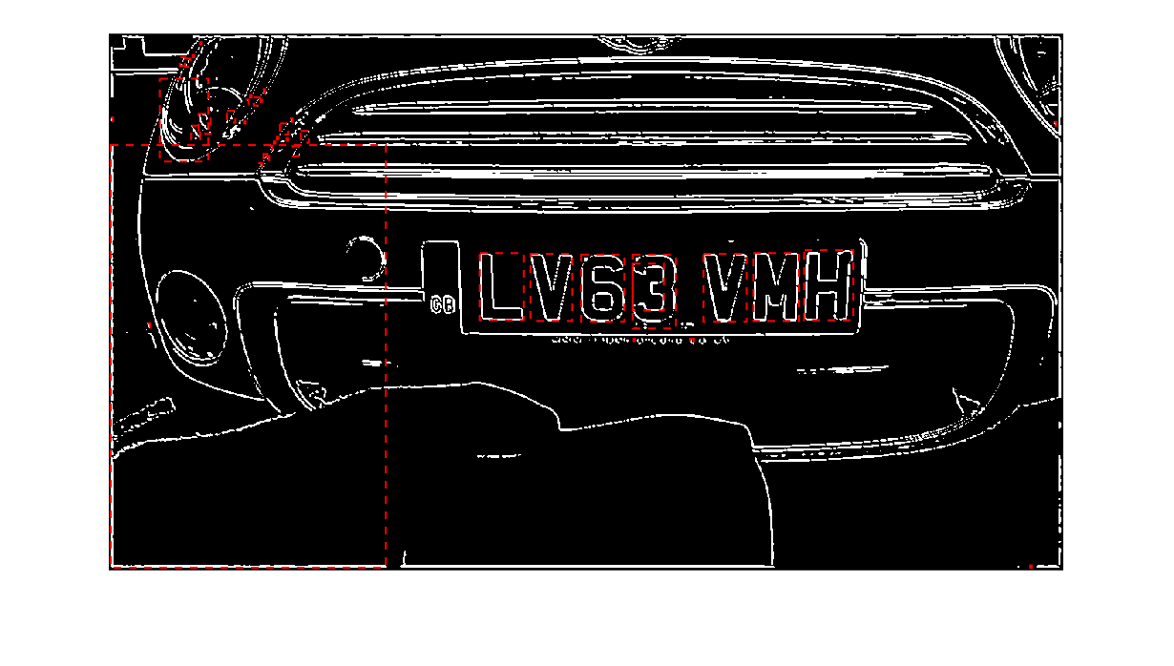

The initial ratio filter is displayed above, with only those bounding boxes passing being shown. This is out of a total of around 40 bounding boxes, which is more than plausible for 40 floating point calculations to be made in a short time.

The next filter stage is the min/max width boundary filter.

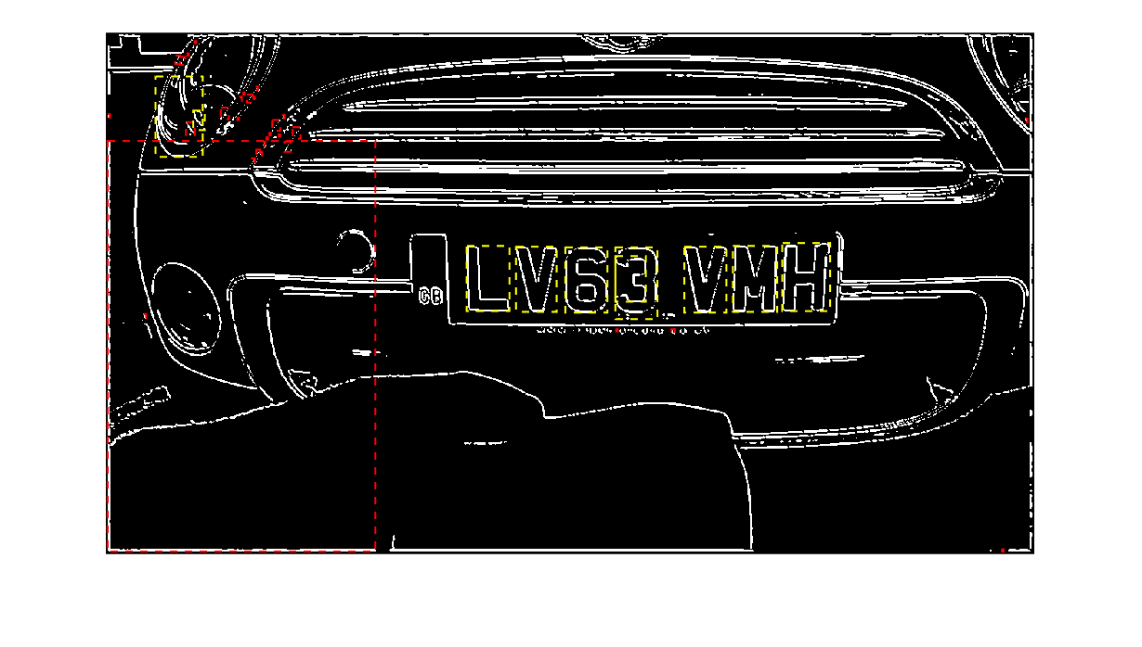

A range of 1-10% was set for the width range above (yellow boxes pass this test) but further testing will probably be needed to find a stable range for the plates.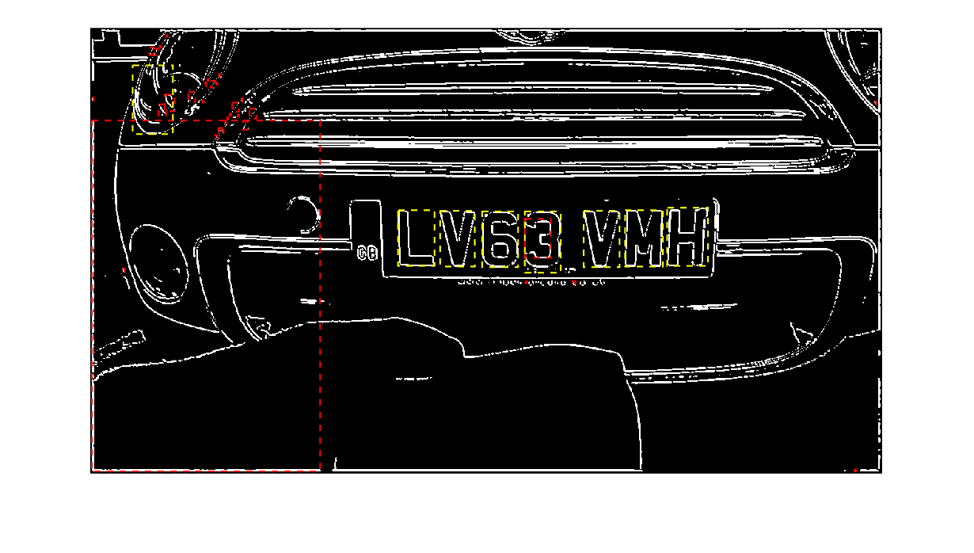

4-10% appears to work best for this image but there is nothing to say that this wouldn’t be too tight for other images. This is why later filtering stages where implemented.

The final filter is the x/y closeness test, which finds the largest set of boxes that are within a certain range of each other. This should remove any outliers and return the desired set of boxes.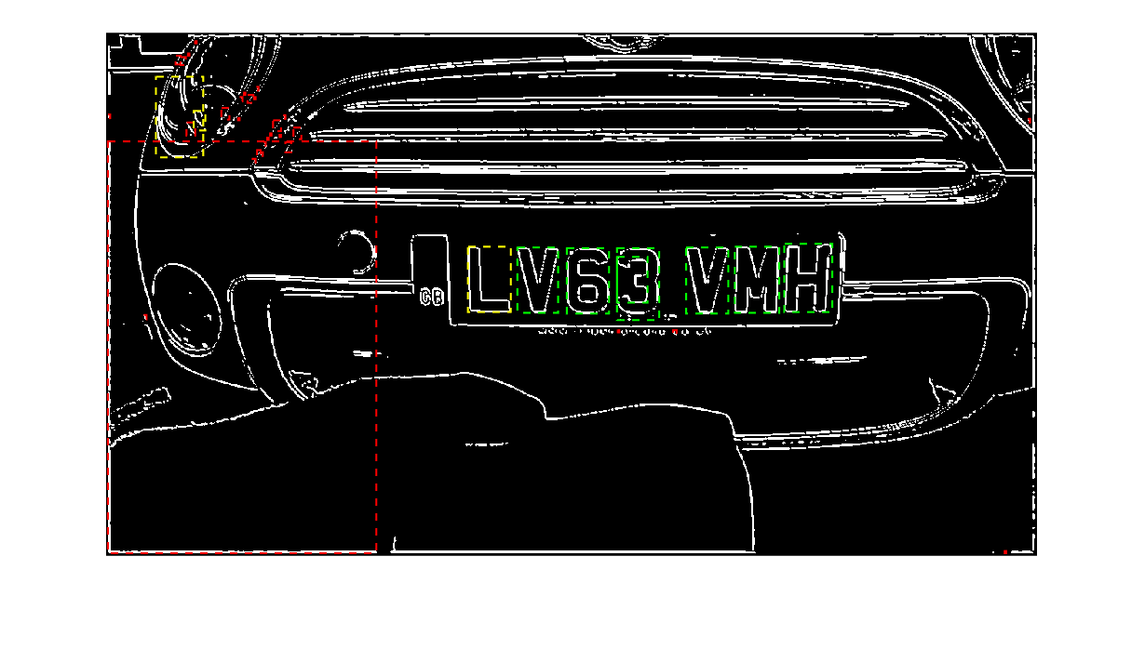

This filter appears to have worked well, but the left-out letter at the side could be corrected. All of the licence plate boxes are of a very similar size, perhaps it would be a better idea to find boxes of a similar y coordinate and size. The rounding method seems to be too restrictive in what it can do, perhaps a new method of finding similar data points is needed.

Perhaps a new algorithm could solve the issue, allowing for rounding to the closest N. N could be multiplied until the boundary multiplication, the two multiplications that contain the data point in their range, then the closest multiplication to the data point would be set as the rounded number. Then the mode of the new list could be found to get the most likely collection of boxes.

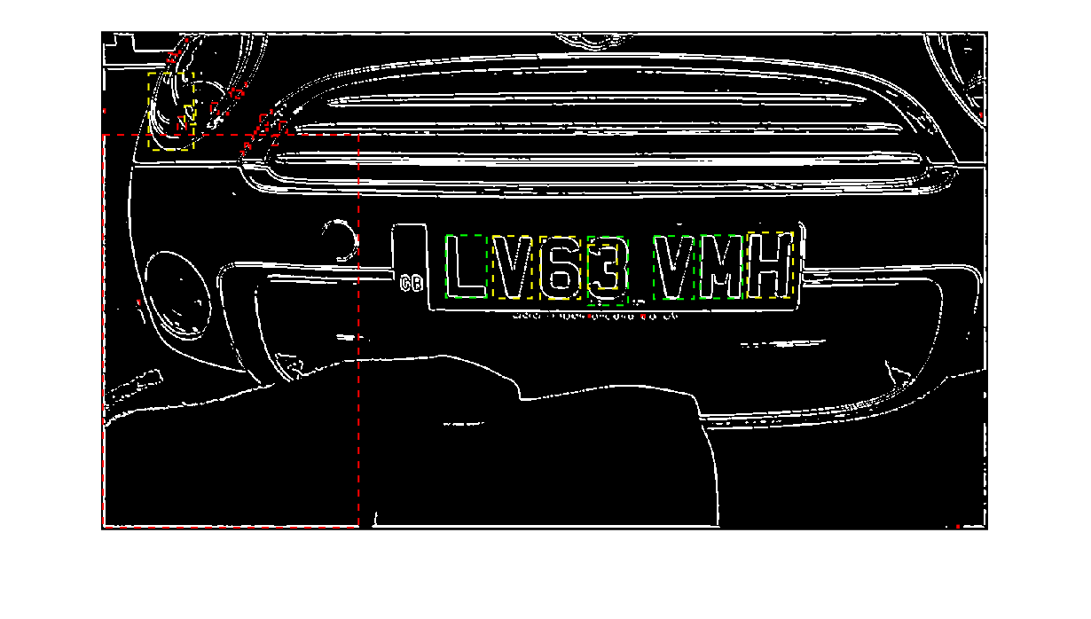

Rounding the area of each box to the nearest 500 pixels sq and taking the mode there are no false positives, but the false negatives could be corrected by increasing the rounding level.

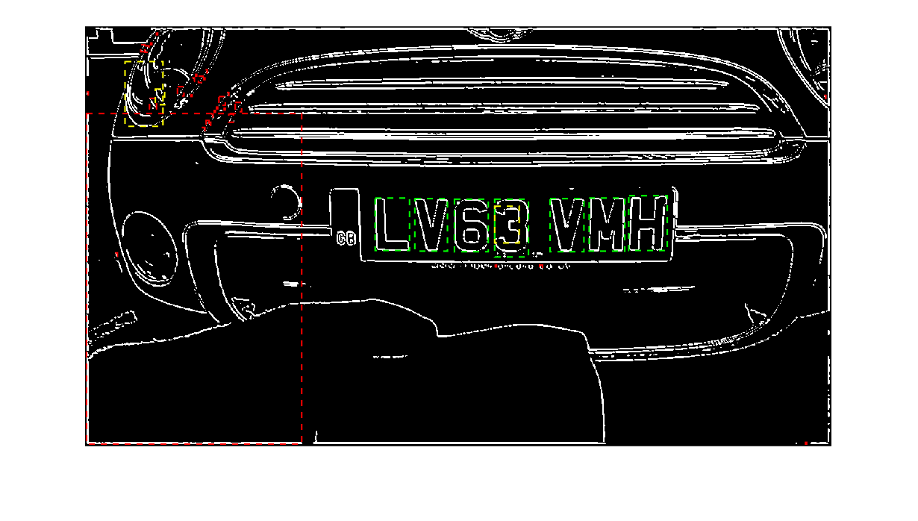

Increasing the rounding to nearest 1000 pixels sq appears to properly collect all of the boxes. The area statistic appears to be the best to work with for selection, likely because it is the most sensitive to changes in the dimensions of the bounding box.

For an extra degree of safety, a y coordinate check should also be implemented as this should have small variance for the wanted boxes. Implementing this has no effect on the image, but should help to clean up more box-rich images.

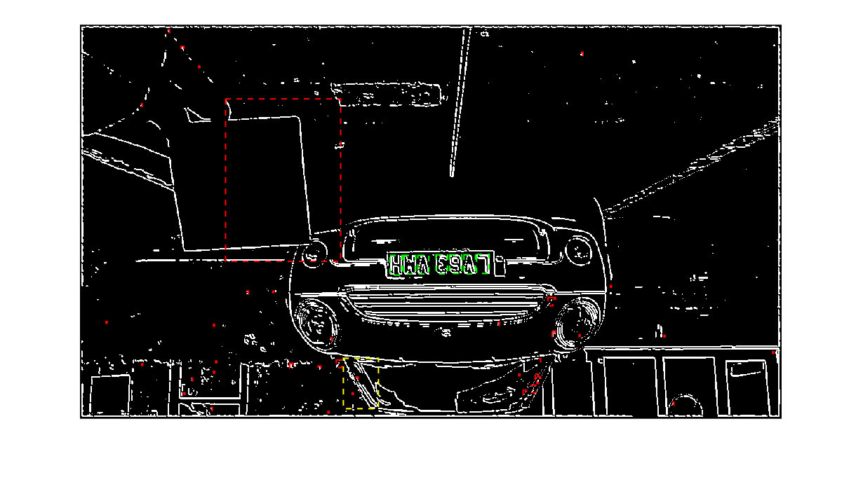

The process still works on images taken 2.5m away. A max distance will have to be found but this could potentially be increased by increasing resolution to the highest possible under the compute available.

Once the bounding boxes of the letters have been found, the average bounding box can be found. This is just an average of all valid boxes’ coordinates, which is then stored for later use.

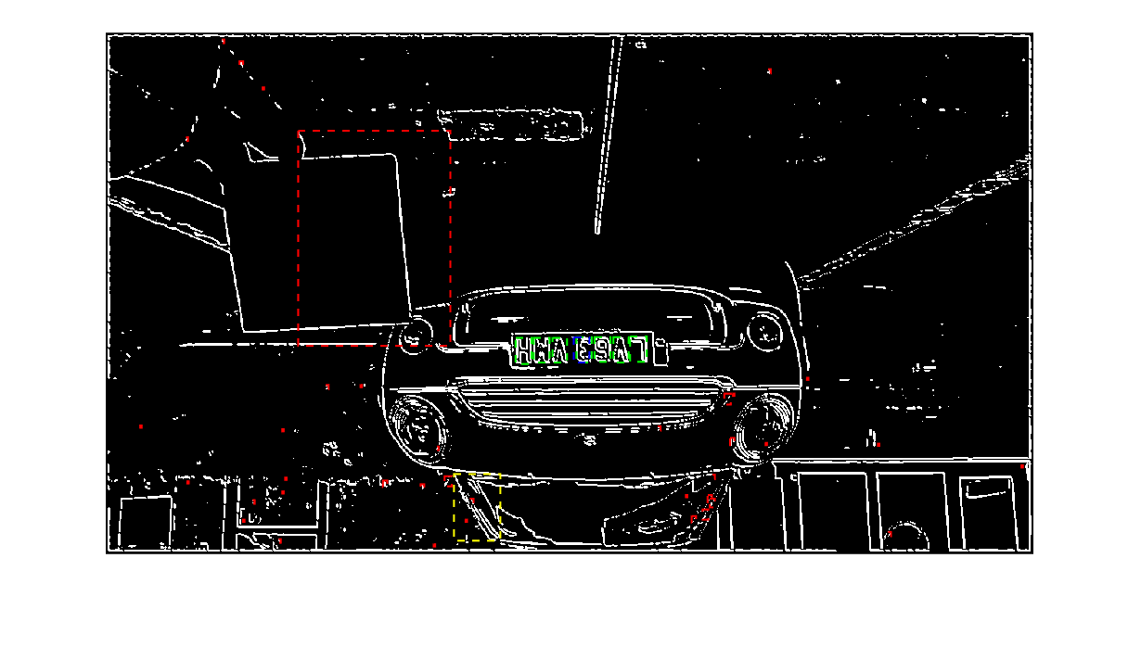

The average box area (seen in blue) can be compared to a lookup table to be later developed, and a distance per image found. Once the distance per image is found, assuming a constant number of images per second, the change between images can be divided by the frame period and the speed calculated. This is the core of how the speed camera will work.

The only step left is to create a script to extract the average box size over a set of images, then return this information.

19/11/2022 – Bounding box info selection

As the average bounding box is stored as a set of coordinates, it is trivial to calculate its area and dimensions

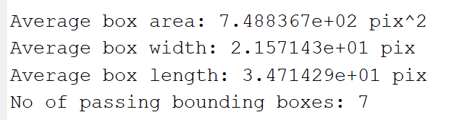.

This was the result from the 2.5m image.

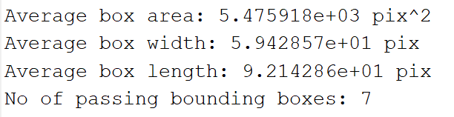

And above is the result for the 1m image. From casual observation, there appears to be a far greater difference in overall area compared to the change in length or width. A test would be best to observe this, I will apply the filter to all my 0.5-3m photos in sequence and plot the resultant change in size values.

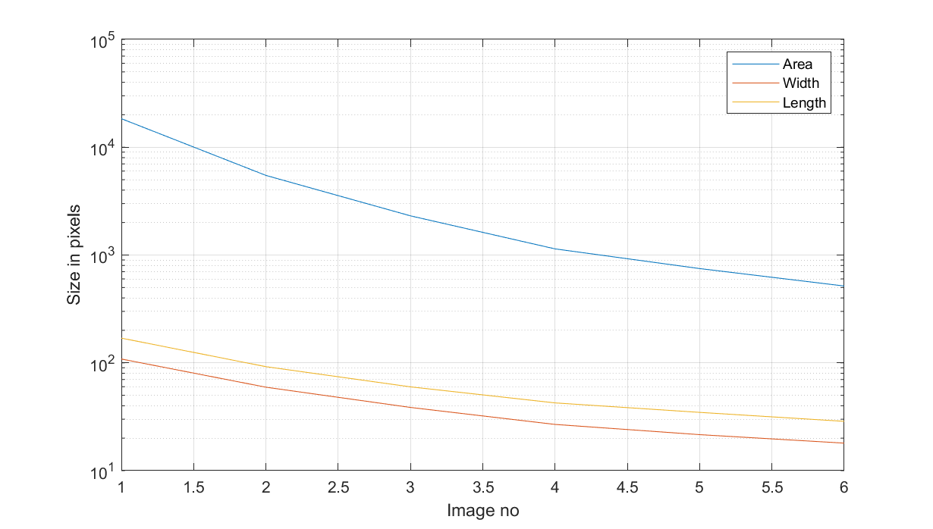

This graph represents the sizes for the bounding boxes across all the images (the lower axis refers to the number of the image, real distance started at 0.5m and progressed in 0.5m increments to 3m, ignore non integers need to find a way to get rid of them).

What appears to be the case from this data is what I initially suspected, the size of the average area traverses a far larger distance as the vehicle gets further away in the images. This means that area is likely the best candidate for the final metric to use to determine the distance from the camera for a given image.

An extra point to make is what occurred with the 3m image

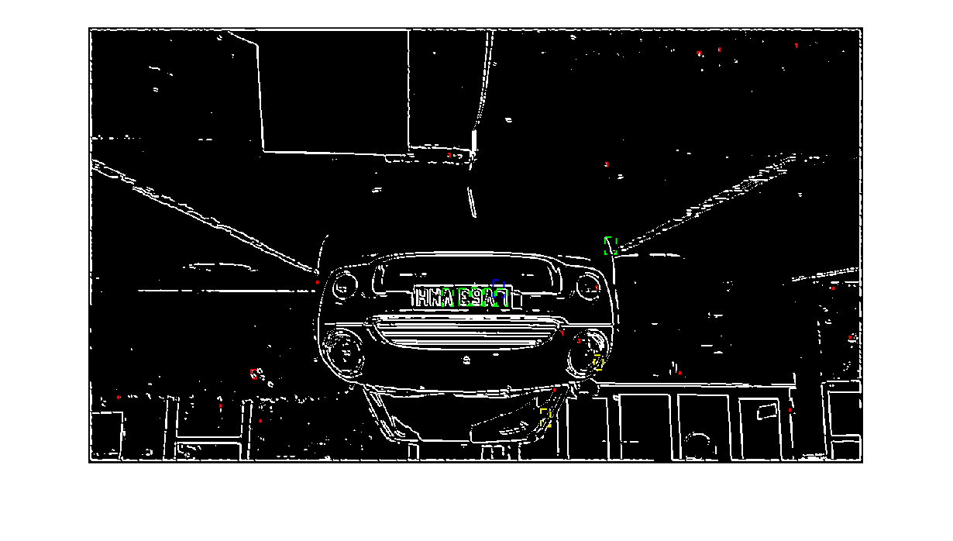

It appears that the y axis difference filter is set too leniently, I will attempt to reduce it.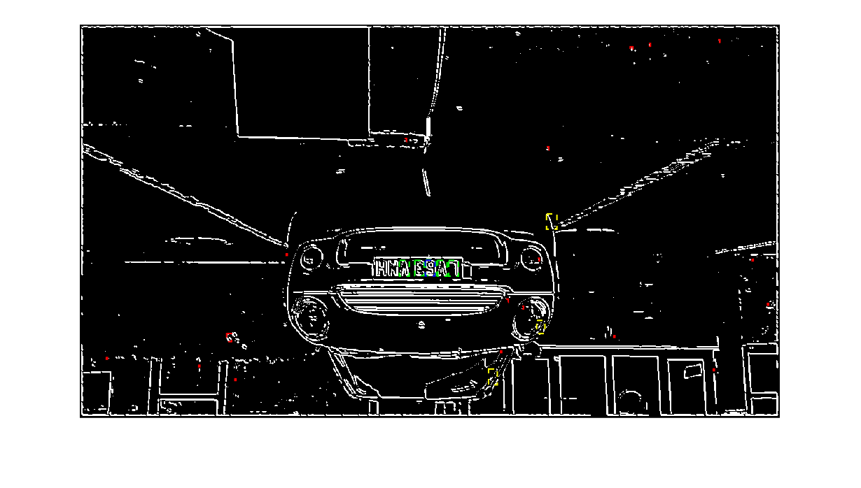

From testing it appears the correct way to apply the rounding and modal filter is to set a low unit for rounding the y coordinate and a high unit for the area rounding. This seems to result in the best performance across all images.

One point of concern is the fact that even at 3m the image is already beginning to be hard to read the licence plate figures in detail from the image. While more testing needs to be done, what could be tried is if the implemented C++ algorithm is sufficiently fast, the image resolution could be increased to capture finer detail.

23/11/2022 – implementing in C++

In order to implement my algorithm into C++ I will need to use an image processing library to both read and write the images into a useable format from basic files.

Given that I intend to only use this library for reading and writing image data to readable files, I will need to find a lightweight library that gives its output in the form of a matrix of int or similar.

A library know as libjpeg might be good for my purposes, this library is intended to work with a rapidly compress/decompress jpeg files, a format my camera supports as an output.

Having looked at this library, I feel it may be beyond the time I have to attempt to comprehend how to implement this library in my code. To this end I think it might be a good idea to view the other formats my camera can output and think about writing a custom library to read from them.

Another promising candidate is the stb libraries, these are a series of single file C++ libraries that seem to support both PNG and JPEG for file reading and PNG for image writing. In addition, it is heavily displayed that all of the code contained is open source and under no licence.

Looking at the stb_image.h file, it appears to only need a short macro to implement the header file into a useable set of functions. I have written a short algorithm that gets the library to read an image file into its buffer and report the width, height, and bytes per pixel of a given jpeg image.

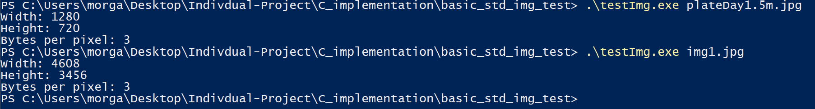

This seems to be very promising, with a simple function call it appears that the library can work without issue.

The image file is read into a char * buffer, the documentation states that, “The pixel data consists of *y scanlines of *x pixels, with each pixel consisting of N interleaved 8-bit components; the first pixel pointed to is top-left-most in the image.” x,y and N are passed as pointers to be returned as integer values. This should allow me to easily create a matrix that contains the pixel data in a more sensible format.

A good way to test if my reading and writing is accurate is to use another stb file: stb_image_write.h. If I can read an image file into my own format then write it back out correctly then I will be sure that I have implemented a correct format transfer.

24/11/2022 – Image object creation

The first task is to write an image class which has methods to take a filename to read an image file and write an image file. The class will, as part of the reading method, convert the raw data into a pixel matrix, then convert back to the raw format when writing. As I will never need to utilize the colour images in my processing, the reading shall also convert to grayscale using the same formula as MATLAB:

0.299 * R + 0.587 * G + 0.114 * B = pixelVal

This should probably be converted to a more integer friendly format for calculation. The equation could be simplified into: 0.3 * R + 0.6 * G + 0.1 * B. All coefficients sum to and have an LCM of 1.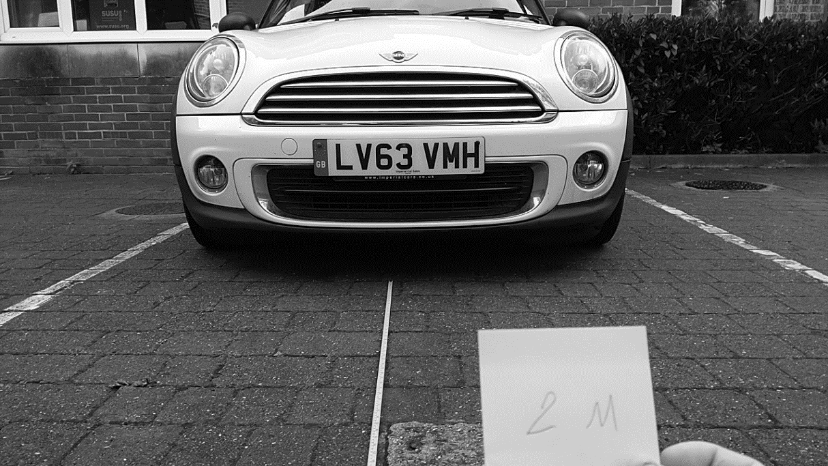

Looking at the grayscale created by this formula, no significant information is lost by this simplification.

27/11/2022 – cont

There is however, a quest of how to conduct this division with bitwise operations to speed up the calculation, one way could be to increase all the coefficients by a factor of 10 and then divide by 10, but this could be difficult in pure bit operations.

Having done some research, apparently compilers will already do what I am thinking of already, implementing constant dividers as bit shifts. This only means I need to convert my multiplications into bit shift operations, which can be easily done by factoring the multiplier into powers of 2.

3 = 2*1 , 6 = 4*2 , 1 = 1

Thus, the final equation becomes:

R: ( (R<<1) + R ) / 10, G: ( (G<<2) + (G<<1) ) / 10, B: B / 10

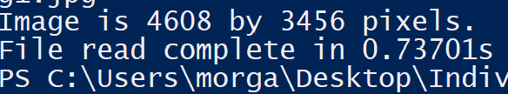

This seems to be a promising start, the image read and grayscale processing time is not bad. Per pixel this would be 0.73701 / (4608*3456) = 46 ns per pixel, including reading time. Assuming scaling effects are non-existent, this would mean a 1080p image could be written into memory as grayscale in 0.01s.

After some work creating the file writing routine, this was the output:

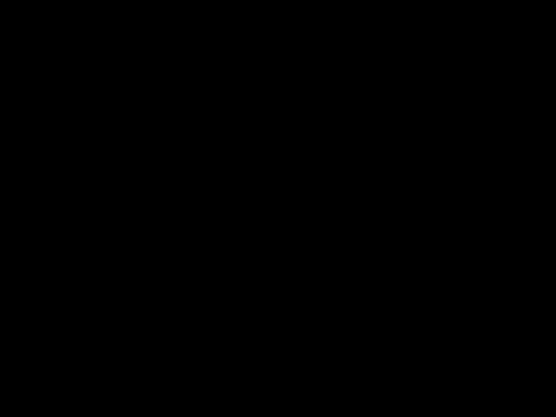

This is not the intended result, although closer examination of the image shows a single line of pixels in the first row of the image. The function to write has a return code that is return a success (non-zero value), so it seems likely that I am making some failure in arguments or my image reader.

Perhaps the issue lies in the composition setting I am using, the monochrome setting may be different in byte expectations to the grayscale values I am providing, perhaps I should use the RGB composition settings and replicate each pixel value across the RGB values for simplicity.

The problem had nothing to do with this, I was making errors in how I indexed the linear output buffer as opposed to the matrix pixel array. Replacing the faulty code with a simple incrementing number, I was given this output.

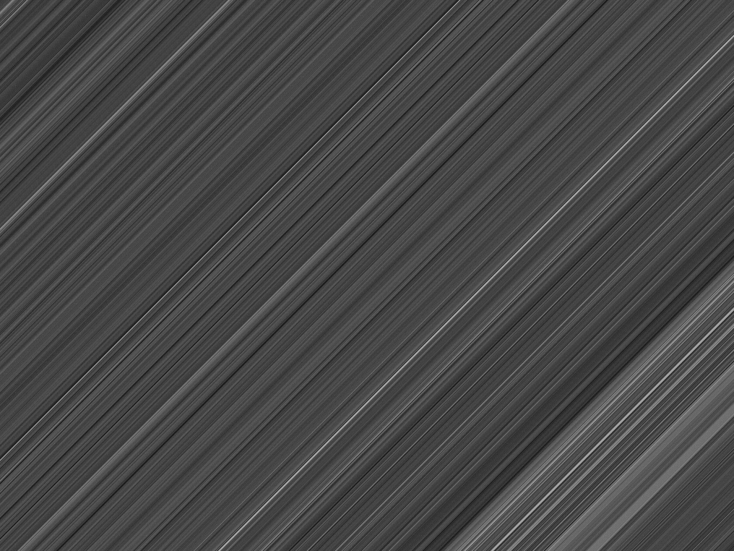

This is still not correct, but an improvement from a black screen.

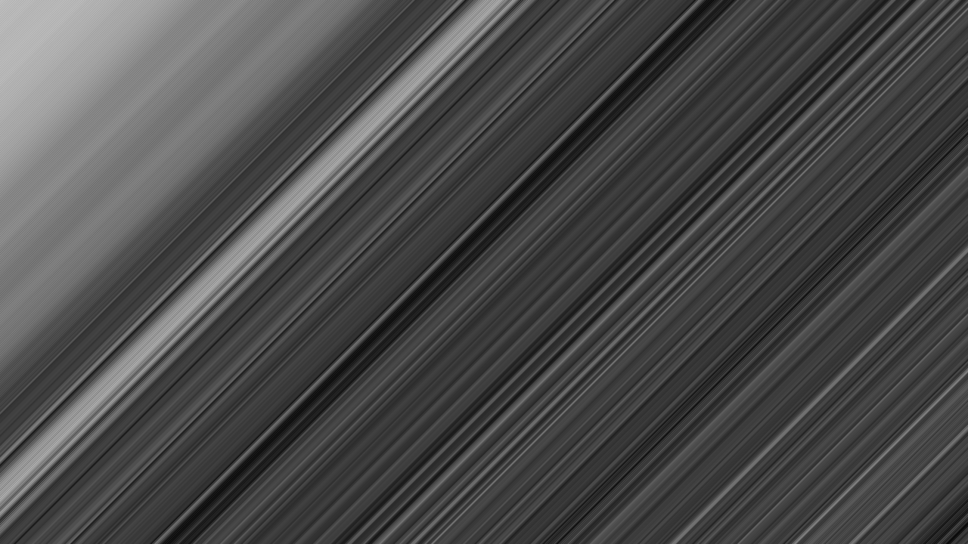

Checking a different image and image output format (bmp), it seems clear that the same type of image distortion is occurring. This means that the problem likely lies in my interpretation of the initial data given to me by the jpg output buffer.

29/11/2022 – I have found the problem

The issue was not just with how I was indexing the final pointer but also how I was indexing the initial data, I was failing to properly account for the 3 pixels per index property of the input data, and thus I was advancing my index pointer incorrectly. Fixing this results in the output being correct.

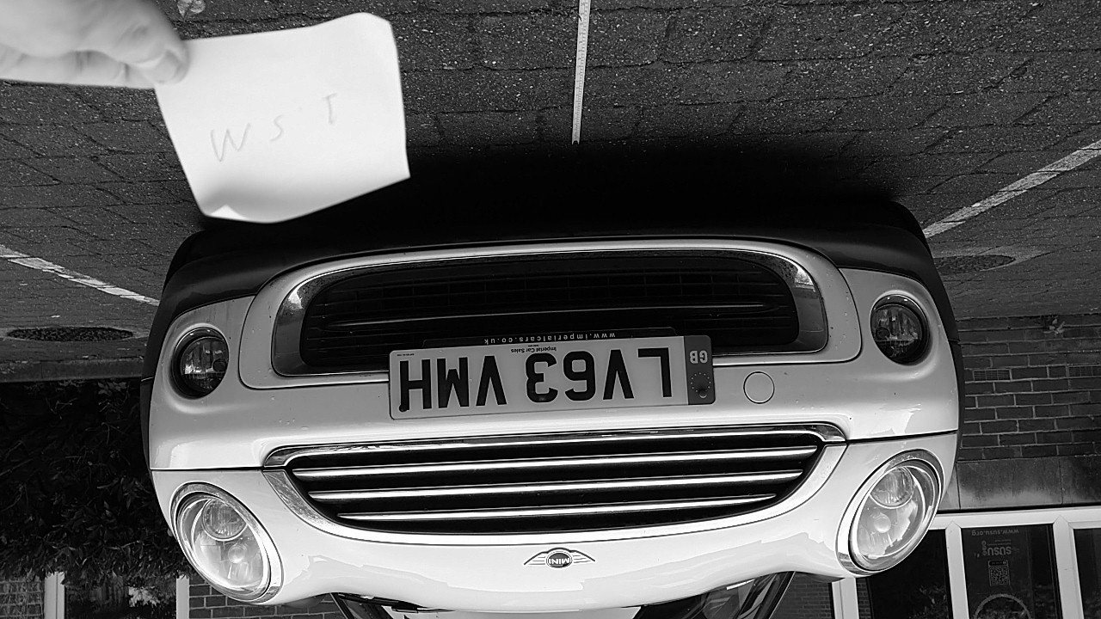

The above is the final output from my program, which is very clearly accurate and legible for an image processing algorithm. Coincidentally, all the output images from the library come out flipped vertically. While this should not have any effect on the final speed calculation as long as all images are flipped, I will remedy this for security of mind.

I have found that flipping the order that rows are read does nothing, I am perplexed. Doing some reading about jpg files, apparently the filetype requires some extra information to set orientation, something that the stb library is likely not doing. As was said before, it doesn’t affect calculations if all internal data is not affected or affected in a consistent way.

With a working file reading routine, this now leaves open the task of creating the filter stack in C++.

30/11/2022 – Gaussian filter

Before programming can start, i need to select the desired length of my convolution kernel. I will choose 11 for 720p images as this gave the best result in testing although this can be changed later easily.

The sum for a 11 length nCr list is: 1 10 45 120 210 252 210 120 45 10 1

This sums to 1024, which makes the final bit division easy as this can be reduced to a bit shift log2(1024) = 10 places.

Creating my gaussian blur routine, it is clear my code works:

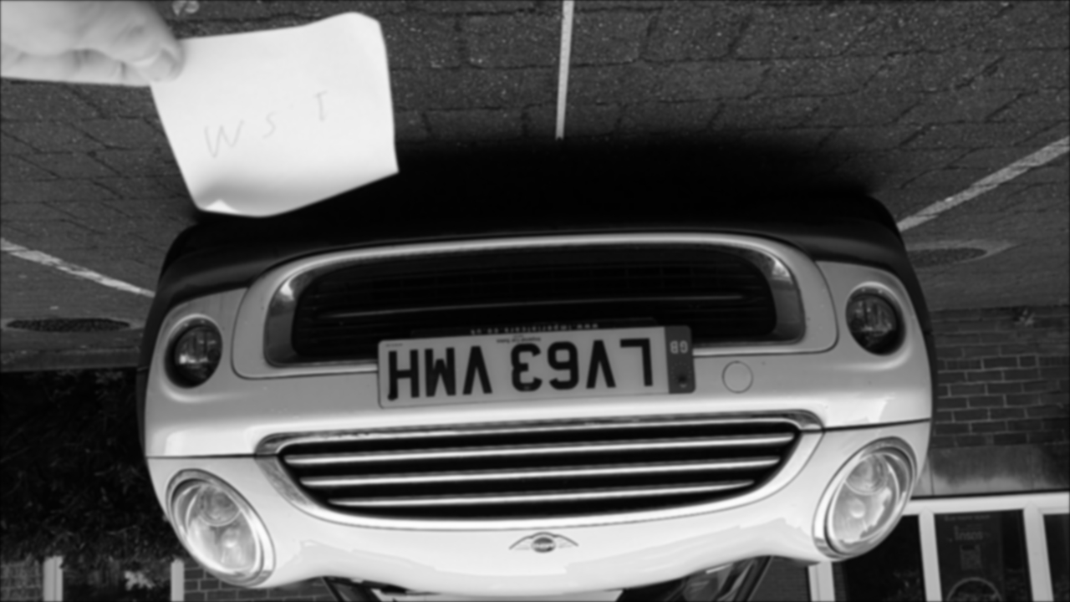

But the time taken to calculate this image is concerning:



This is far longer than the expected time for the program to complete an image of this size, which should be in the order of half a second. It is clear some optimization will have to be done to the main loop of the code. The contents of the longest section, the main calculation loop, are the best parts to look at.

Changing the list of coefficients from a vector to a direct memory access may help with speed.

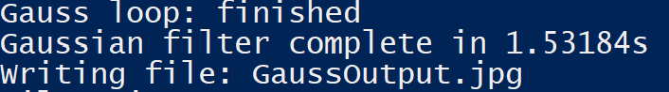

This clearly has done something to help. The only other place this could be implemented is if it was applied to the whole matrix of values for the image. While this would create a large amount of potential danger for memory indexing violations, it seems it must be done as no other major time losses can be found.

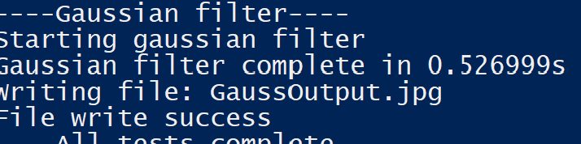

This seems to have taken a whole second off the time to process a 1280 by 720 pixel image. Given that access to the matrix of pixels will likely be the majority of the memory accesses for all my algorithms, this will probably lead to time savings down the line as well. While this is an improvement over the MATLAB time, this is still not as high a time saving as I had hoped. But considering the algorithm is as bare bones as it can be at this point, there liklley isn’t any speed improvements to be found aside from trying to parallelize the processing of images.

After creating a basic outline for the convolution routine with the gaussian filter, implementing the sobel filter should be a relatively easy task.

In the meantime, I have rewritten the structure of my code to use an enumerated type storing the stage of the filtering process that the internal pixel matrix is at, helping to ensure that no stage is repeated.

The Sobel filter code has been written.

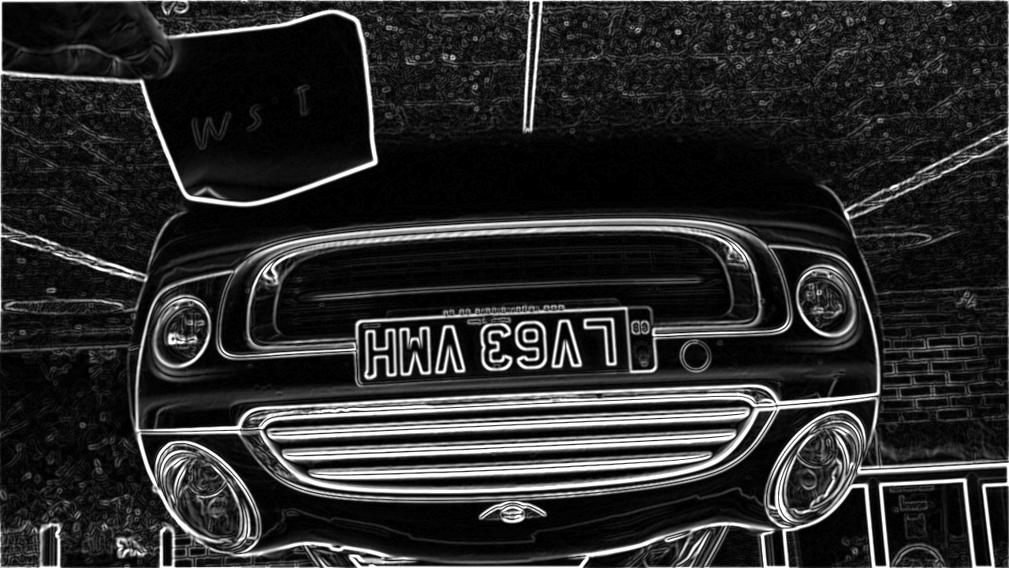

This seems to be working very well, with edges clearly not extending too far into shapes. This can later be non-maximum supressed to further clarify the image.

The time to complete this process is also very positive.

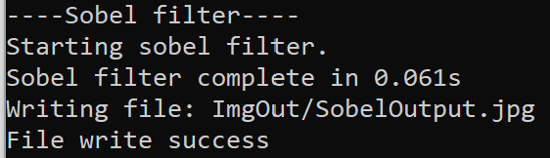

This is incredibly rapid and makes up a major time save compared to the MATLAB routine. I suspect that my routine has an O time associated polynomially with both the image size and the convolution kernel size, which is why the gaussian blur takes so much longer as it has an 11 by 11 kernel compared to Sobel’s 3 by 3.

01/12/2022 – Non max suppression implementation

The suppression code was simple to implement, just read my direction code from its matrix and compare the origin of the 3 x 3 square against the 2 pixels on the direction.

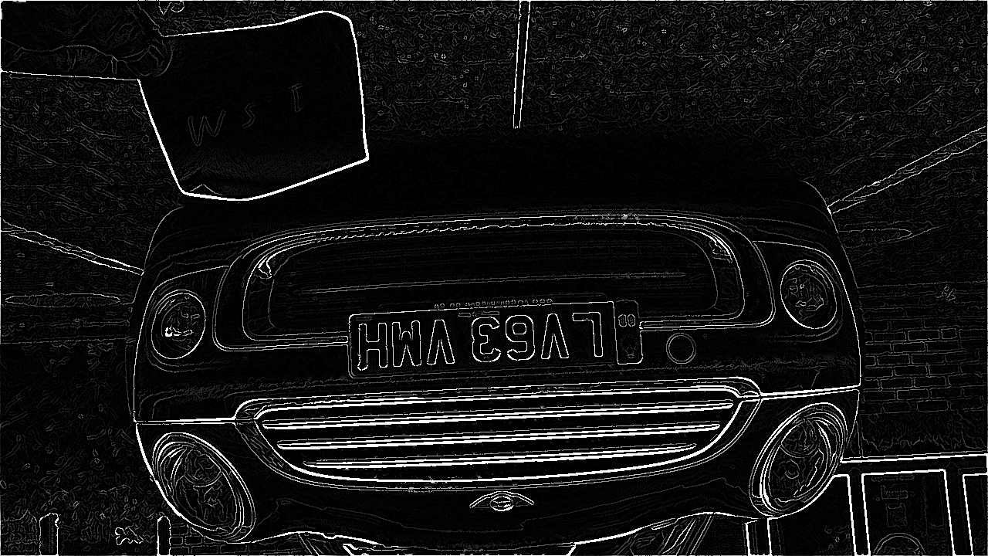

Some notable parts of the image include the fact that the dimming I saw as part of the MATLAB filter stack is not present in the final non-binary stage. The reason for this could be that MATLAB is engaging in some normalization that I do not perform with values larger than 255, which I simply clip to 255. Additionally, there is a thin jagged border around the image of white pixels, this is likely due to all pixels ‘outside’ of the image being treated as 0 and thus an artificial edge being created.

Regardless, the image is very clearly sharpened by the non-max suppression and usable for my edge linking and bounding box finding algorithms. With a very fast algorithm, the task of writing the routine is complete.

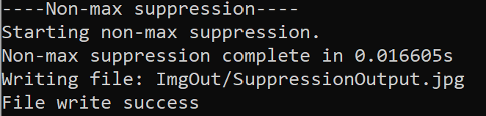

Writing the edge linking algorithm should be a similarly simple task.

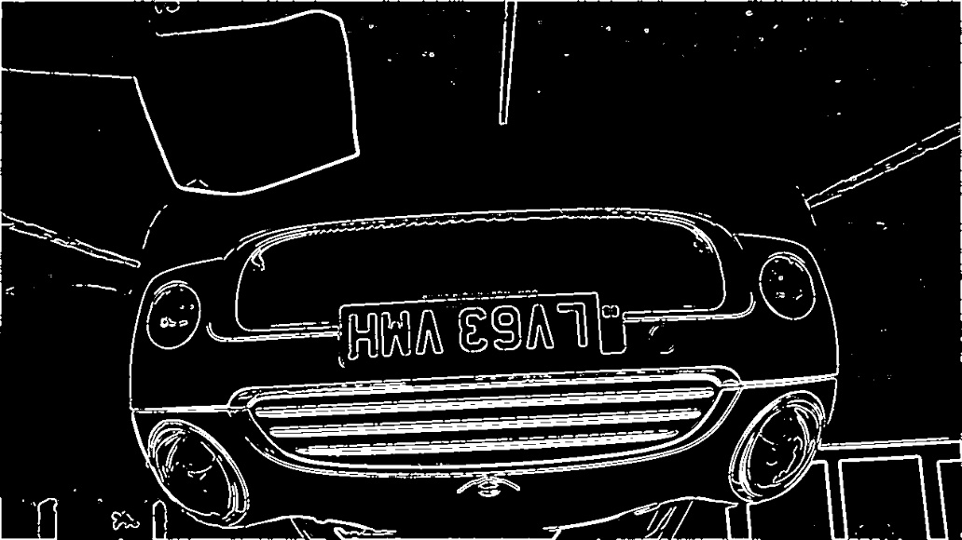

This end result is clearly correct and can be searched for bounding boxes.

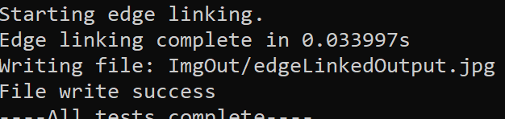

02/12/2022 – Bounding box finding

The bounding box algorithm is returning a normal number of bounding boxes.

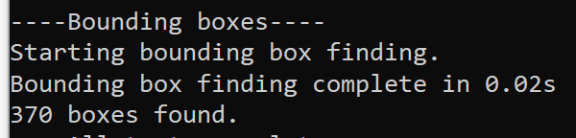

Comparing with the MATLAB routine, this is a smaller number than the amount found with its routine. If this is a problem will have to be determined in the filtering stage, as the vast majority of boxes are discarded anyway. Regardless fast algorithm good.

04/12/2022 – Filtering bounding boxes

Interesting error, conversion from uint16 to double doesn’t work well when done implicitly. Also divide by 0 results in access violation?